**Practical File of C**

**(BCA 171)**

**BACHELOR OF COMPUTER APPLICATIONS**

**Academic Session: - 2021-22 Batch-2021-24**



**Submitted To: - Submitted By: -**

**Name- AMBOOJ YADAV Name: - AAYUSHI TYAGI**

**Designation: - (Assistant Professor) Programme: -BCA**

**Semester: -1**

**Shift: - EVENING**

**Division: - B**



|  |  |  |
| --- | --- | --- |
| S.NO | TOPIC | SIGNATURE |
| 1. | WRITE A PROGRAM TO PRINT HELLO. |  |
| 2. | WRITE A PROGRAM TO CALCULATE SUM OF 2 NUMBERS. |  |
| 3. | WRITE A PROGRAM TO PRINT THE AREA AND PERIMETER OF CIRCLE. |  |
| 4. | WRITE A PROGRAM TO PRINT YOUR RESUME. |  |
| 5. | WRITE A PROGRAM TO SWAP THE VALUE OF TWO VARIABLES USING THIRD VARIABLE. |  |
| 6. | WRITE A PROGRAM TO SWAP THE VALUE OF TWO VARIABLES WITHOUT USING ANY THIRD VARIABLE. |  |
| 7. | WRITE A PROGRAM TO PRINT A PRIME DATATYPE AND STRING. |  |
| 8. | WRITE A PROGRAM TO PRINT THE SUM AND PERCENTAGE OF 5 SUBJECTS MARKS. |  |
| 9. | WRITE A PROGRAM TO PRINT TO FIND REMAINDER AND QUOTIENT. |  |
| 10. | WRITE A MENU DRIVEN PROGRAM TO CONSTRUCT CALCULATOR FOR FOLLOWING ARITHEMATIC OPERATIONS: +, -,*,DIVIDE,AVERAGE |  |
| 11. | WRITE A PROGRAM TO PRINT THE NO.IS EVEN OR ODD. |  |
| 12. | WRITE A PROGRAM TO PRINT THAT THE PERSON IN ELIGIBLE FOR VOTING OR NOT. |  |
| 13. | WRITE A PROGRAM TO FIND THE GREATEST OF 3 NUMBERS. |  |
| 14. | WRITE A PROGRAM TO FIND THE GREATEST OF 3 NUMBERS USING CONDITIONAL OPERATOR. |  |
| 15. | WRITE A PROGRAM TO FIND POST AND PRE INCREMENT AND DECREMENT FOR DIFFERENT VARIABLES. |  |
| 16. | WRITE A PRINT SIZE OF VARIABLES/OPERATORS. |  |
| 17. | WRITE A PROGRAM TO PRINT CHARACTER TYPE VARIABLE. |  |
| 18. | WRITE A PROGRAM TO PRINT THE ASCII VALUE OF A VARIABLE. |  |
| 19. | WRITE A PROGRAM TO CHECK NO IS GREATER THAN 100 AND LESS THAN 1000. |  |
| 20. | WRITE A PROGRAM TO PRINT NUMBER IS ODD OR EVEN BY USING GOTO. |  |
| 21. | WRITE A PROGRAM TO CREATE A CALCULATOR OF ARITHEMATIC FUNCTIONS USING SWITCH CASE. |  |
| 22. | WRITE A PROGRAM TO DEMONSTRATE SIZE OF OPERATORS |  |
| 23. | WRITE A PROGRAM TO CHECK THAT NUMBER IS PRIME OR NOT |  |
| 24. | WRITE A PROGRAM TO CONVERT CELCIUS INTO FAHRENHEIT. |  |
| 25. | WRITE A PROGRAM TO FIND SIMPLE INTEREST AND COMPOUND INTEREST. |  |
| 26. | WRITE A PROGRAM FOR GIVING SPACE BEFORE AND AFTER. |  |
| 27. | WRITE A PROGRAM TO FIND THE SQUARE OF THE FOLLOWING SERIES. |  |
| 28. | WRITE A PROGRAM TO FIND THE PERFECT SQUARE BETWEEN 1 TO 500. |  |
| 29. | WRITE A PROGRAM TO CALCULATE SALARY OF A MEDICAL REPRESENTATIVE BASED ON THE SALES, BONUS AND INCENTIVES TO BE OFFERED TO HIM WILL BE BASED ON TOTAL SALES, IF THE SALES EXCEED OR EQUAL TO RS.100000. FOLLOW THE PARTICULAR OF TABLE 1 OTHERWISE TABLE 2: |  |
| 30. | WRITE A PROGRAM TO PRINT 2’s TABLE. |  |
| 31. | WRITE A PROGRAM TO PRINT FACTORIAL. |  |
| 32. | WRITE A PROGRAM TO REVERSE A NUMBER. |  |
| 33. | WRITE A PROGRAM USING FOR LOOP. |  |
| 34. | WRITE A PROGRAM USING WHILE LOOP. |  |
| 35. | WRITE A PROGRAM USING NESTED LOOP. |  |
| 36. | WRITE A PROGRAM USING DO WHILE LOOP. |  |
| 37. | WRITE A PROGRAM TO PRINT REVERSE NO. 100-1 FROM FOR LOOP. |  |
| 38. | WRITE A PROGRAM TO PRINT REVERSE NO. 100-1 FROM DO WHILE LOOP. |  |
| 39. | WRITE A PROGRAM TO DISPLAY FIBONACCI SERIES. |  |
| 40. | WRITE A PROGRAM TO PRINT PRIME NUMBER USING WHILE LOOP. |  |
| 41. | WRITE A PROGRAM TO PRINT WHETHER IT IS A LEAP YEAR OR NOT? |  |
| 42. | WRITE A PROGRAM TO PRINT 1-D ARRAY ELEMENTS. |  |
| 43. | WRITE A PROGRAM TO PRINT MATRICES IN 2-D ARRAY. |  |
| 44. | WRITE A PROGRAM TO PRINT SUM OF ARRAY. |  |
| 45. | WRITE A PROGRAM TO PRINT MAXIMUM NUMBER BY USING ARRAY. |  |
| 46. | WRITE A PROGRAM TO CHECK WHETHER THE NUMBER IS ARMSTRONG. |  |
| 47. | WRITE A PROGRAM TO CHECK A NUMBER IS PALINDROME OR NOT. |  |
| 48. | WRITE A PROGRAM TO COUNT THE NUMBER OF STUDENTS HAVING AGE LESS THAN 25 AND WEIGHT LASS THAN 50KG. |  |
| 49. | WRITE A PROGRAM TO SHOW GLOBAL VARIABLE AND LOCAL VARIABLE |  |
| 50. | WRITE A PROGRAM TO SHOW INCREMENT. |  |
| 51. | WRITE A PROGRAM TO SHOW DECREMENT. |  |
| 52. | WRITE A PROGRAM TO DEMONSTRATE THE USE OF BREAK KEYWORD. |  |
| 53. | WRITE A PROGRAM TO DIAMOND PATTERN (TAKING NUMBER OF ROWS FROM THE USER). |  |
| 54. | WRITE A PROGRAM TO PRINT GOOD MORNING, GOOD EVENING, GOOD NIGHT USING FUNCTIONS. |  |
| 55. | WRITE A PROGRAM TO FIND QUOTIENT AND REMAINDER. |  |
| 56. | WRITE A PROGRAM TO CHECK WHETHER THE NUMBER IS GIVEN IS PRIME OR NOT, USING USER DEFINE FUNCTION (WITH ARGUMENT &WITH RETURN TYPE). |  |
| 57. | WRITE A PROGRAM TO CALCULATE THE SQUARE OF NUMBERS FROM 1-5 USING A USER DEFINED FUNCTION. (WITH ARGUMENT & WITHOUT RETURN VALUE). |  |
| 58. | WRITE A PROGRAM TO CALCULATE THE AVERAGE OF THREE NUMBERS USING FUNCTIONS. (WITH ARGUMENT & WITH RETURN VALUE). |  |
| 59. | WRITE A PROGRAM TO DESCRIBE THE CALL BY REFERENCE CONCEPT IN FUNCTIONS BY SWAPPING TWO VARIABLES WITH THE HELP OF THIRD. |  |
| 60. | WRITE A PROGRAM TO SKIP A NUMBER IN SERIES USING CONTINUE |  |
| 61. | WRITE A PROGRAM TO DISPLAY THE FOLLOWING PATTERN N ROWS AND ROWS TAKING THE VALUE OF N FROM THE USER. |  |
| 62. | WRITE A PROGRAM TO EXCHANGE THE VALUE OF TWO VARIABLE BY CALL BY REFERENCE OF THE FUNCTION. |  |
| 63. | WRITE A PROGRAM TO INITIALIZE ARRAY AND PRINT ADDRESS INDEX VALUE. |  |
| 64. | WRITE A PROGRAM TO PRINT SIZE OF ARRAY. |  |
| 65. | WRITE A PROGRAM TO BY TAKING USER INPUT FOR ARRAY INDEX LOOPS ELEMENT LOOP. |  |
| 66. | WRITE A PROGRAM TO ADD EVEN AND ODD NUMBERS FROM ONE TO TEN STORE THEM AND DISPLAY THEM IN 2 SEPARATE ERASE INPUT NUMBER FROM THE USER. |  |
| 67. | WRITE A PROGRAM USING POINTER. |  |
| 68. | WRITE A PROGRAM OF POINTER TO A POINTER. |  |
| 69. | WRITE A PROGRAM OF NULL POINTER. |  |
| 70. | WRITE A PROGRAM TO SHOW VOID POINTER. |  |
| 71. | WRITE A PROGRAM OF MALLOC. |  |
| 72. | WRITE A PROGRAM OF CALLOC. |  |
| 73. | WRITE A PROGRAM TO INPUT MARKS OF 50 STUDENTS USING AN ARRAY AND DISPLAY THE AVERAGE MARKS OF THE CLASS. |  |
| 74. | WRITE A PROGRAM TO SEARCH FOR A NUMBER ENTERED BY THE USER IN A GIVEN ARRAY AND DISPLAY THE ARRAY IN ASCENDING ORDER. |  |
| 75. | WRITE A PROGRAM TO CHECK IF A STRING IS PALINDROME OR NOT. |  |
| 76. | WRITE A PROGRAM TO ADD, SUBTRACT MULTIPLY AND DIVIDE TWO NUMBERS USING POINTERS. |  |
| 77. | WRITE A PROGRAM TO NULL POINTERCREATE A STRUCTURE FOR EMPLOYEES CONTAINING THE FOLLOWING DATA MEMBERS: EMPLOYEE ID, EMPLOYEE NAME, AGE, ADDRESS, DEPARTMENT AND SALARY. INPUT DATA FOR 10 EMPLOYEES AND DISPLAY THE DETAILS OF THE EMPLOYEE FROM THE EMPLOYEE ID GIVEN BY THE USER. |  |
| 78. | WRITE A PROGRAM TO CREATE TWO FILES WITH NAMES EVENFILE AND ODDFILE.INPUT 20 NUMBERS FROM THE USER AND SAVE EVEN NUMBERS IN EVENFILE AND ODDNUMBERS IN ODDFILE. |  |
| 79. | WRITE A MENU DRIVEN PROGRAM TO CONSTRUCT A CALCULATOR FOR FOLLOWING ARITHMETIC OPERATIONS: ADDITION, SUBTRACTION, MULTIPLICATION, DIVISION, AVERAGE AND PERCENTAGE. |  |
| 80. | WRITE A PROGRAM TO CONVERT A HEXADECIMAL NUMBER INTO A BINARY NUMBER |  |
| 81. | WRITE A PROGRAM TO CHECK IF A STRING IS PALINDROME OR NOT. |  |
| 82. | WRITE A PROGRAM TO PERFORM MATRIX ADDITION, (II) MATRIX MULTIPLICATION, AND (III) MATRIX TRANSPOSE) ON 2D ARRAYS. |  |
| 83. | WRITE A PROGRAM TO MAKE USE OF ARRAYS WITH STRUCTURES IN THE FOLLOWING WAYS: (I) USE ARRAY AS A STRUCTURE DATA MEMBER (II) CREATE ARRAY OF STRUCTURE VARIABLES |  |
| 84. | WRITE A PROGRAM TO COMPARE THE CONTENTS OF TWO FILES BY TAKING NAMES OF THE FILES THROUGH COMMAND LINE ARGUMENTS. |  |
| 85. | WAP TO PERFORM I/O AND MAKE USE OF FILE POSITIONING FUNCTIONS ON BINARY FILES. (USING FSEEK, FTELL, REWIND FUNCTIONS) |  |
| 86. | WRITE A MENU DRIVEN PROGRAM TO IMPLEMENT THE FOLLOWING STRING OPERATIONS:  (1) CALCULATE LENGTH OF A STRING  (II) CONCATENATE AT THE END OF A GIVEN  (III) COPY ONE STRING TO ANOTHER  (IV) COMPARE CONTENTS OF TWO STRINGS  (V) COPY NTH CHARACTER STRING TO ANOTHER |  |
| 87. | WRITE A PROGRAM TO READ TIME IN STRING FORMAT AND EXTRACT HOURS, MINUTES AND SECOND ALSO CHECK TIME VALIDITY |  |

PROGRAM 1:

WRITE A PROGRAM TO PRINT HELLO.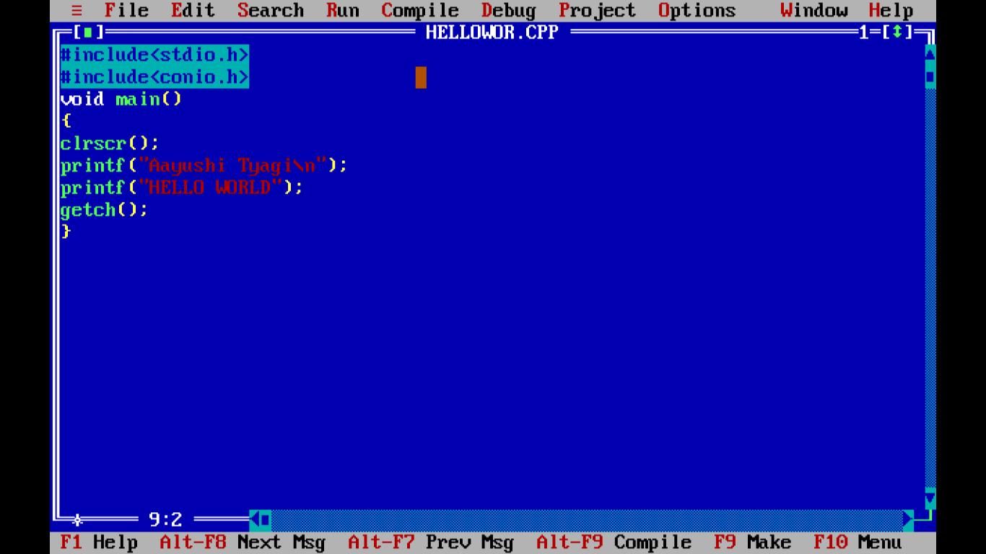

OUTPUT:

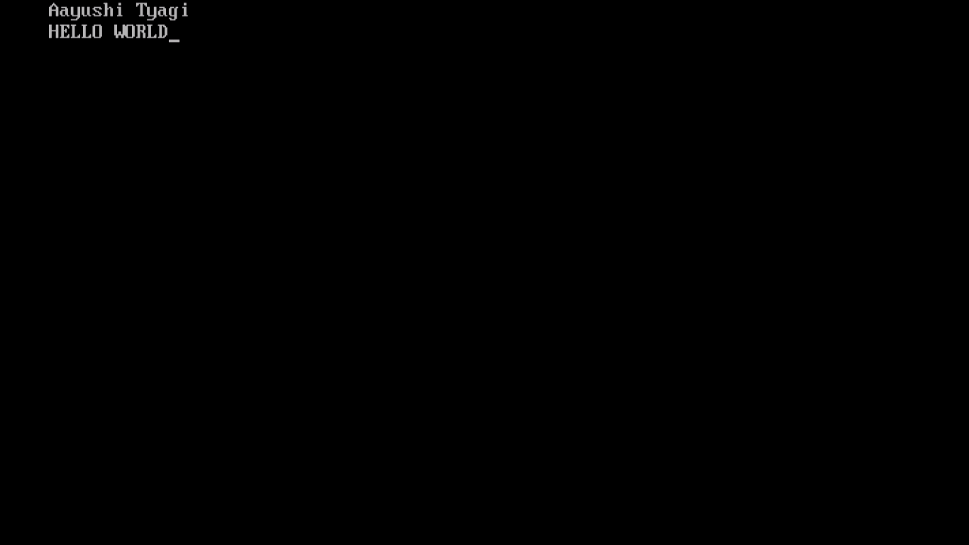

PROGRAM 2:

WRITE A PROGRAM TO CALCULATE SUM OF 2 NUMBERS.

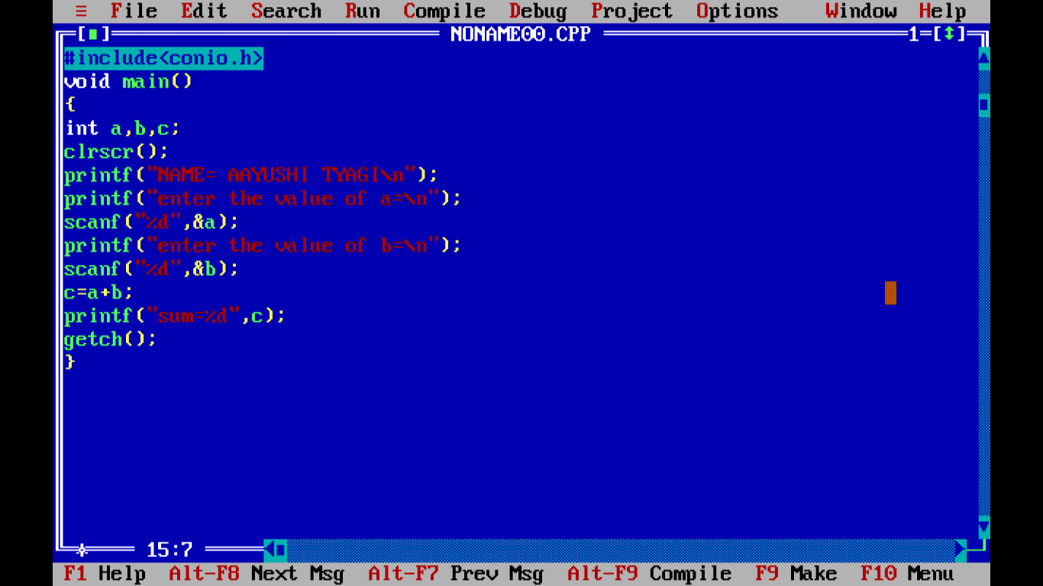

OUTPUT:

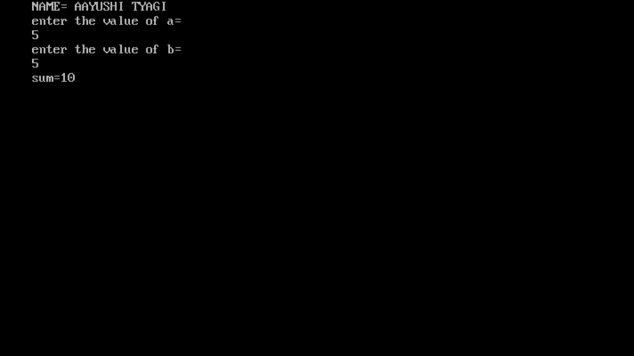

PROGRAM 3:

WRITE A PROGRAM TO PRINT THE AREA AND PERIMETER OF CIRCLE.

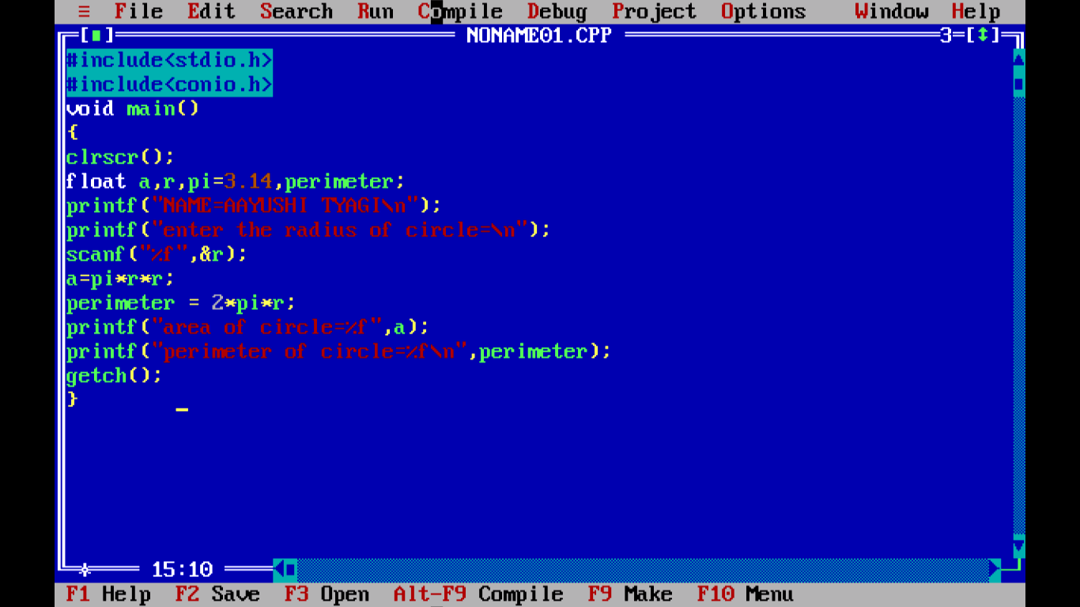

OUTPUT:

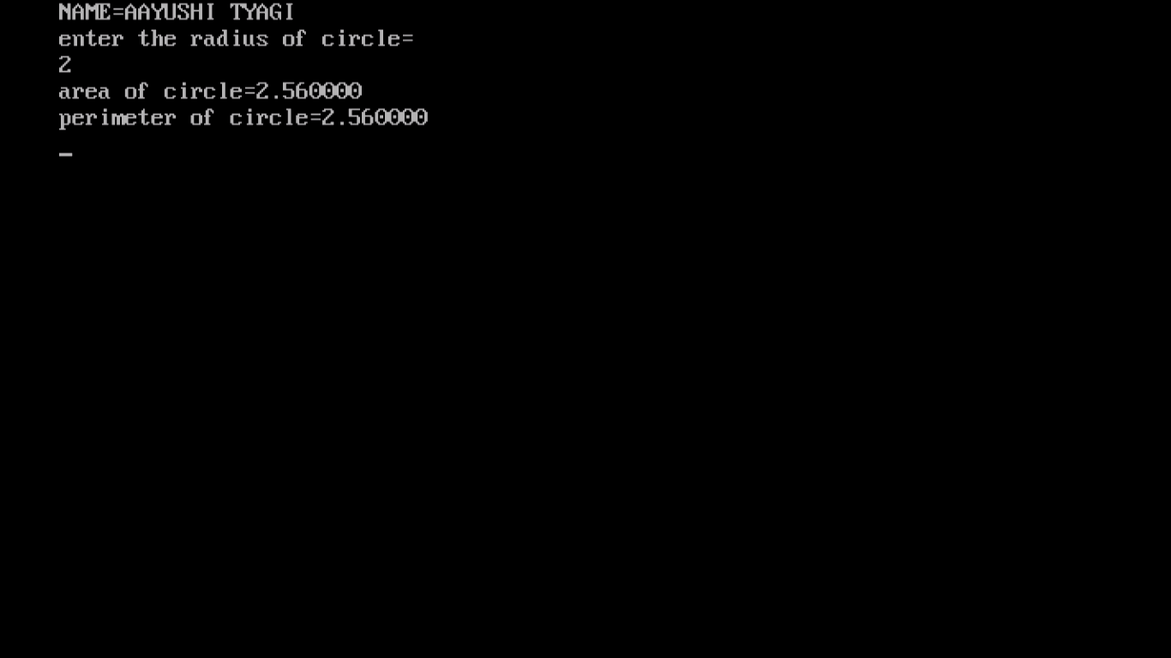

PROGRAM 4:

WRITE A PROGRAM TO PRINT YOUR RESUME.

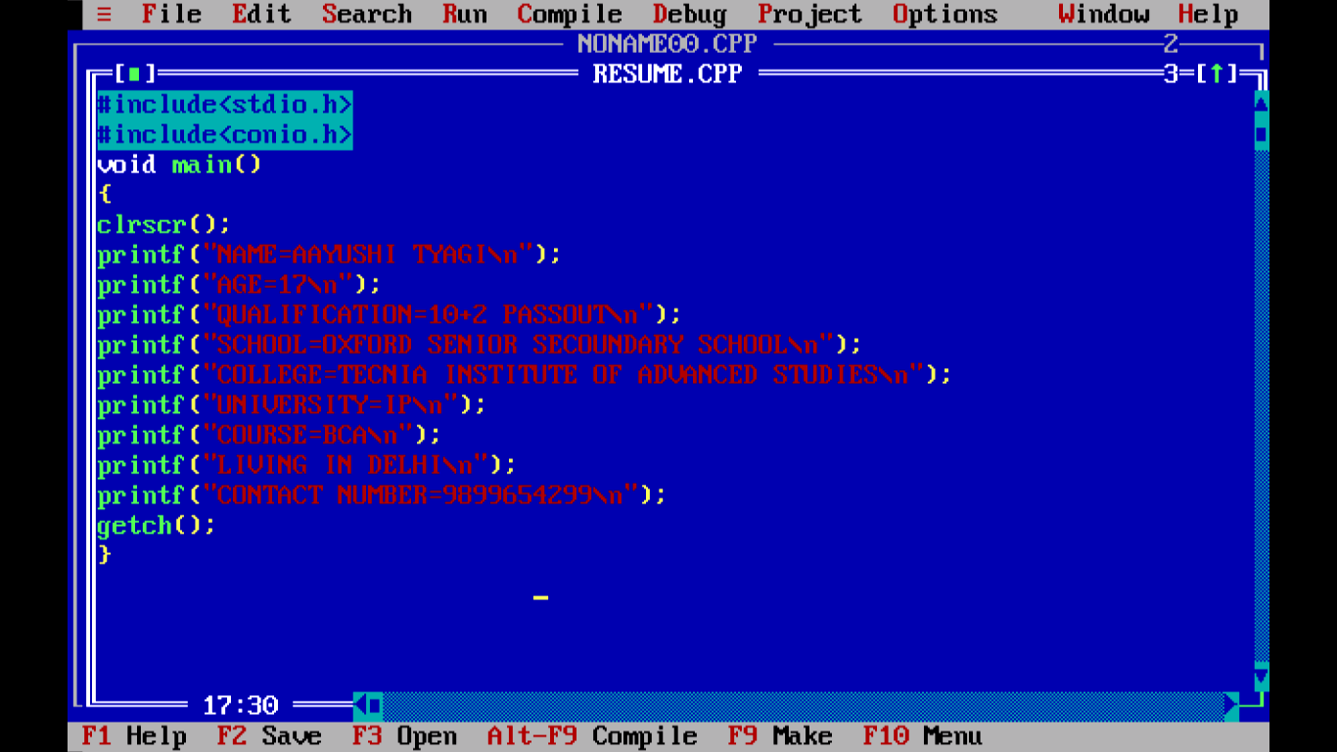

OUTPUT:

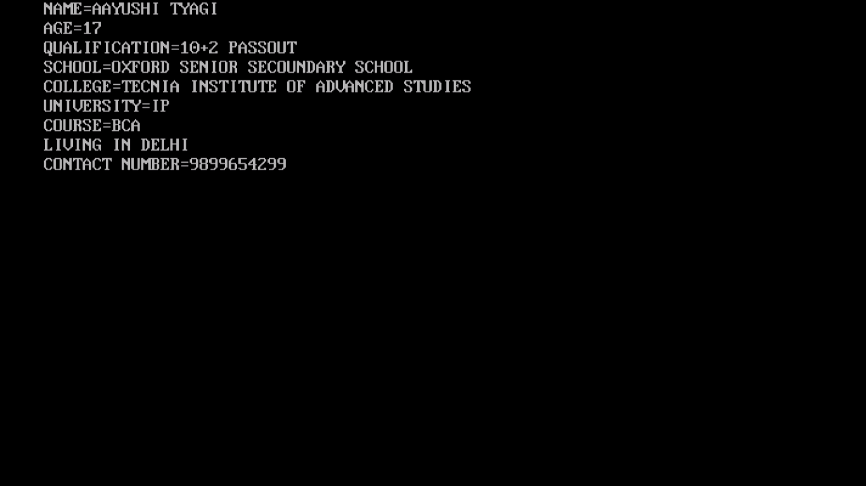

PROGRAM 5:

WRITE A PROGRAM TO SWAP THE VALUE OF TWO VARIABLES USING THIRD VARIABLE.

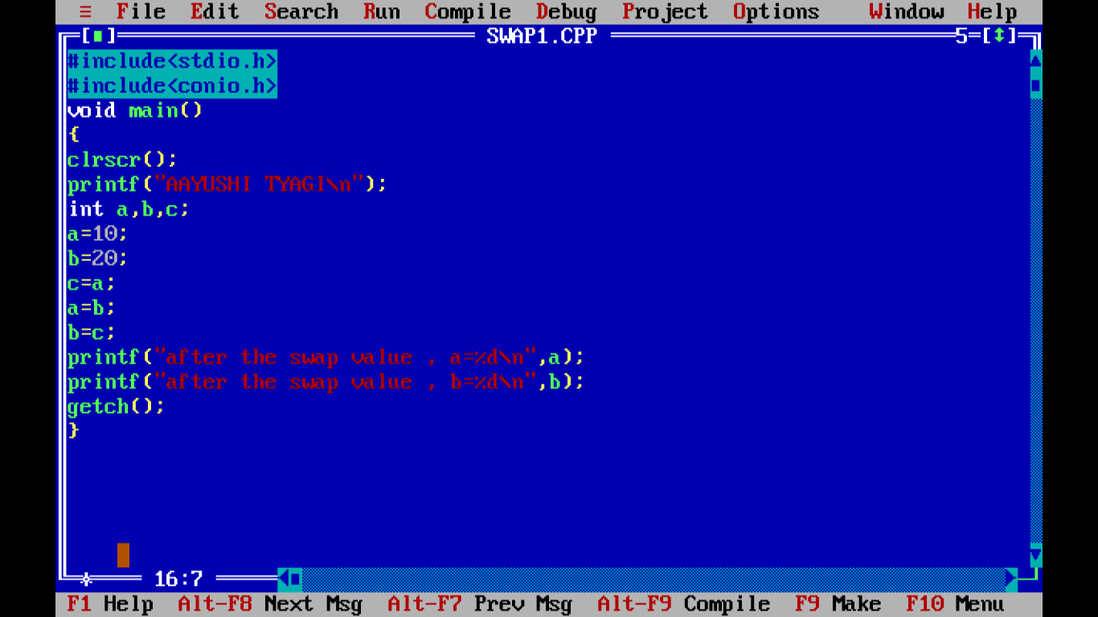

OUTPUT:

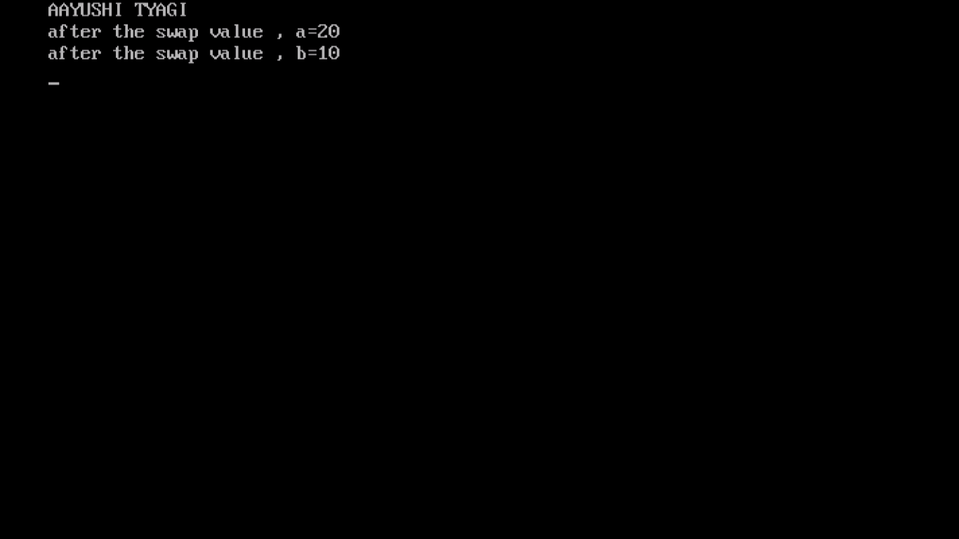

PROGRAM 6:

WRITE A PROGRAM TO SWAP THE VALUE OF TWO VARIABLES WITHOUT USING ANY THIRD VARIABLE.

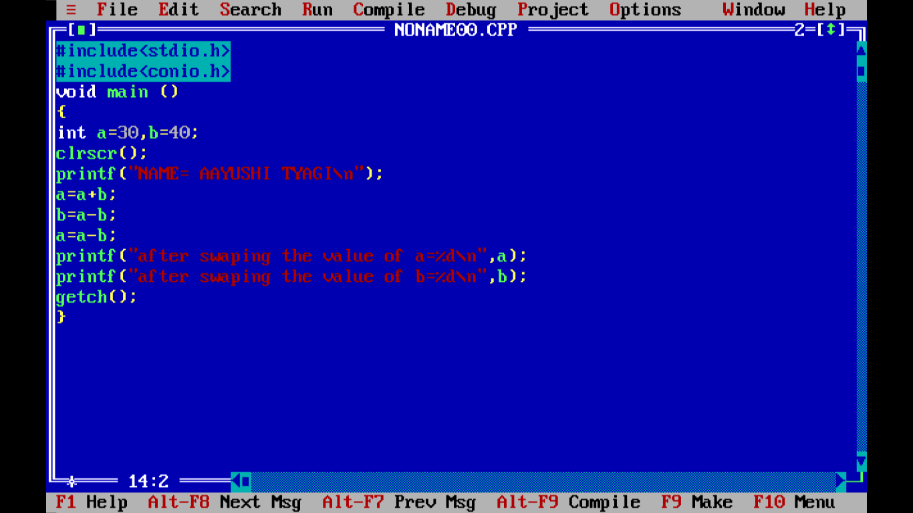

OUTPUT:

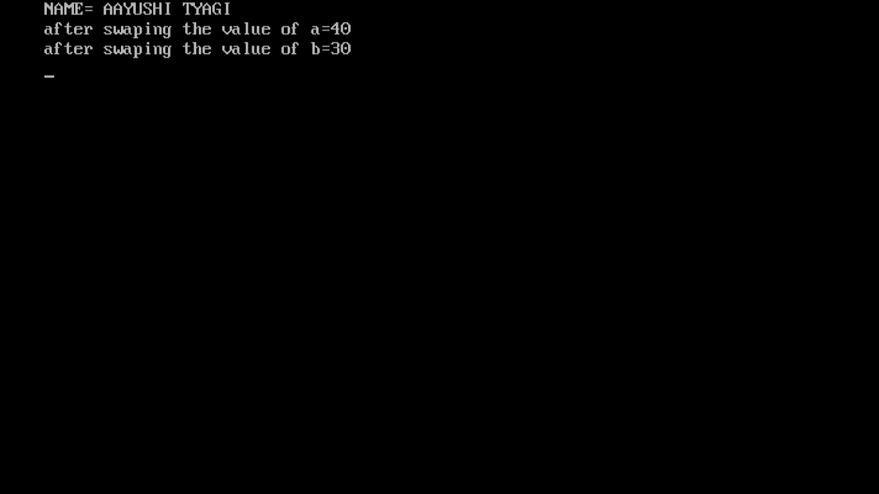

PROGRAM 7:

WRITE A PROGRAM TO PRINT A PRIME DATATYPE AND STRING.

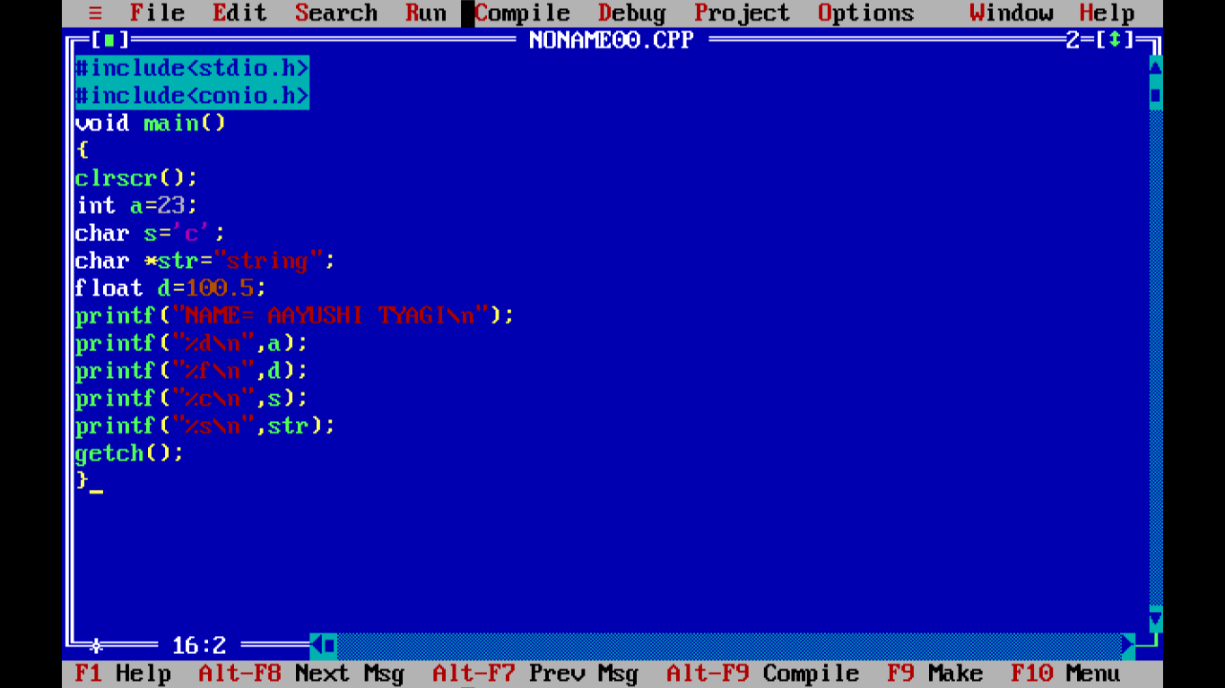

OUTPUT:

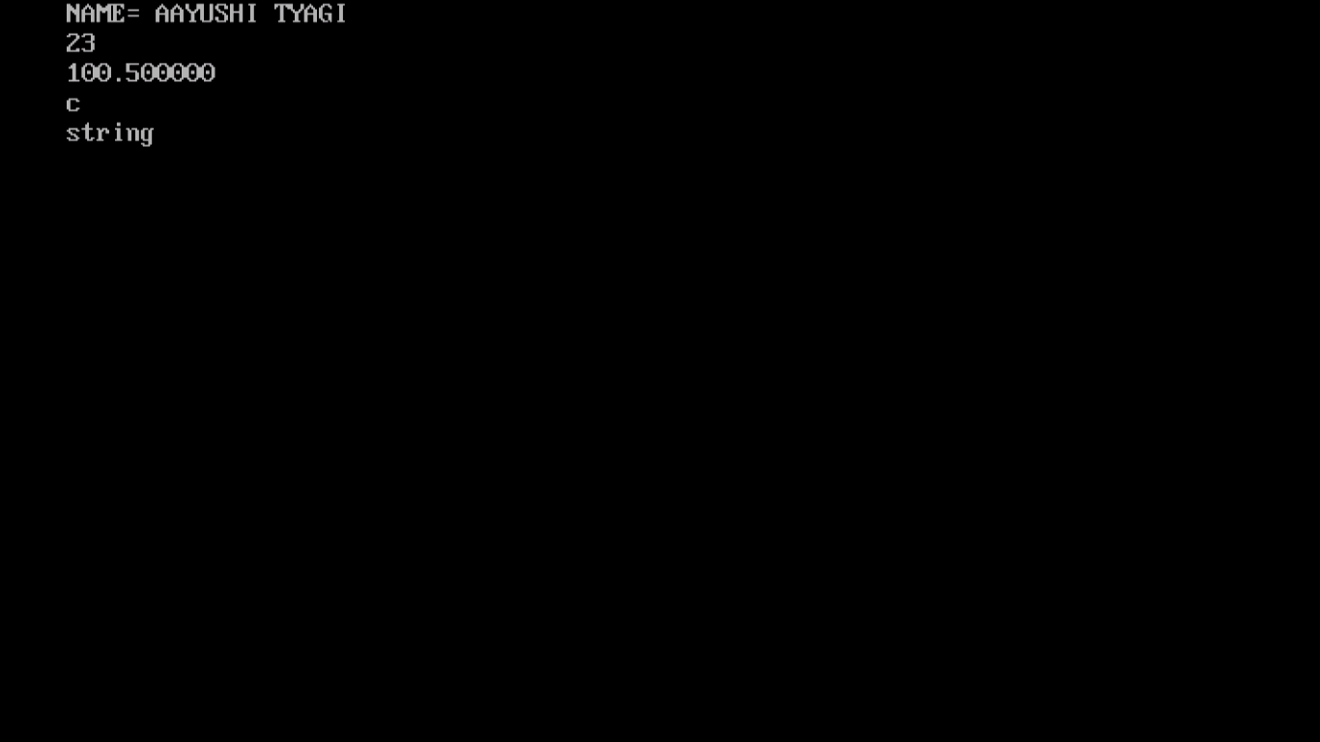

PROGRAM 8:

WRITE A PROGRAM TO PRINT THE SUM AND PERCENTAGE OF 5 SUBJECTS MARKS.

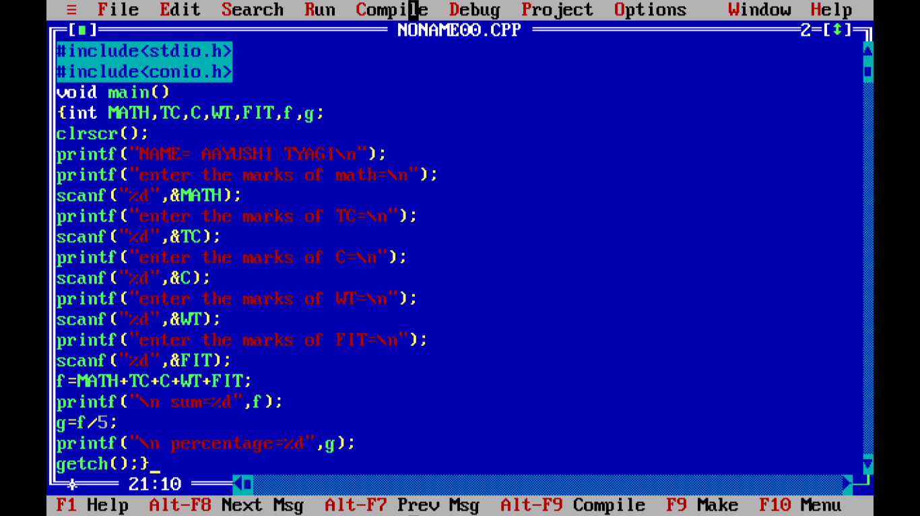

OUTPUT:

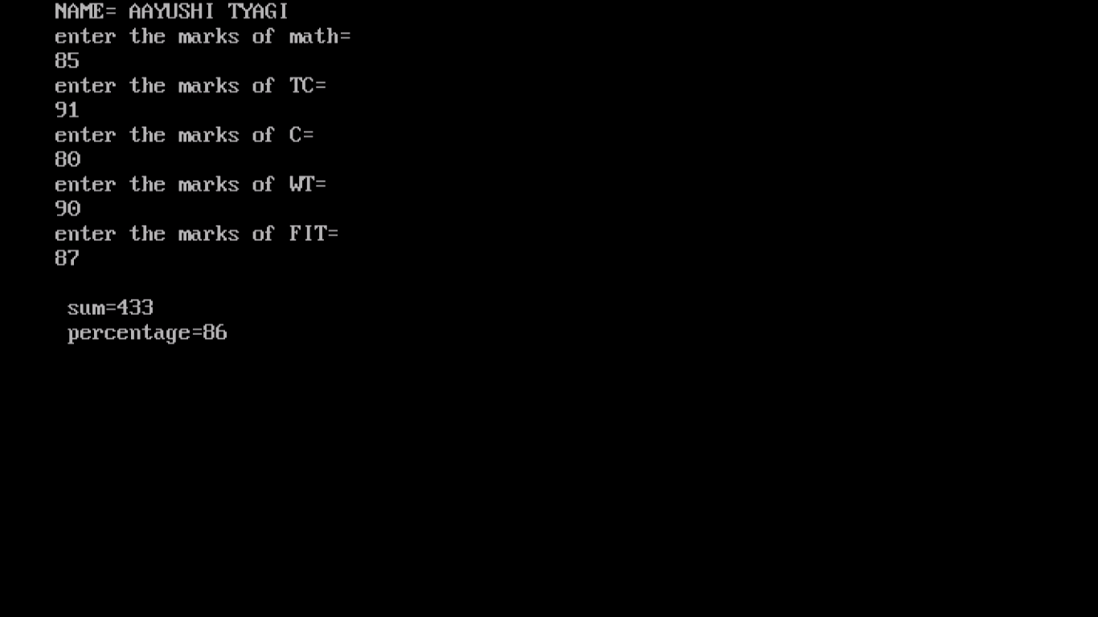

PROGRAM 9:

WRITE A PROGRAM TO PRINT TO FIND REMAINDER AND QUOTIENT.

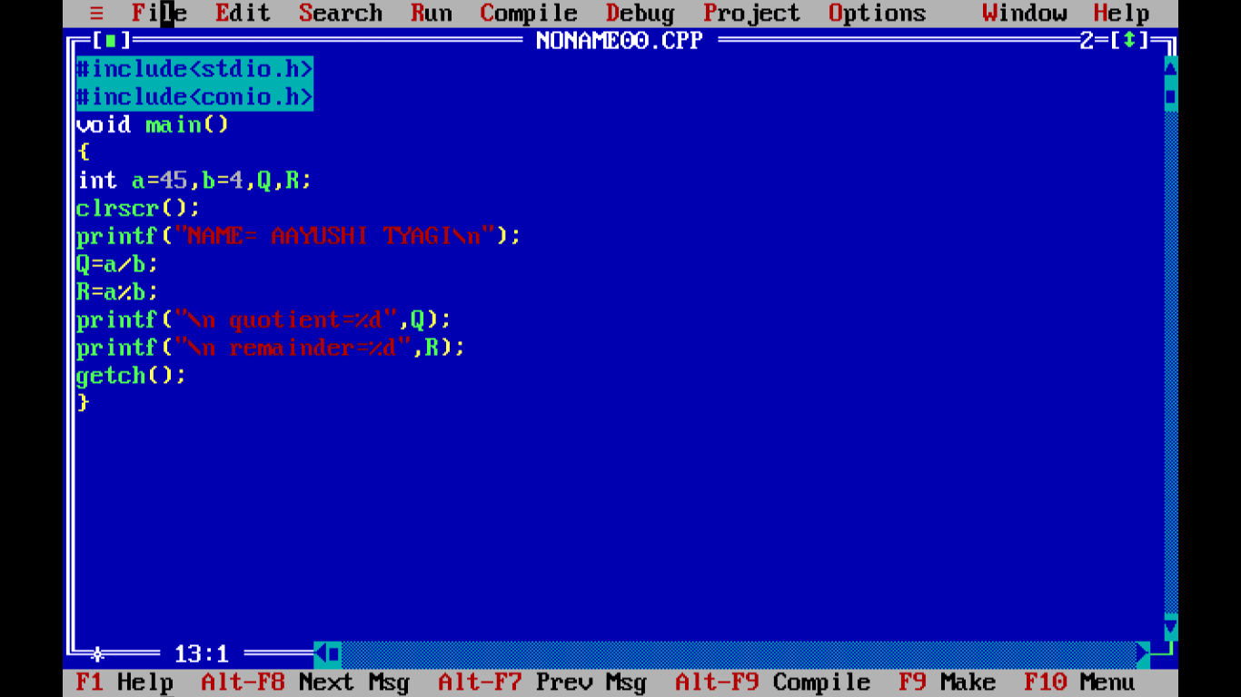

OUTPUT:

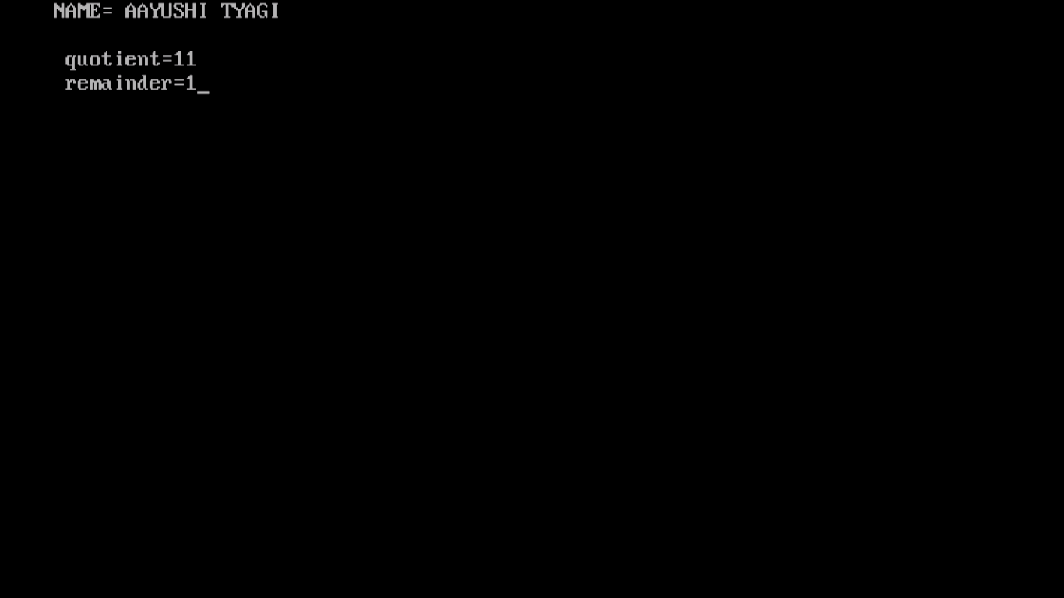

PROGRAM 10:

WRITE A MENU DRIVEN PROGRAM TO CONSTRUCT CALCULATOR FOR FOLLOWING ARITHEMATIC OPERATIONS : +,-,*,DIVIDE,AVERAGE .

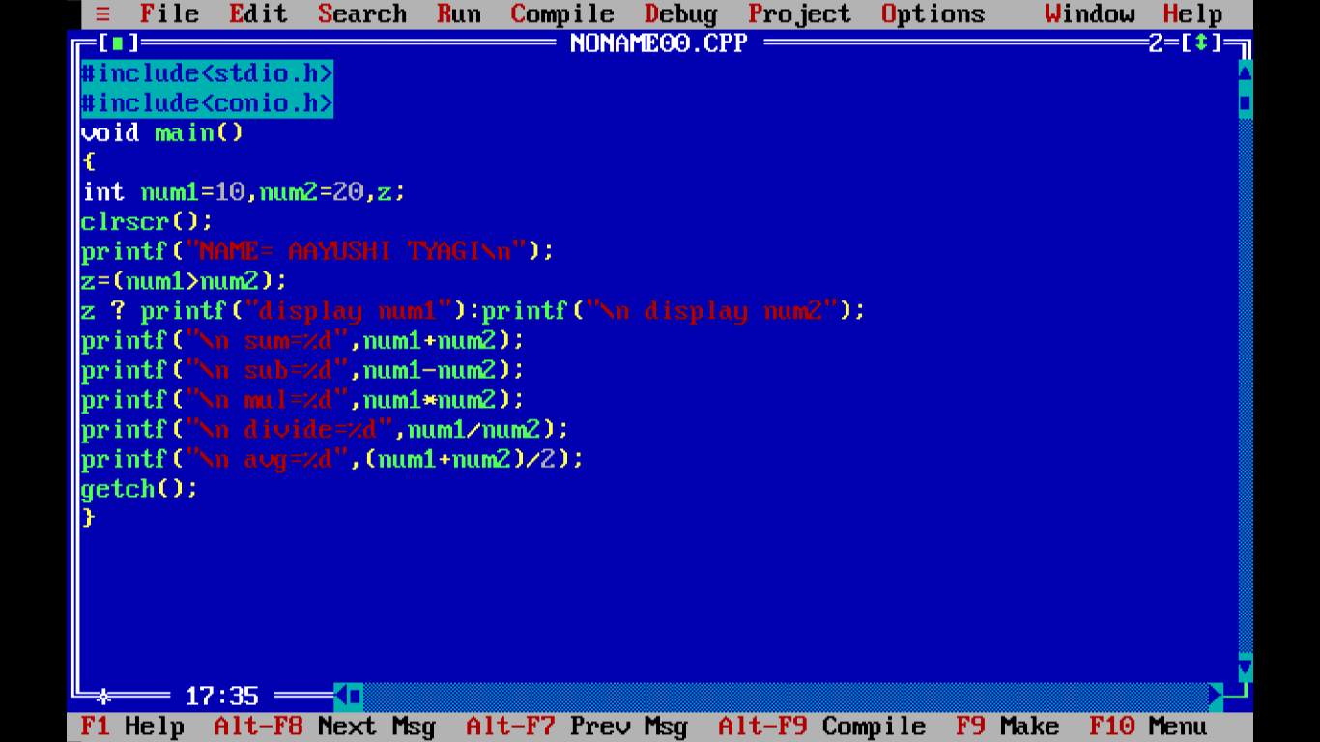

OUTPUT:

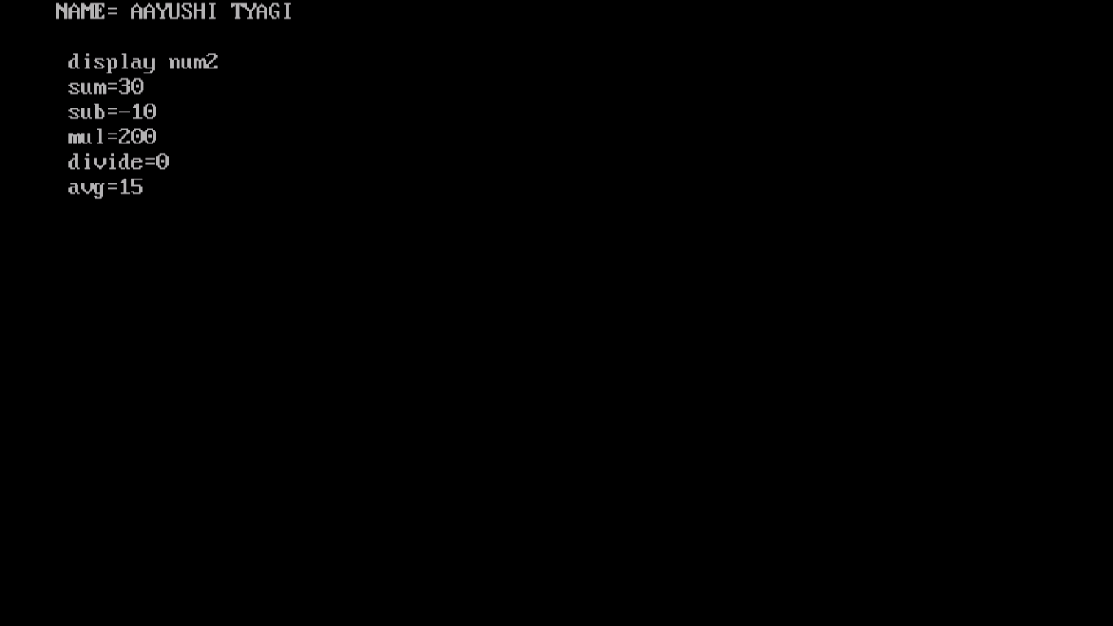

PROGRAM 11:

WRITE A PROGRAM TO PRINT THE NO.IS EVEN OR ODD.

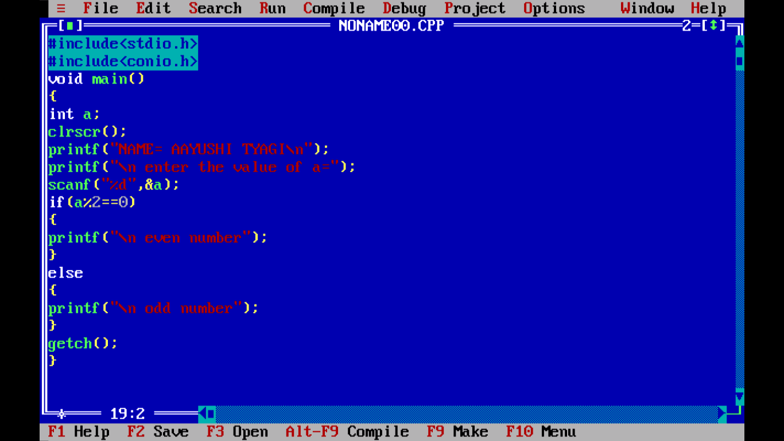

OUTPUT:

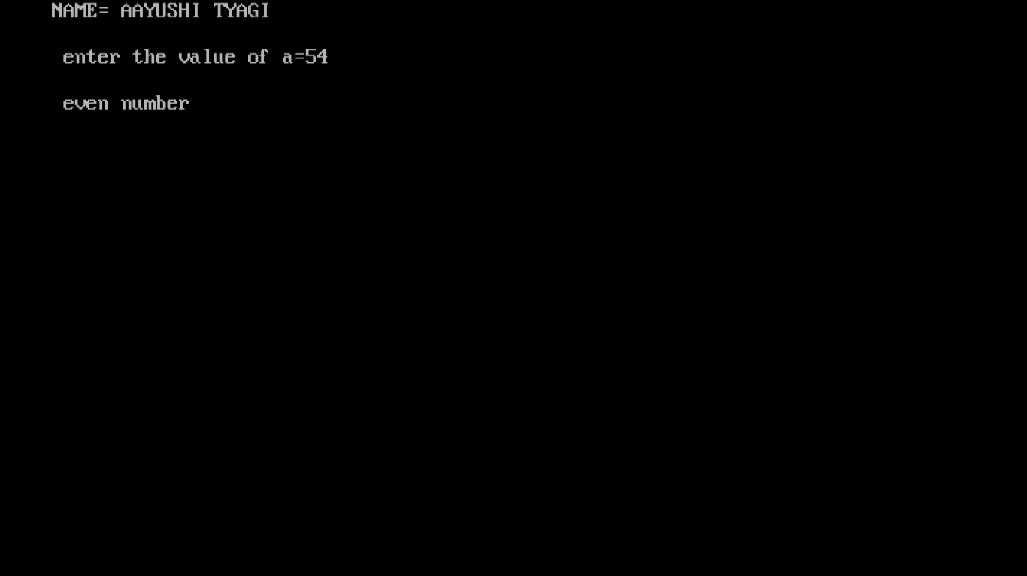

PROGRAM 12:

WRITE A PROGRAM TO PRINT THAT THE PERSON IN ELIGIBLE FOR VOTING OR NOT.

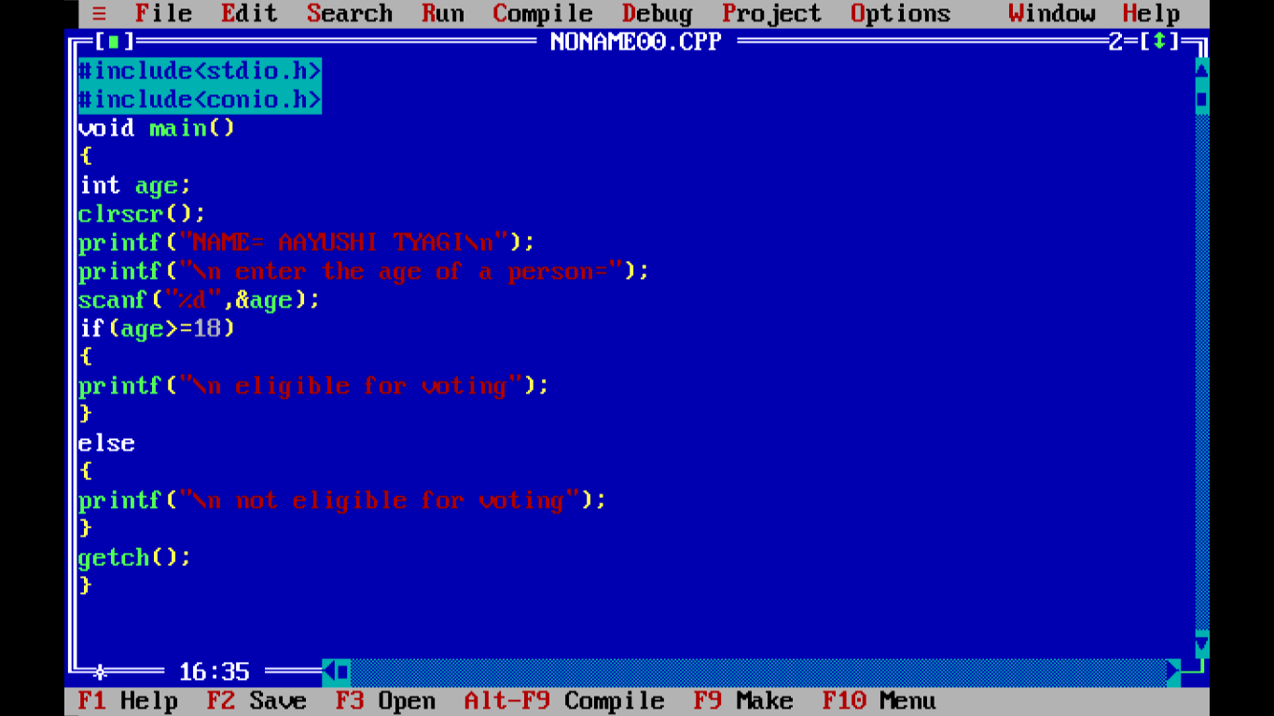

OUTPUT:

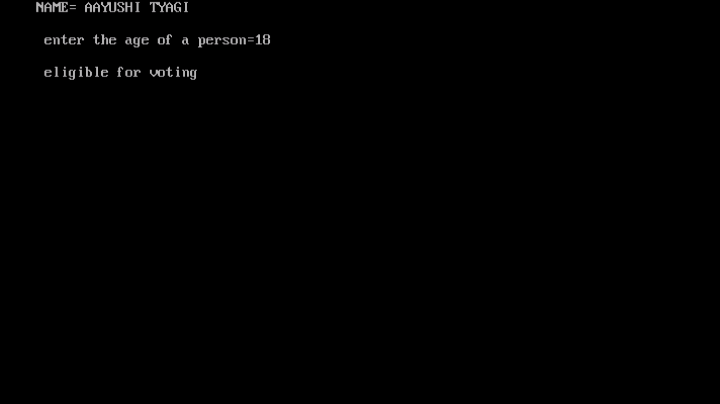

PROGRAM 13:

WRITE A PROGRAM TO FIND THE GREATEST OF 3 NUMBERS.

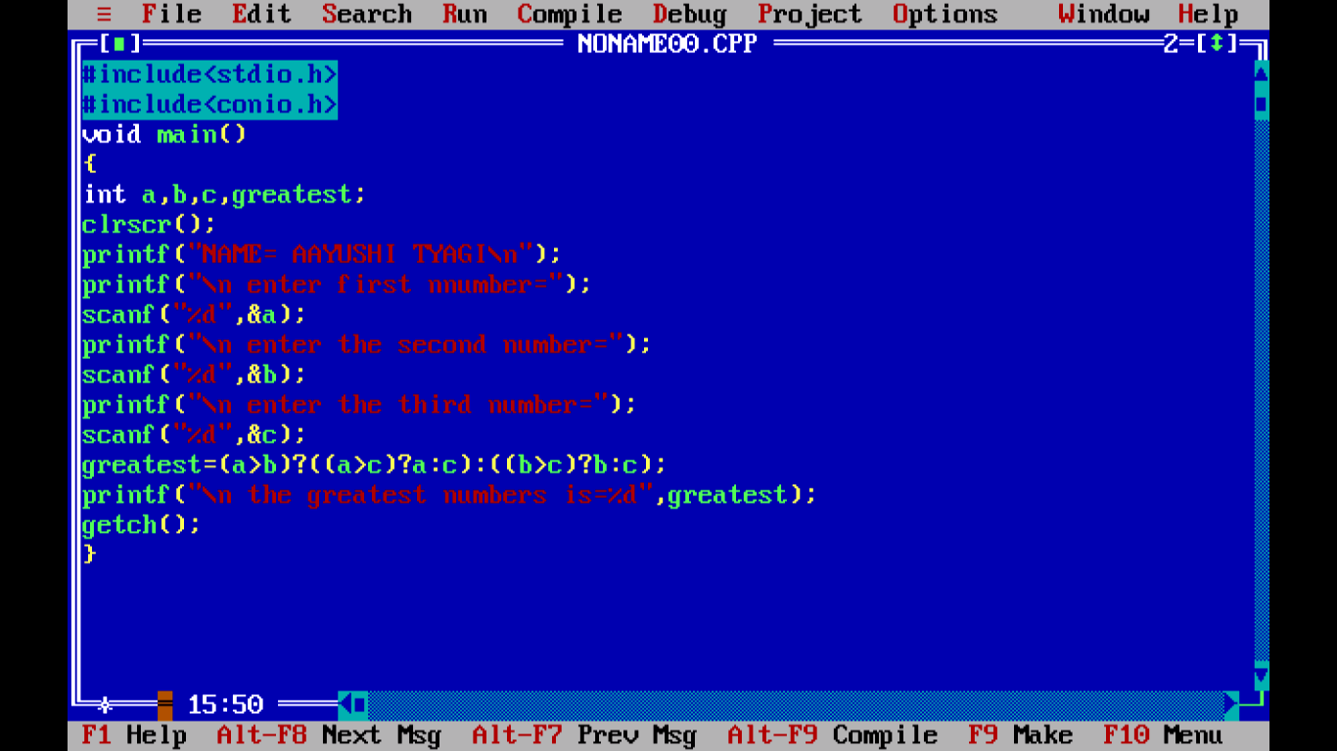

OUTPUT:

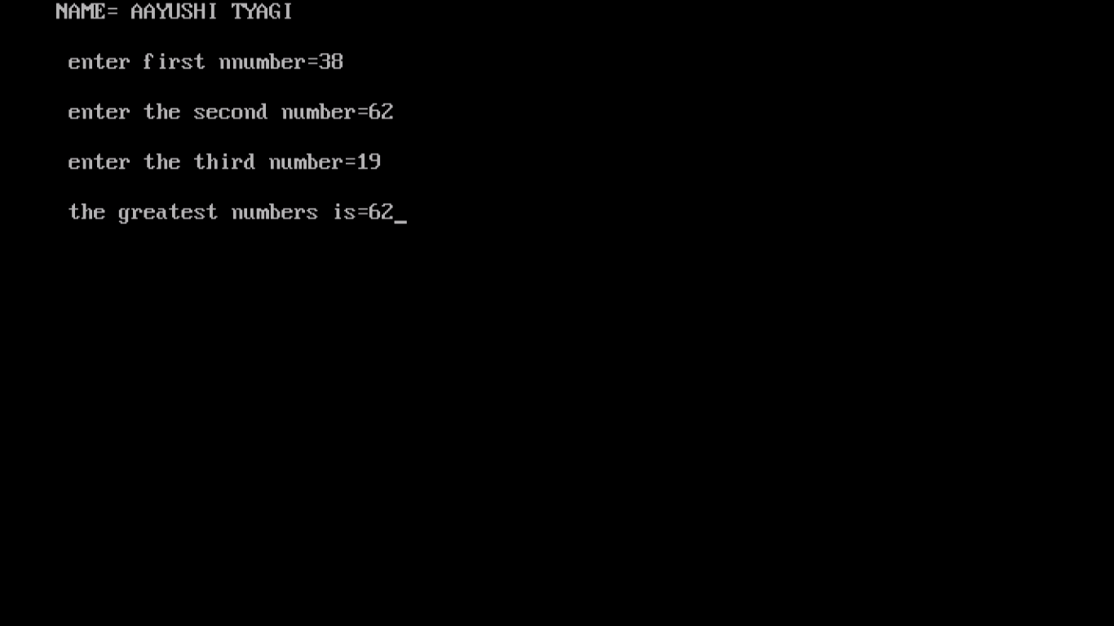

PROGRAM 14:

WRITE A PROGRAM TO FIND THE GREATEST OF 3 NUMBERS USING CONDITIONAL OPERATOR.

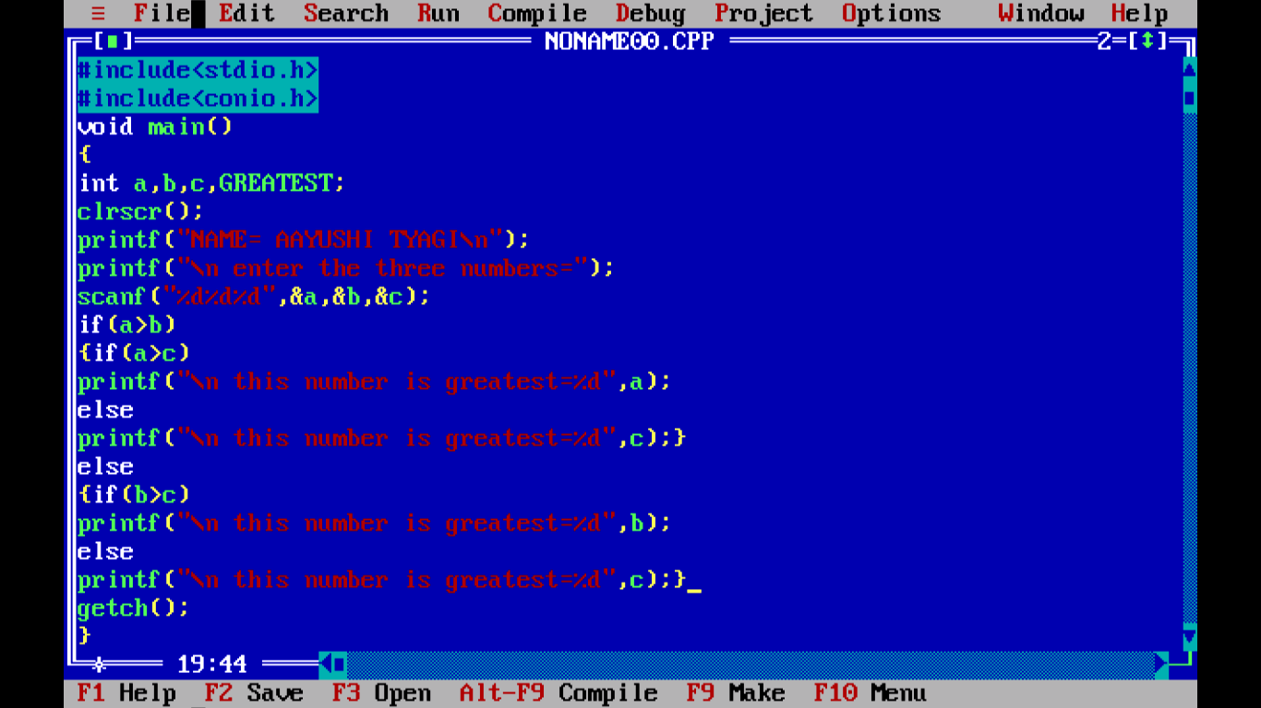

OUTPUT:

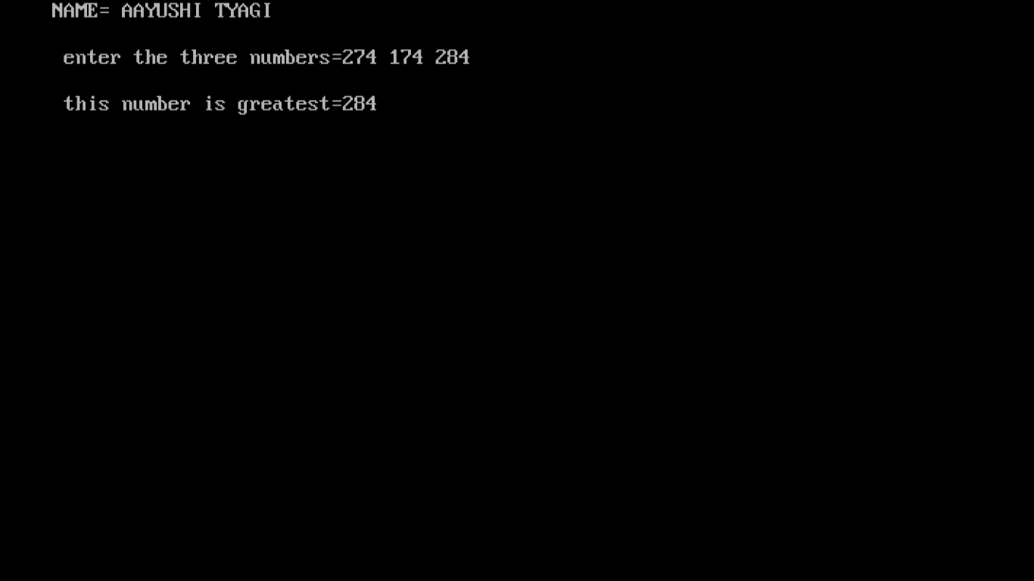

PROGRAM 15:

WRITE A PROGRAM TO FIND POST AND PRE INCREMENT AND DECREMENT FOR DIFFERENT VARIABLES.

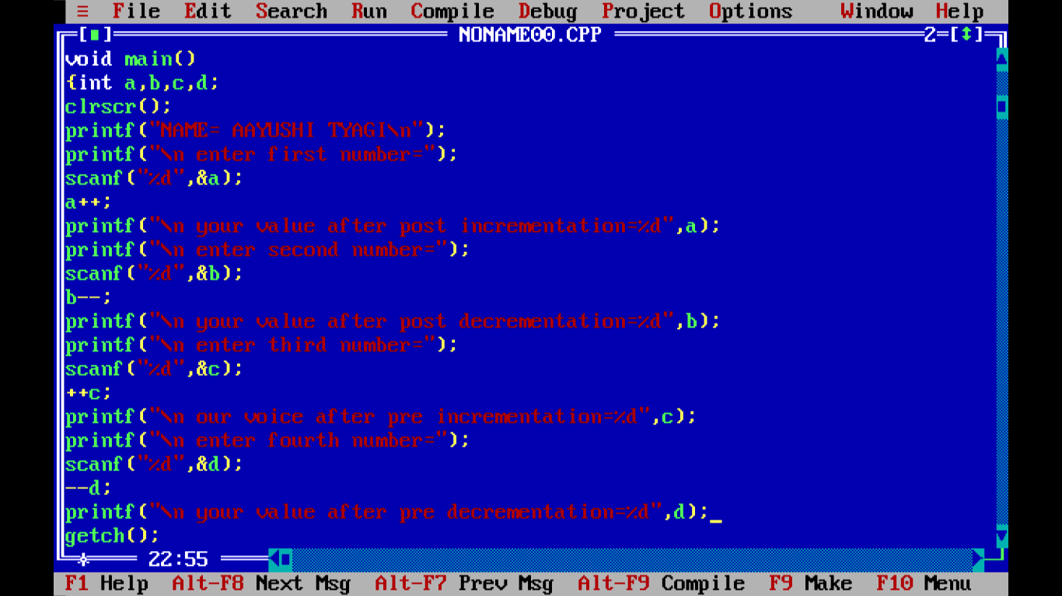

OUTPUT:

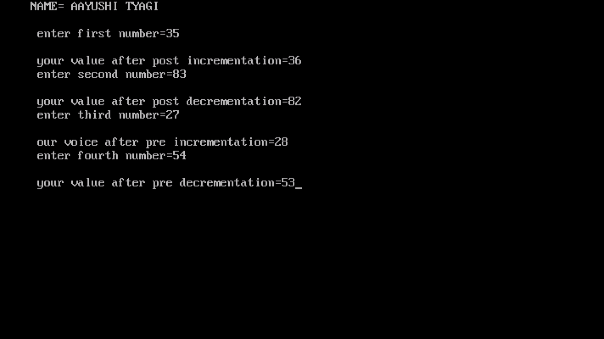

PROGRAM 16:

WRITE A PRINT SIZE OF VARIABLES/OPERATORS.

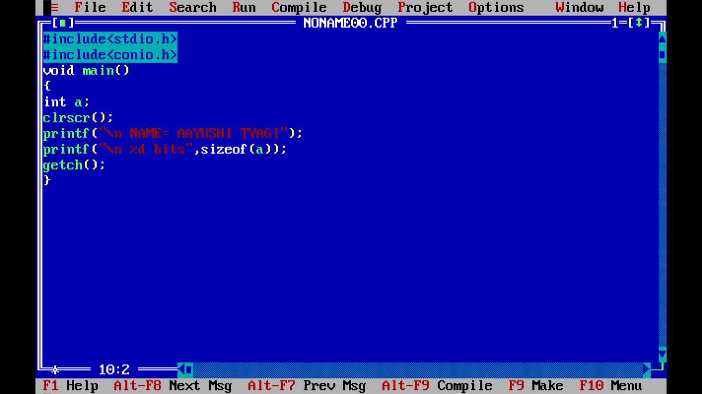

OUTPUT:

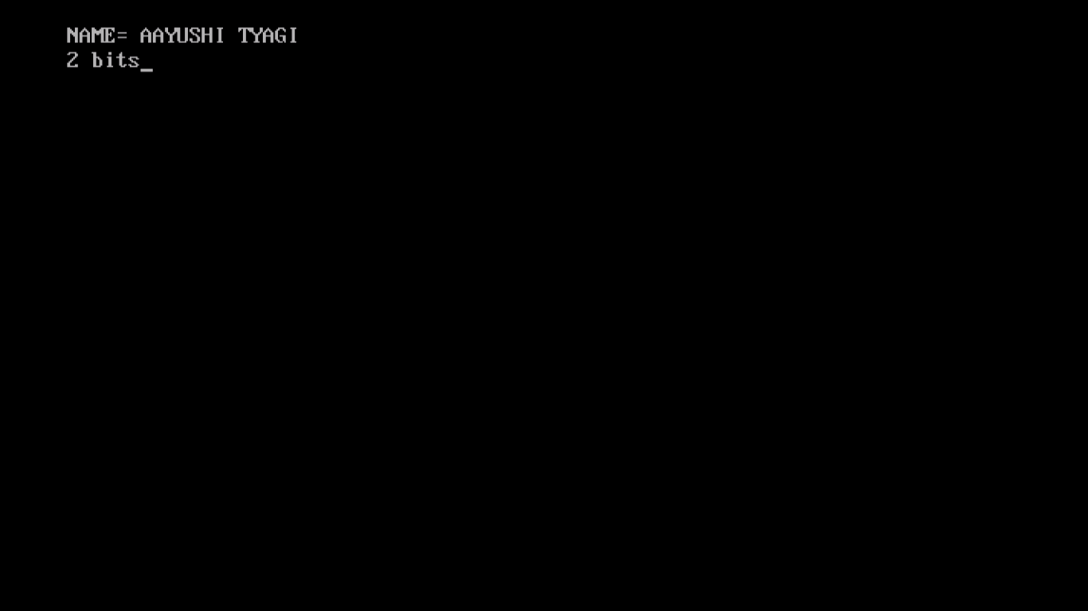

PROGRAM 17:

WRITE A PROGRAM TO PRINT CHARACTER TYPE VARIABLE.

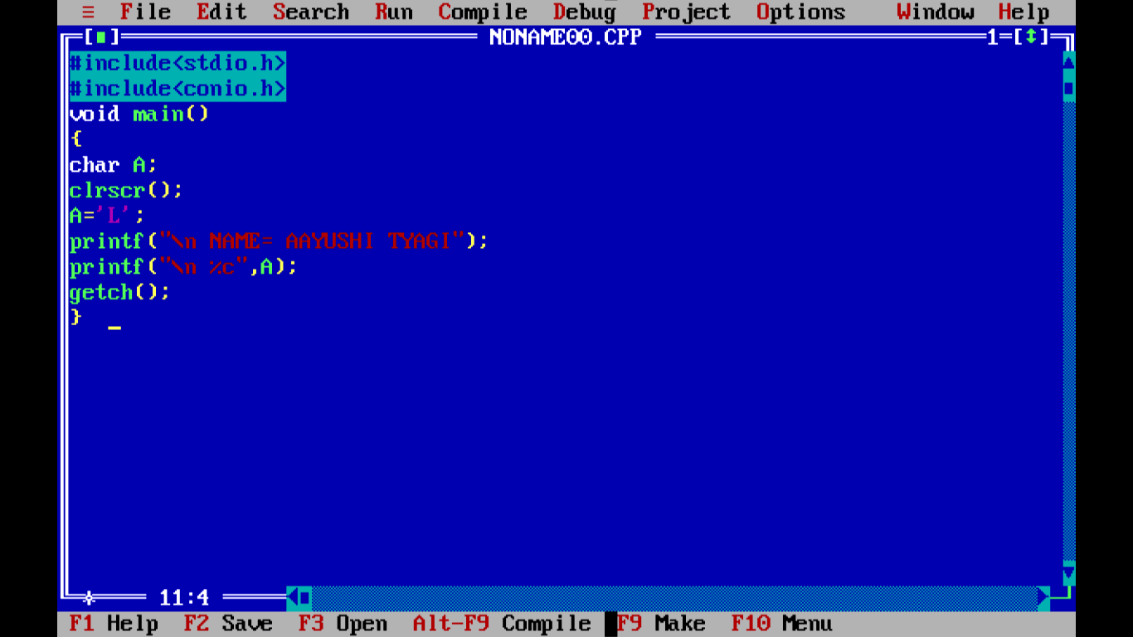

Output:

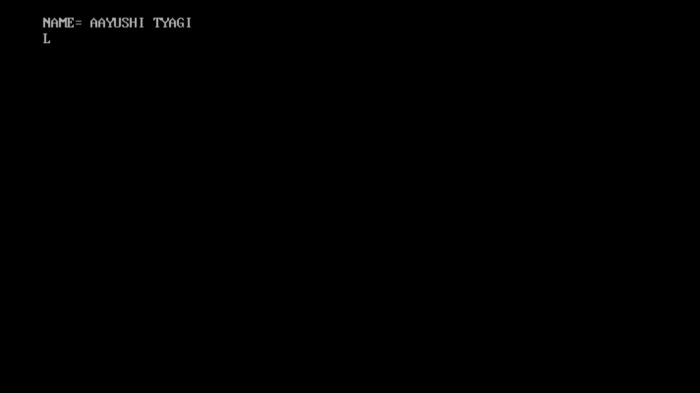

PROGRAM 18:

WRITE A PROGRAM TO PRINT THE ASCII VALUE OF A VARIABLE.

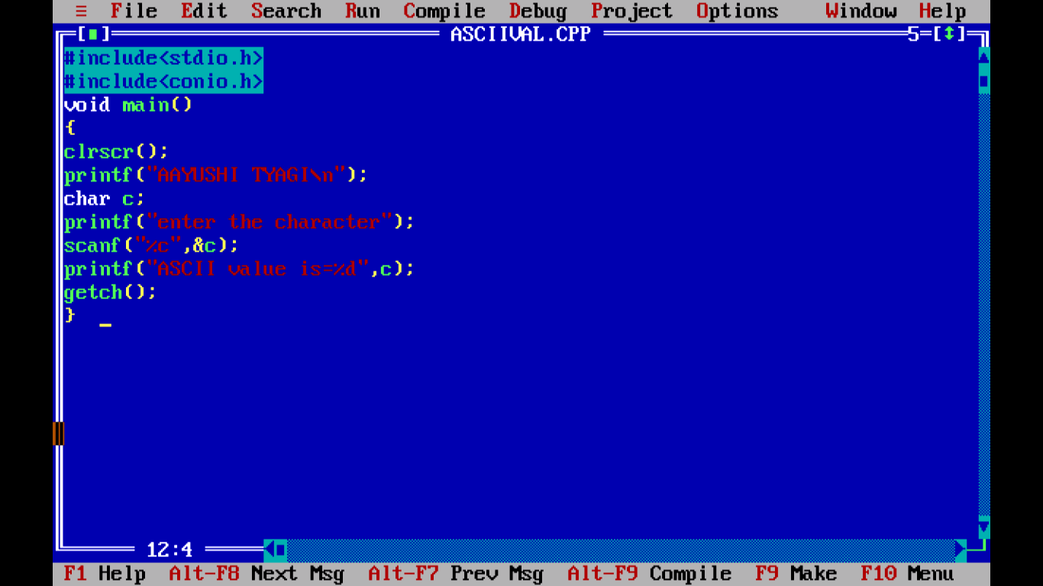

OUTPUT:

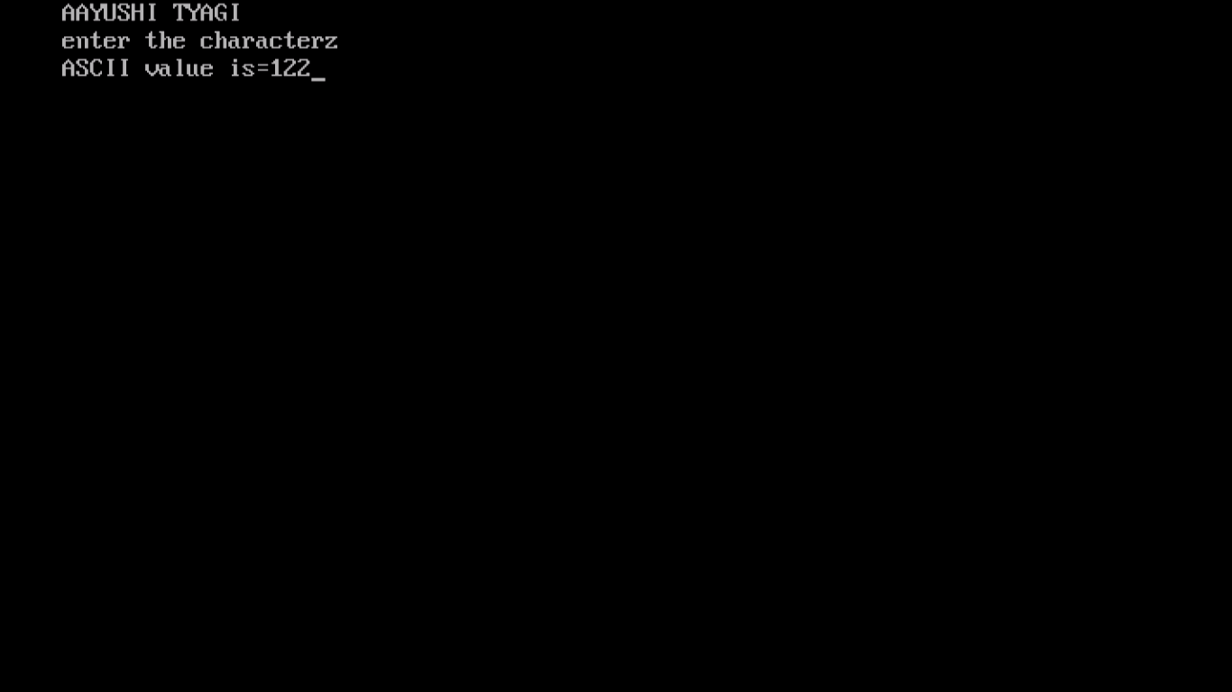

PROGRAM 19:

WRITE A PROGRAM TO CHECK NO IS GREATER THAN 100 AND LESS THAN 1000.

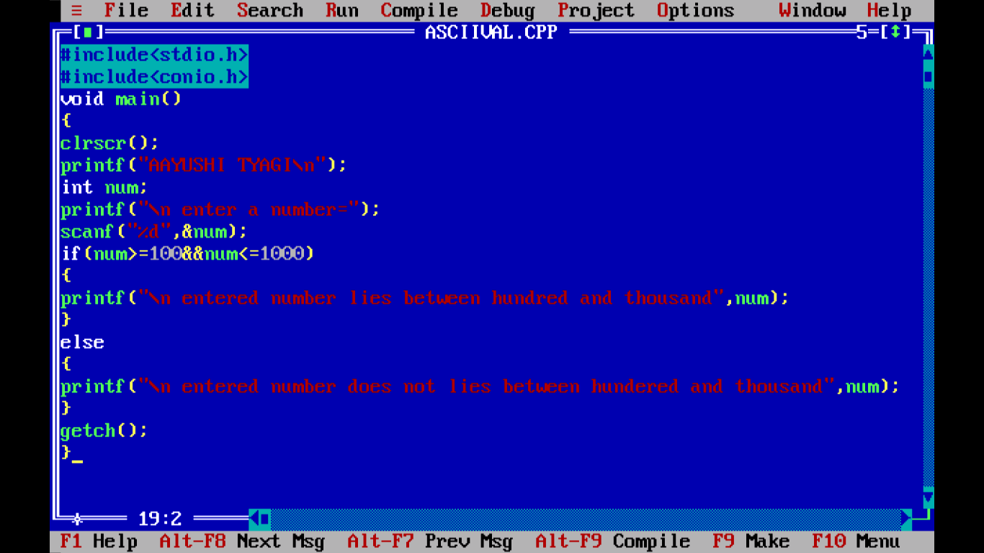

OUTPUT:

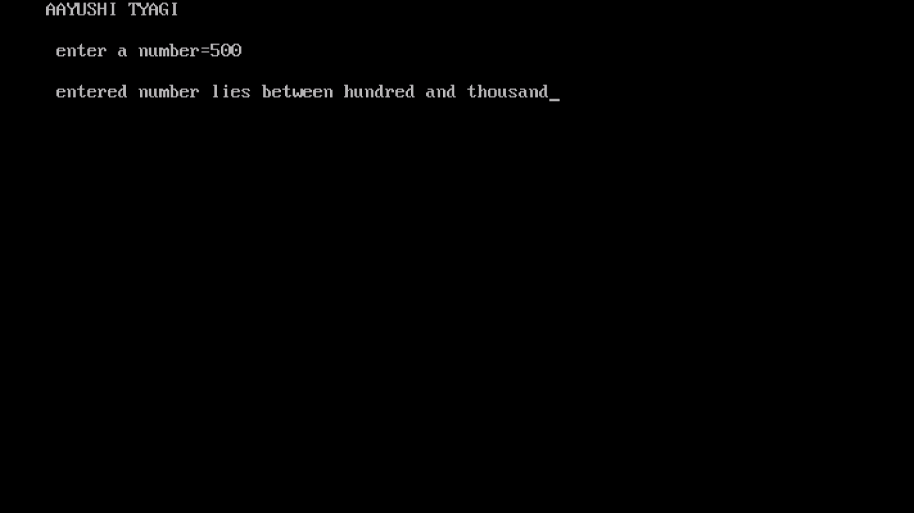

PROGRAM 20:

WRITE A PROGRAM TO PRINT NUMBER IS ODD OR EVEN BY USING GOTO.

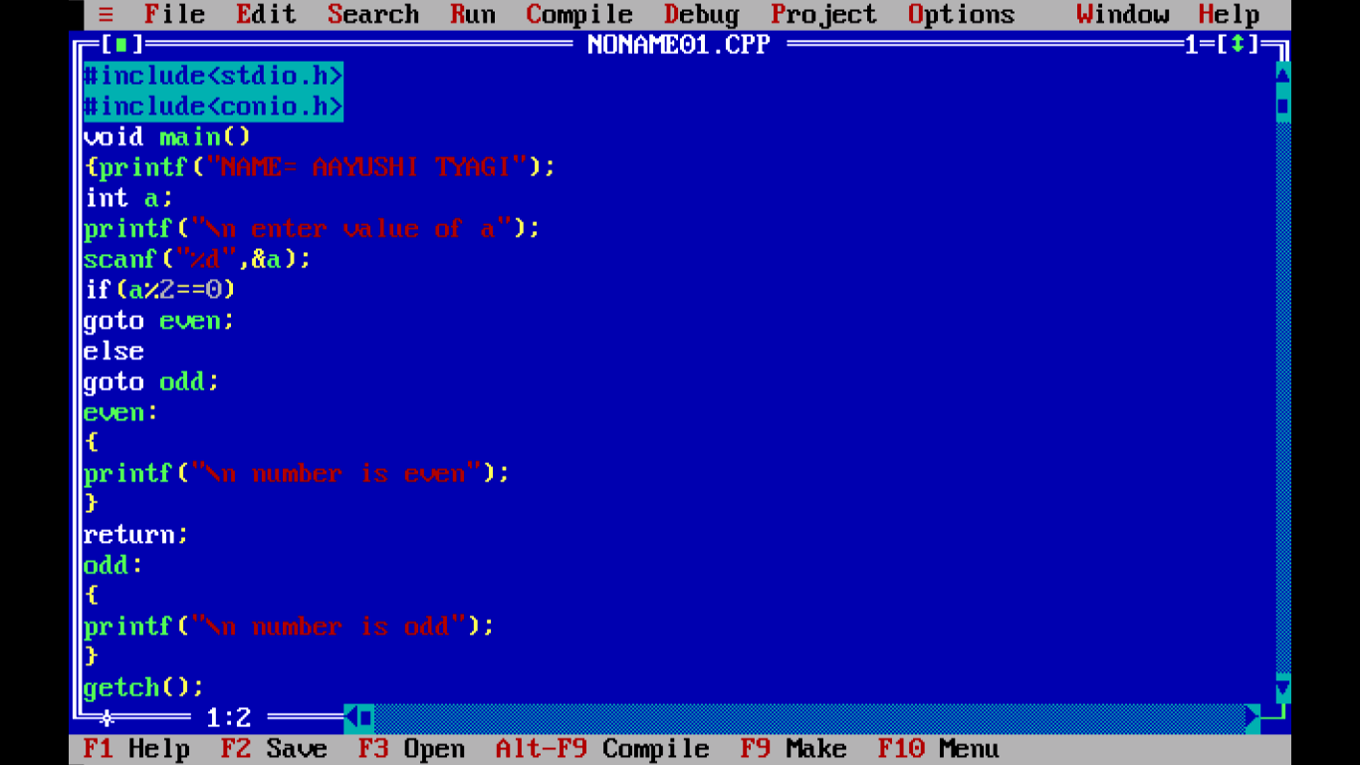

OUTPUT:

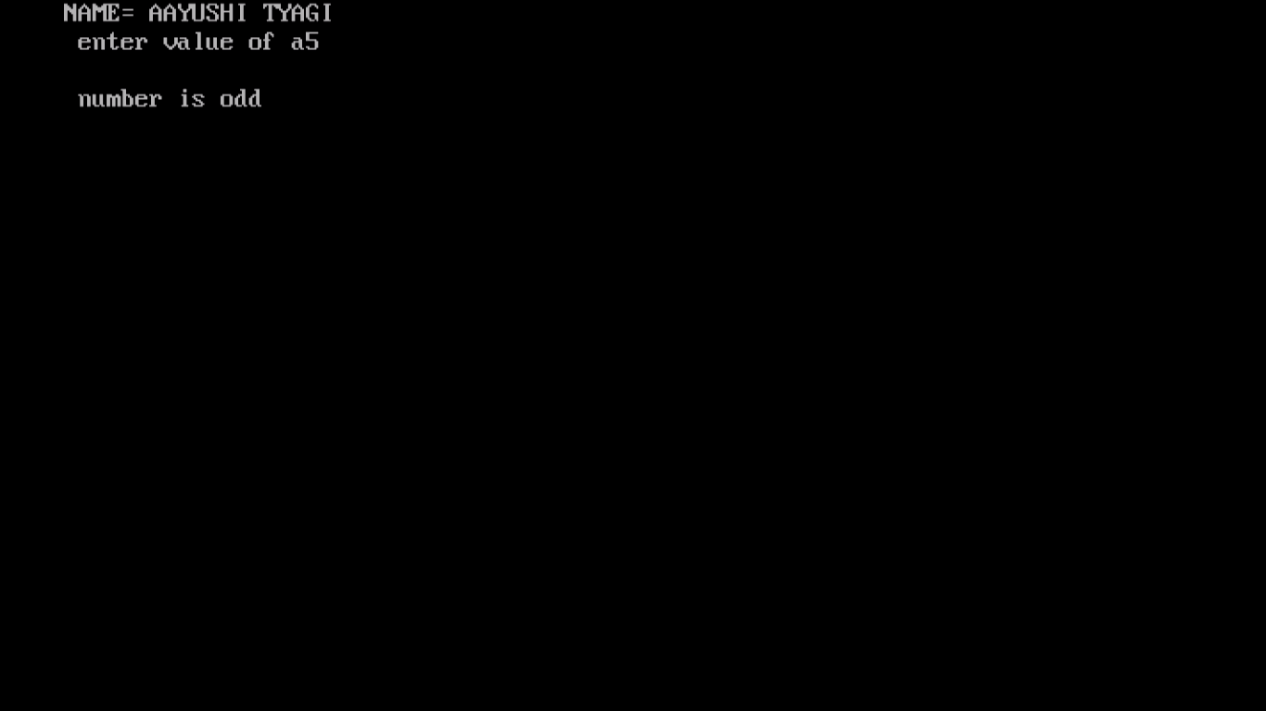

PROGRAM 21:

WRITE A PROGRAM TO CREATE A CALCULATOR OF ARITHEMATIC FUNCTIONS USING SWITCH CASE.

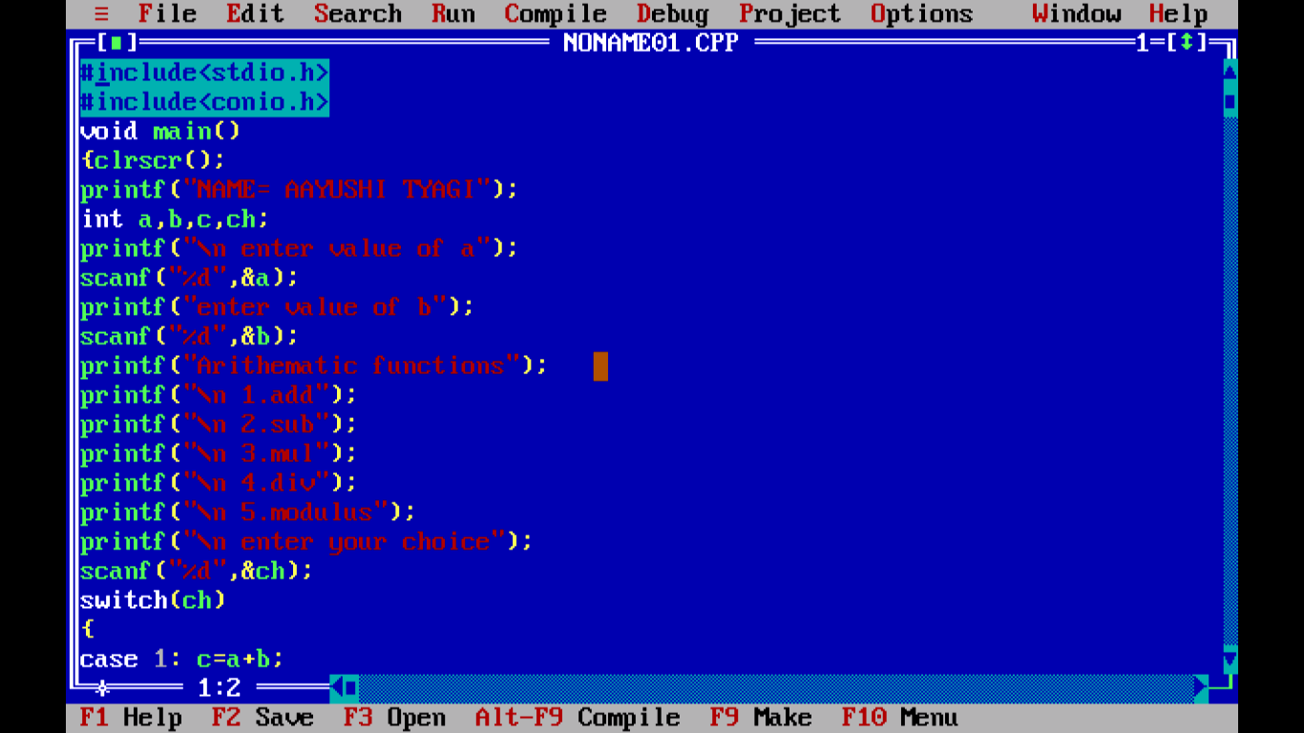

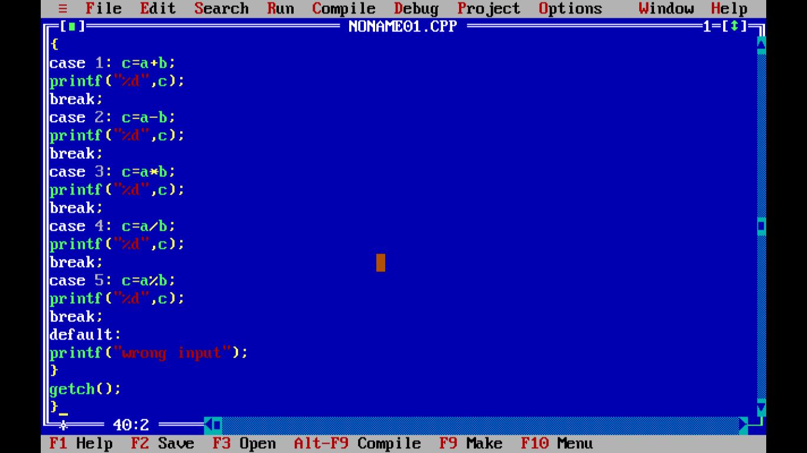

OUTPUT:

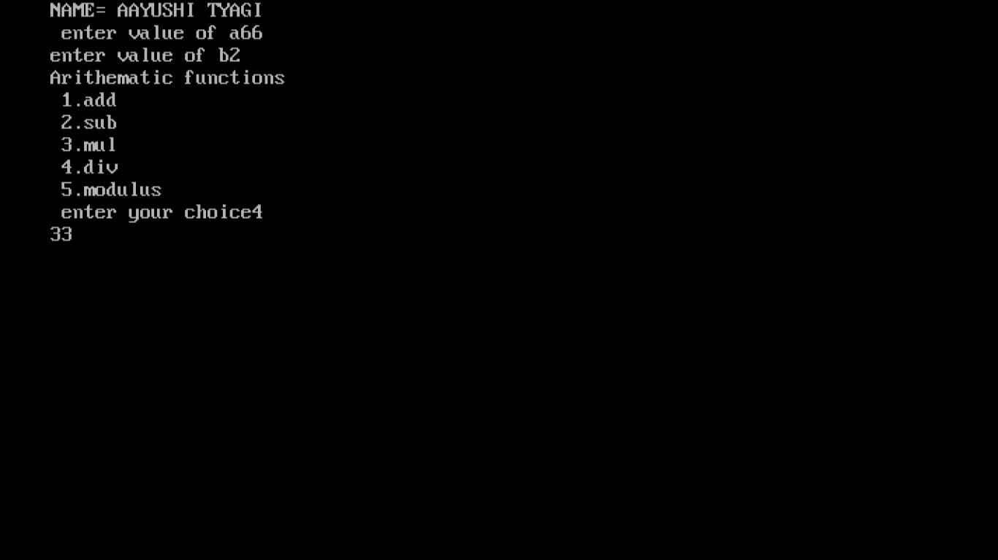

PROGRAM 22:

WRITE A PROGRAM TO DEMONSTRATE SIZE OF OPERATORS.

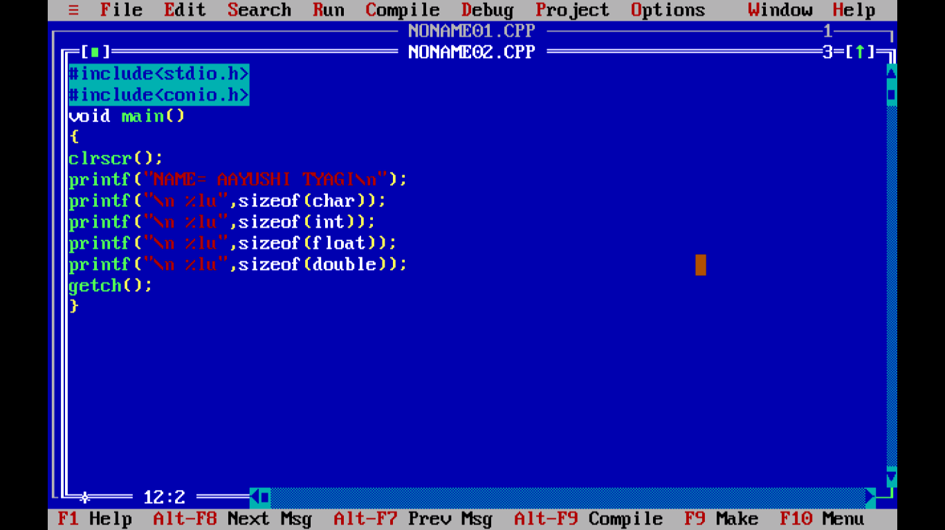

OUTPUT: 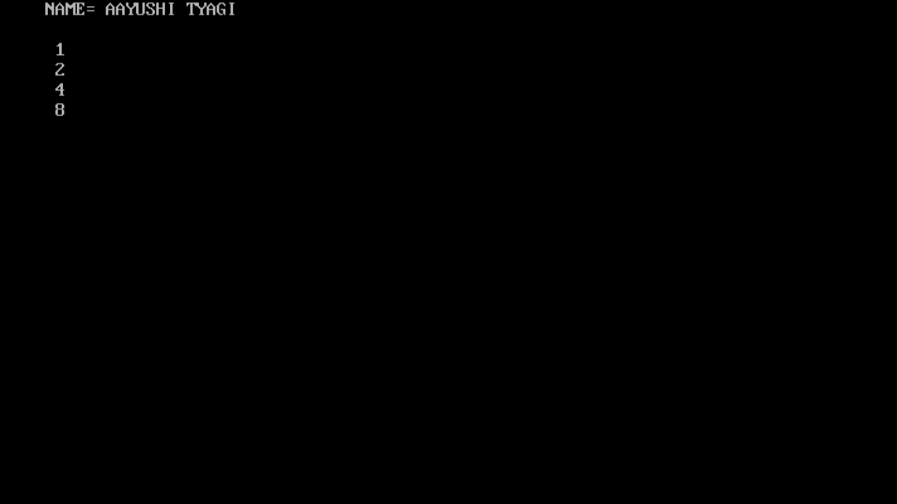

PROGRAM 23:

WRITE A PROGRAM TO CHECK THAT NUMBER IS PRIME OR NOT.

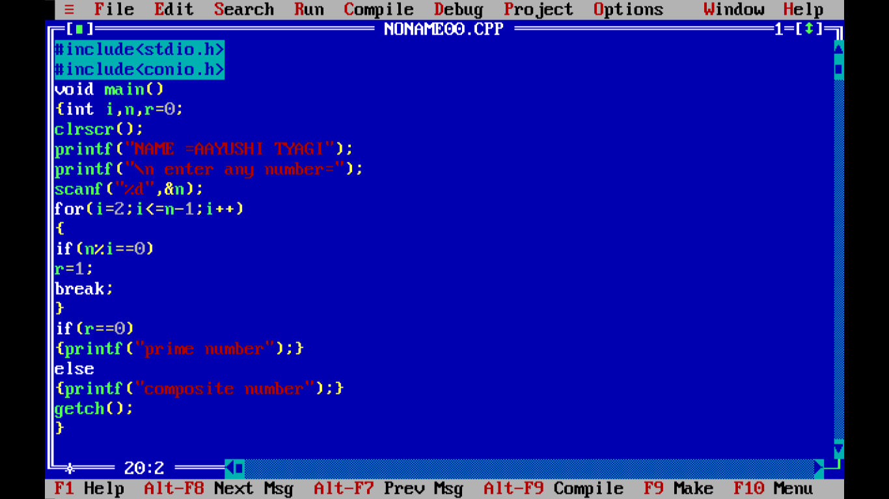

OUTPUT:

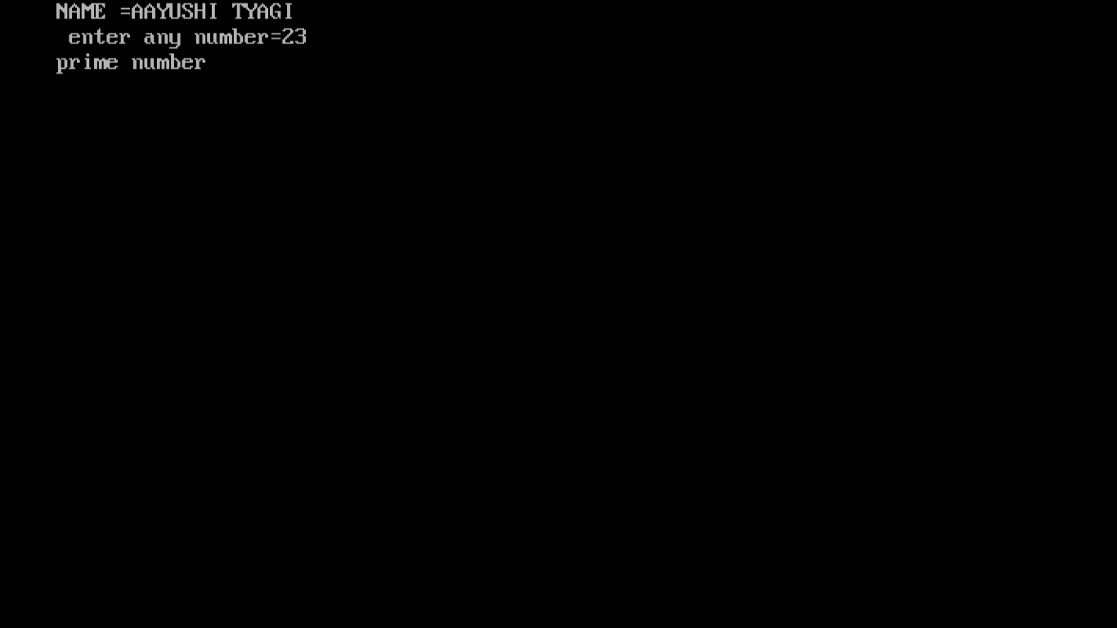

PROGRAM 24:

WRITE A PROGRAM TO CONVERT CELCIUS INTO FAHRENHEIT.

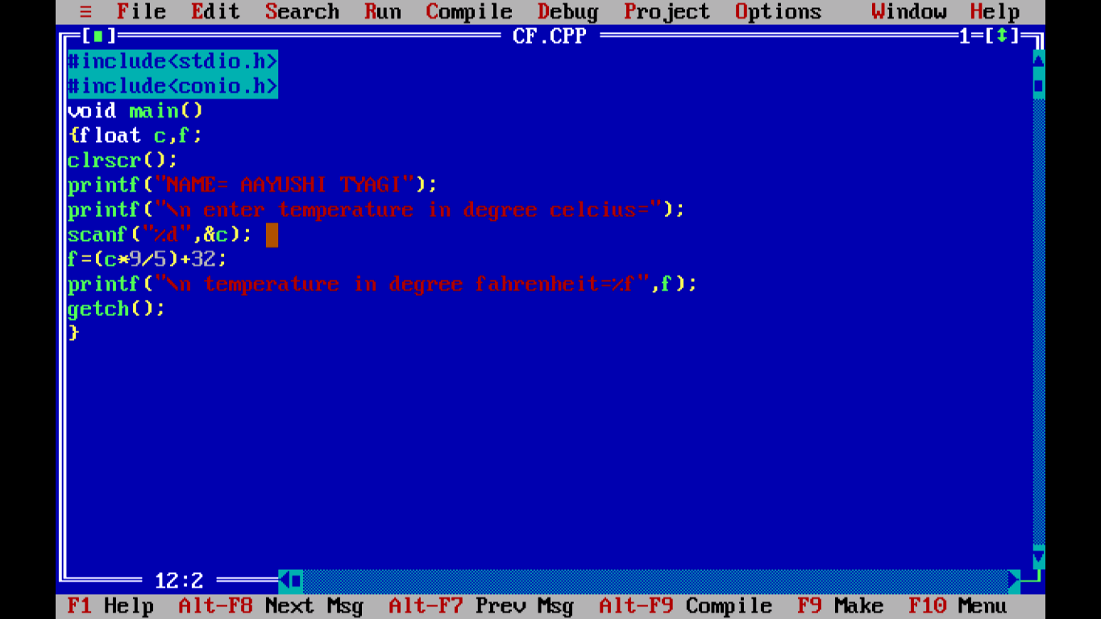

OUTPUT:

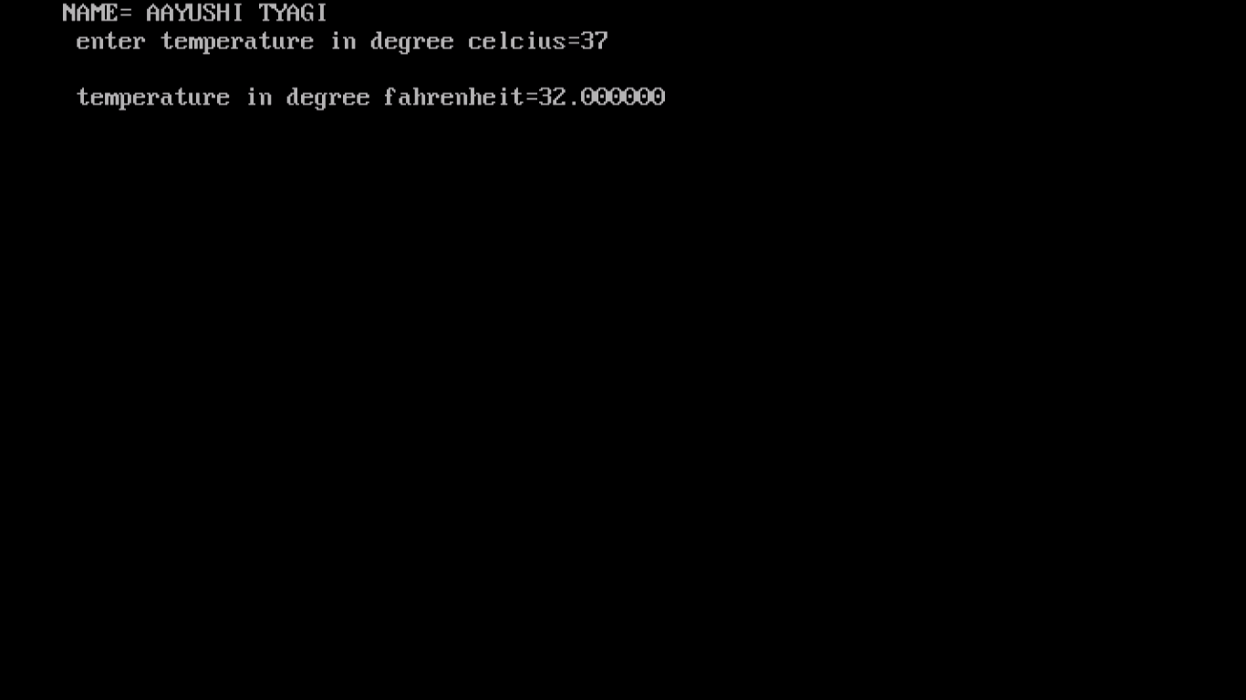

PROGRAM 25:

WRITE A PROGRAM TO FIND SIMPLE INTEREST AND COMPOUND INTEREST.

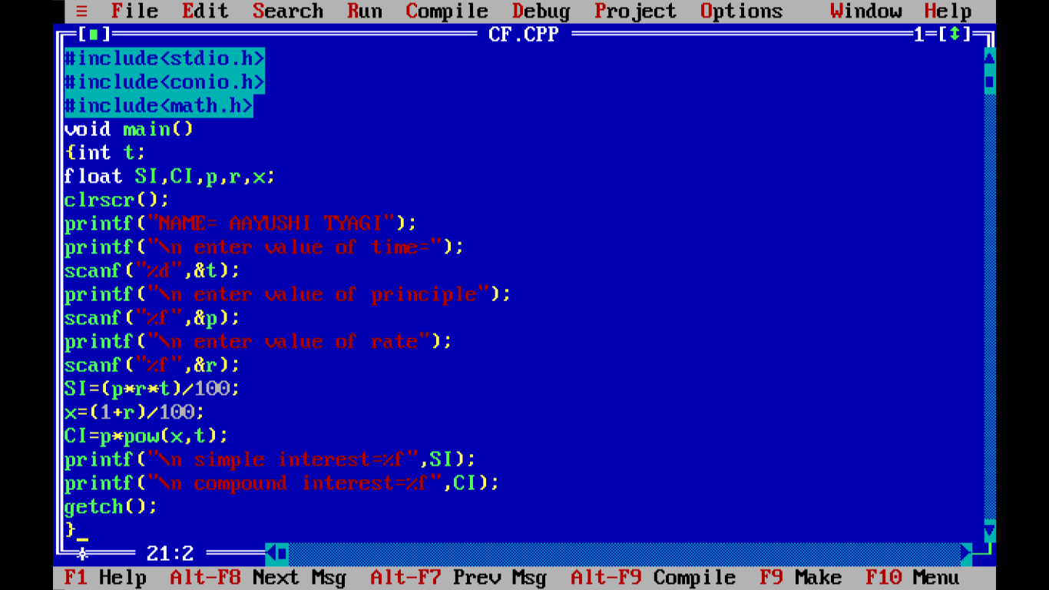

OUTPUT:

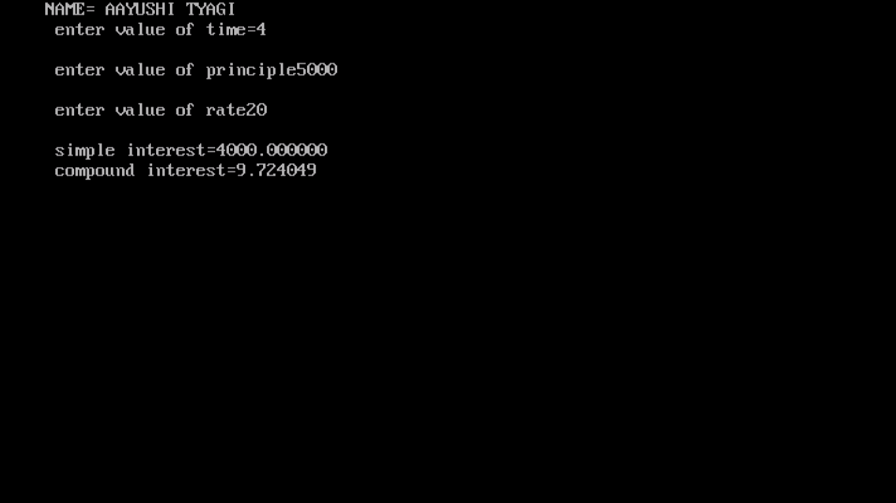

PROGRAM 26:

WRITE A PROGRAM FOR GIVING SPACE BEFORE AND AFTER.

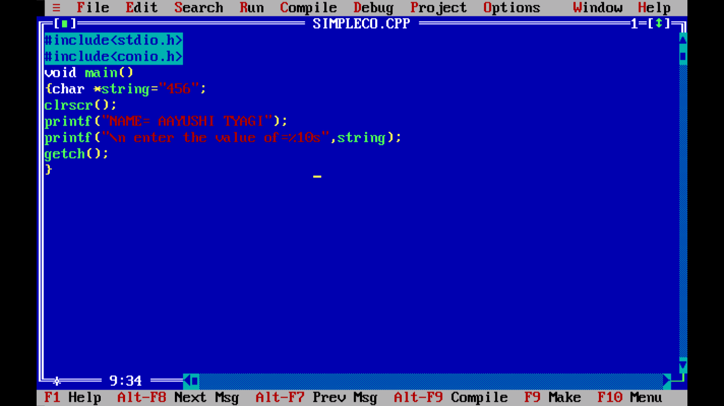

OUTPUT:

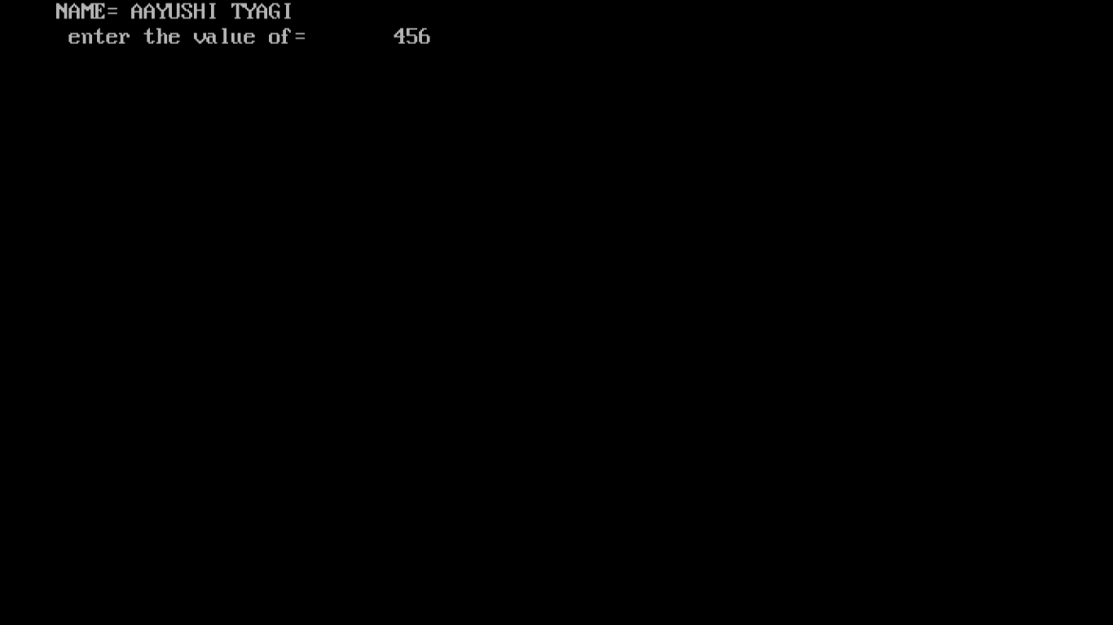

PROGRAM 27:

WRITE A PROGRAM TO FIND THE SQUARE OF THE FOLLOWING SERIES.

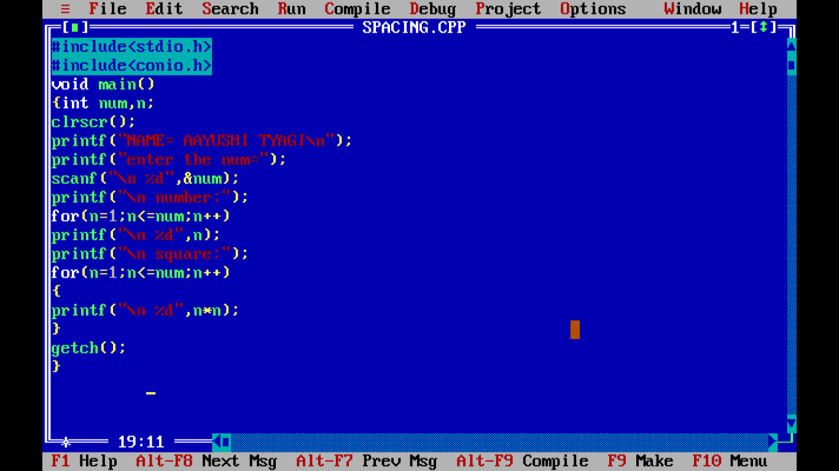

OUTPUT:

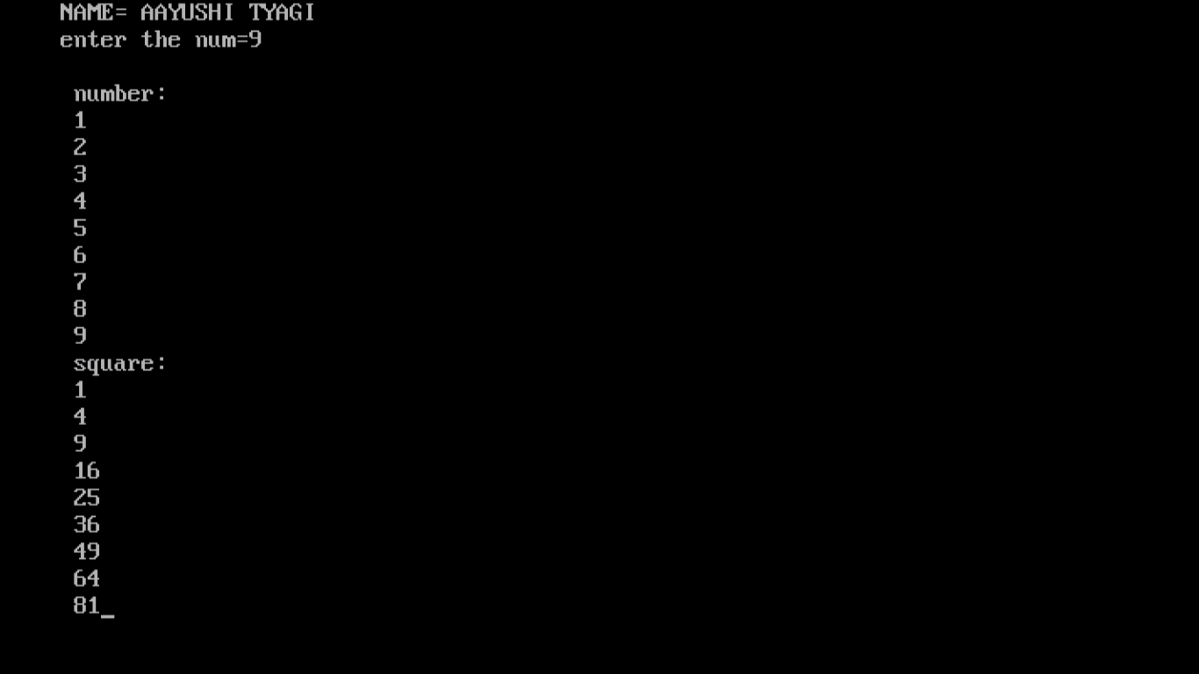

PROGRAM 28:

WRITE A PROGRAM TO FIND THE PERFECT SQUARE BETWEEN 1 TO 500.

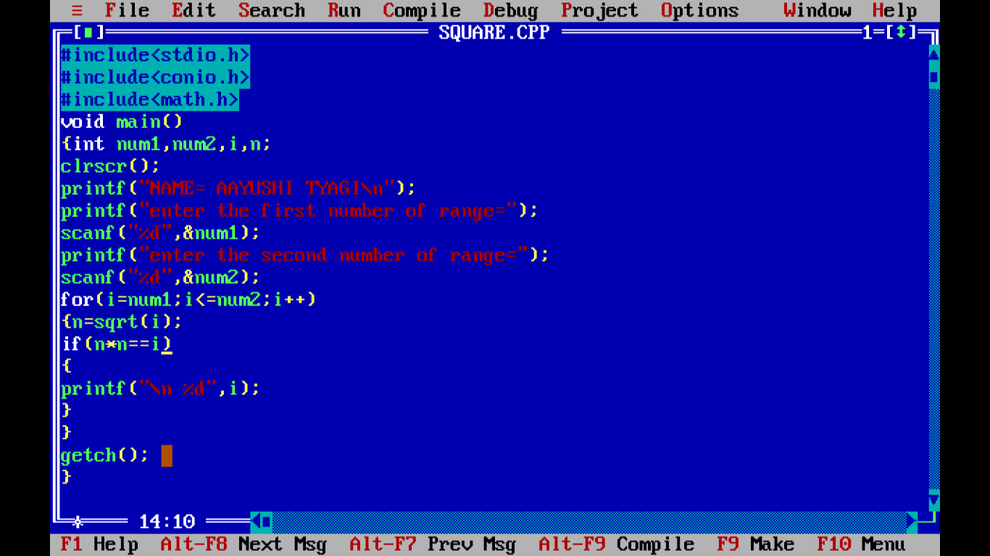

OUTPUT:

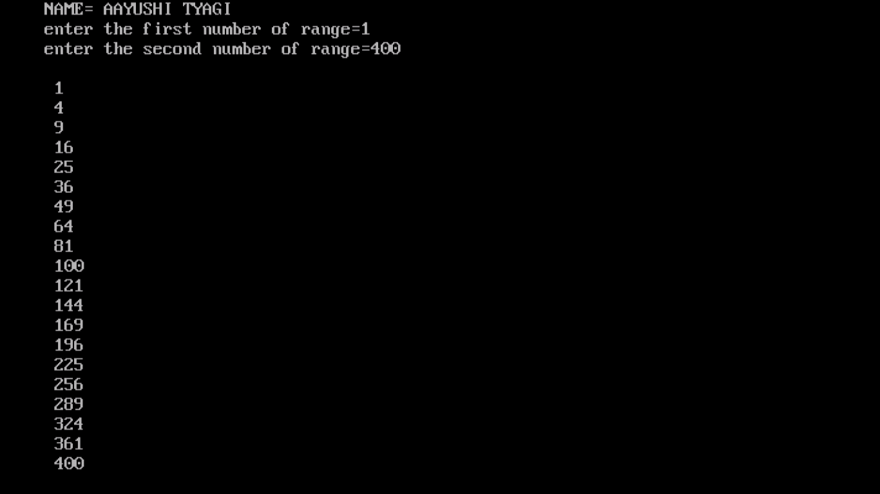

PROGRAM 29:

WRITE A PROGRAM TO CALCULATE SALARY OF A MEDICAL REPRESENTATIVE BASED ON THE SALES, BONUS AND INCENTIVES TO BE OFFERED TO HIM WILL BE BASED ON TOTAL SALES, IF THE SALES EXCEED OR EQUAL TO RS.100000. FOLLOW THE PARTICULAR OF TABLE 1 OTHERWISE TABLE 2:

TABLE1: BASIC=3000RS TABLE2: BASIC=3000RS

HRA=20% OF BASIC HRA=20% OF BASIC

DA=110% OF BASIC DA=110%OF BASIC

CONVERSE=500RS CONVENCE=500RS

INCENTIVE=10% OF SALES INCENTIVE=5% OF SALES

BONUS=500RS BONUS=200RS

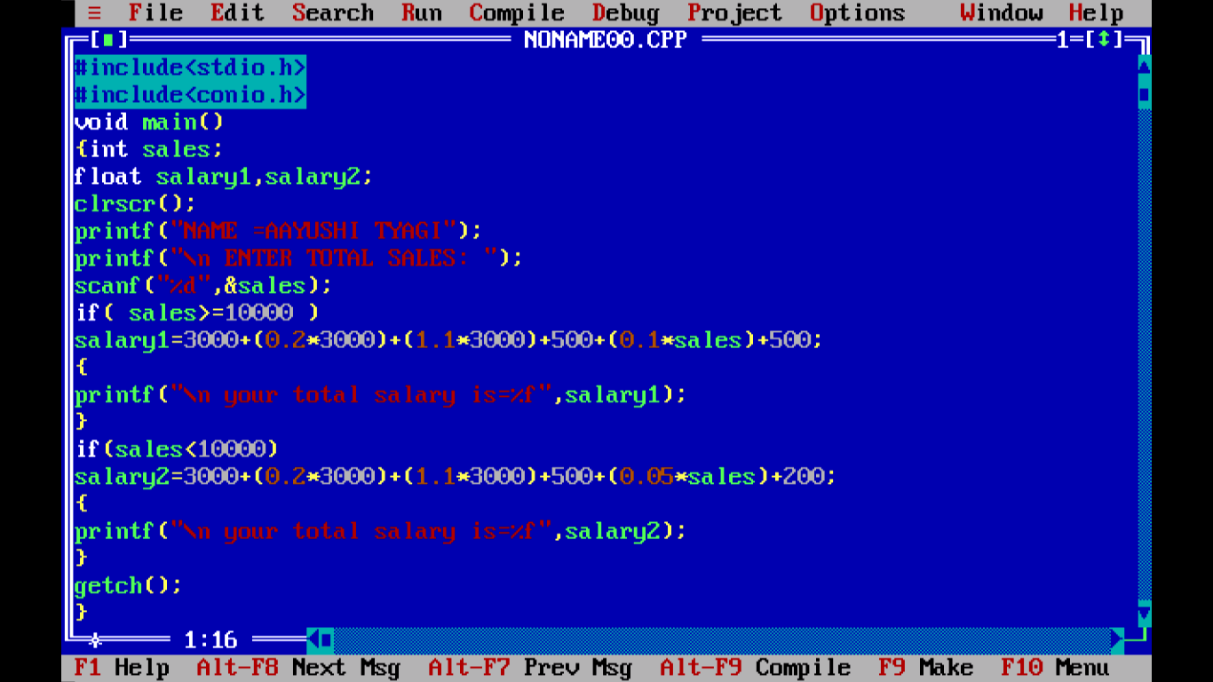

Output:

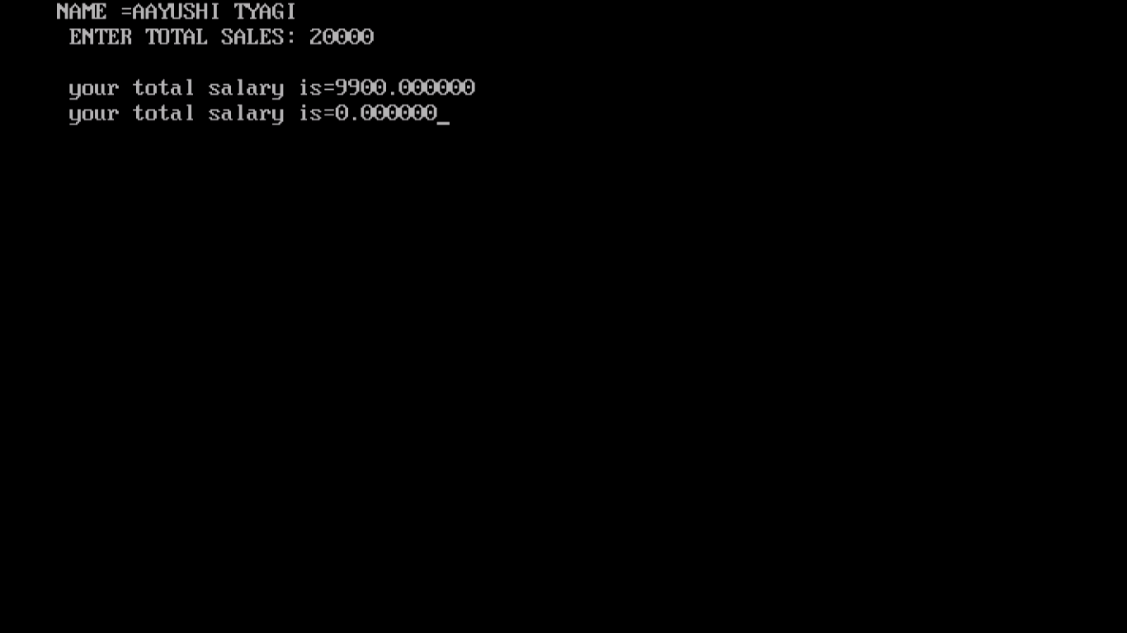

PROGRAM 30:

WRITE A PROGRAM TO PRINT 2’s TABLE.

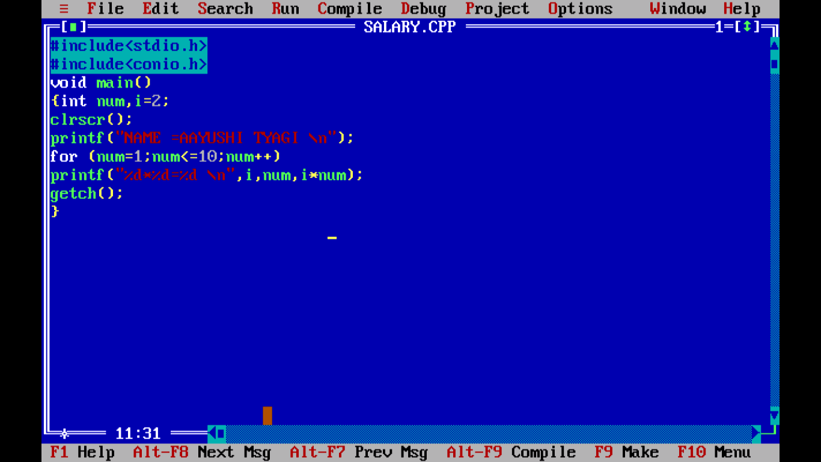

OUTPUT:

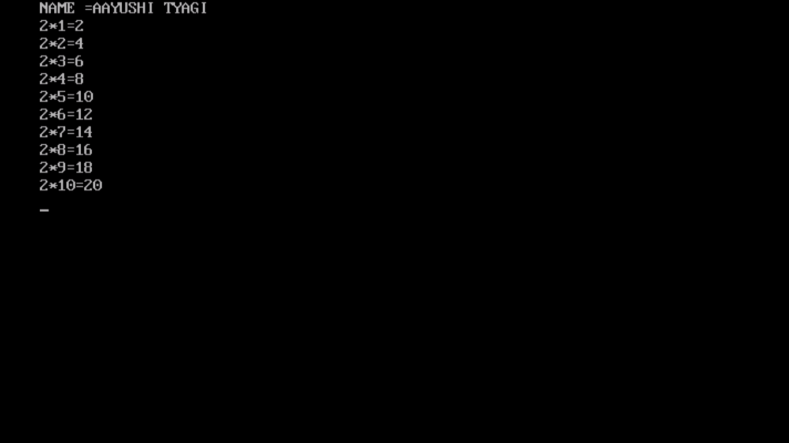

PROGRAM 31:

WRITE A PROGRAM TO PRINT FACTORIAL.

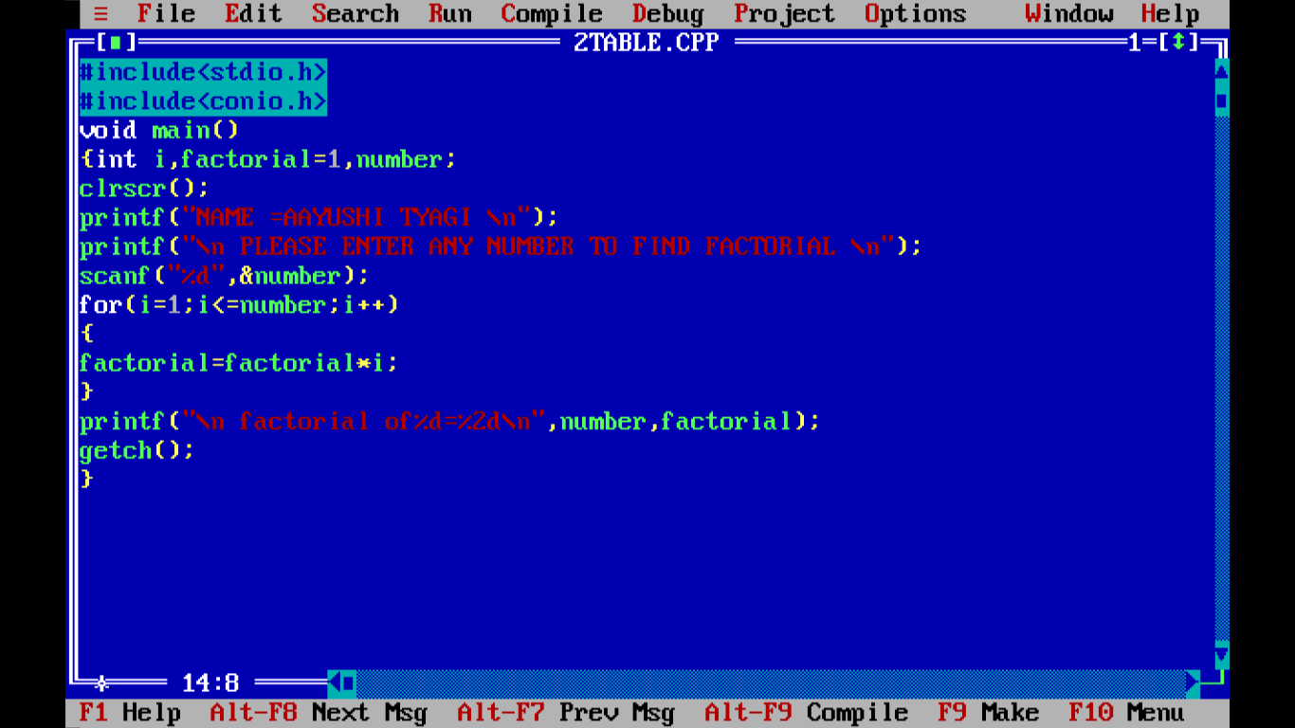

OUTPUT:

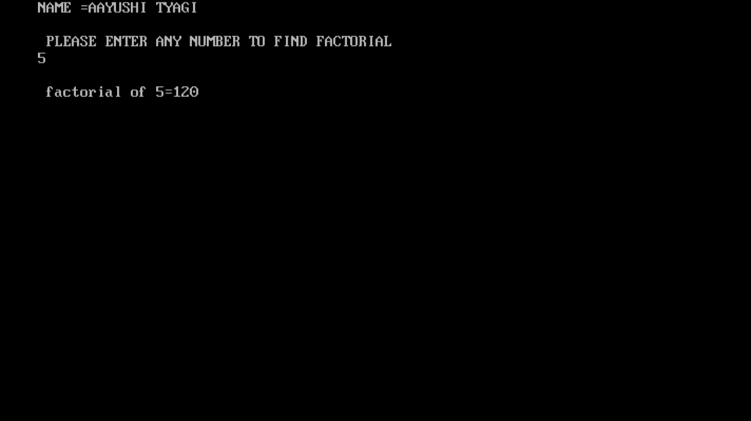

PROGRAM 32:

WRITE A PROGRAM TO REVERSE A NUMBER.

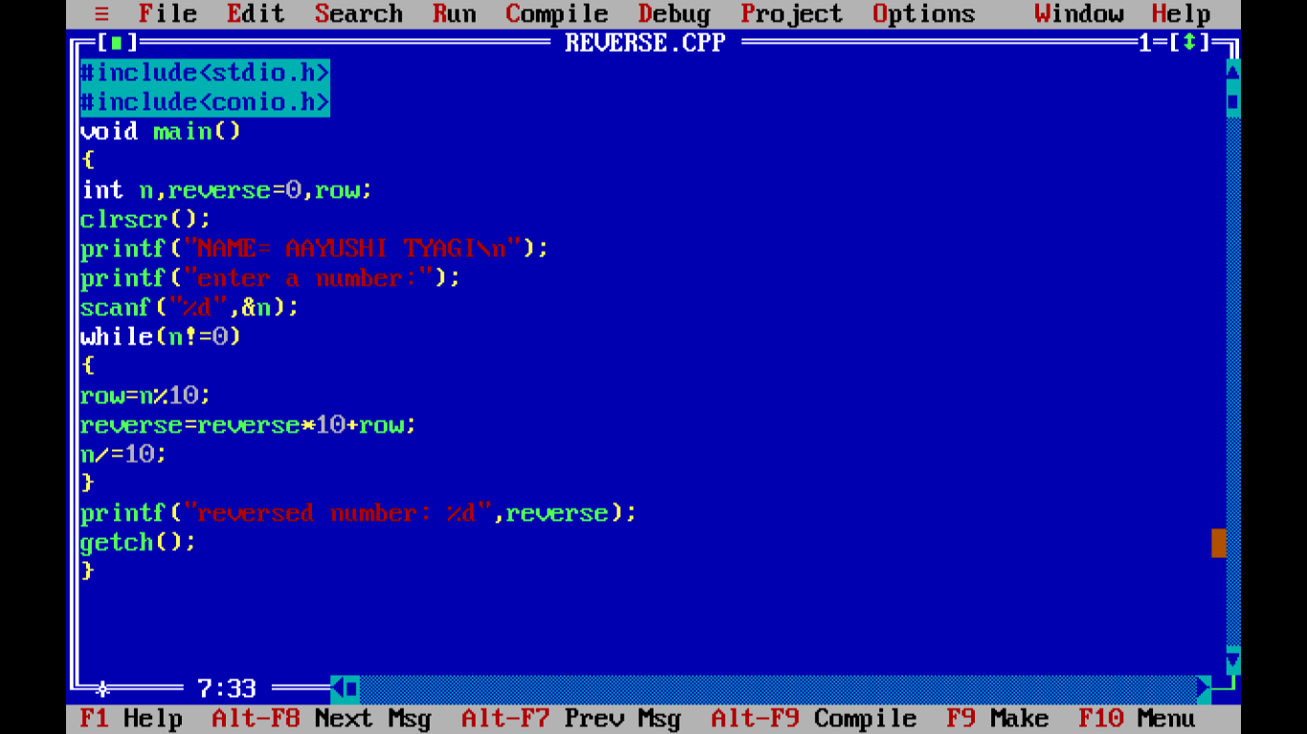

OUTPUT:

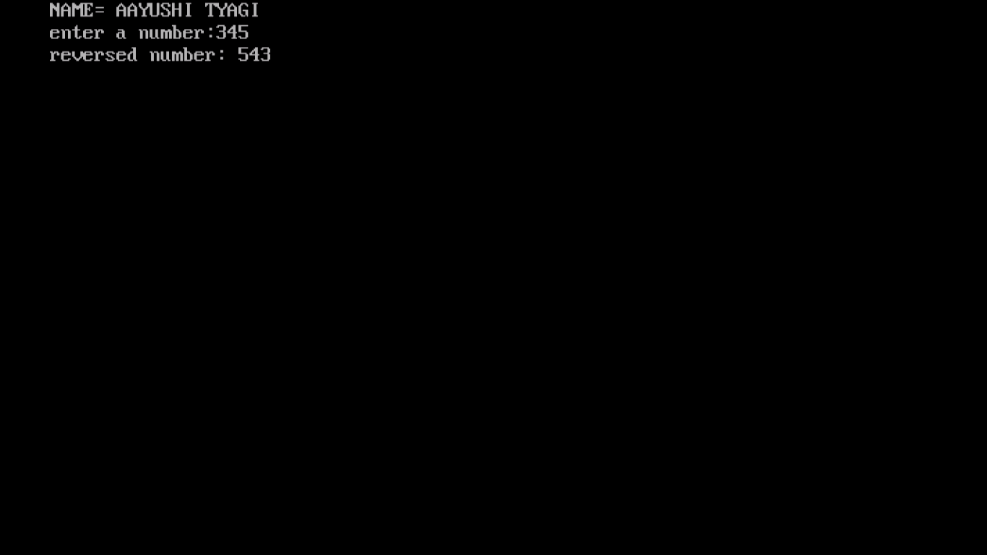

PROGRAM 33:

WRITE A PROGRAM USING FOR LOOP.

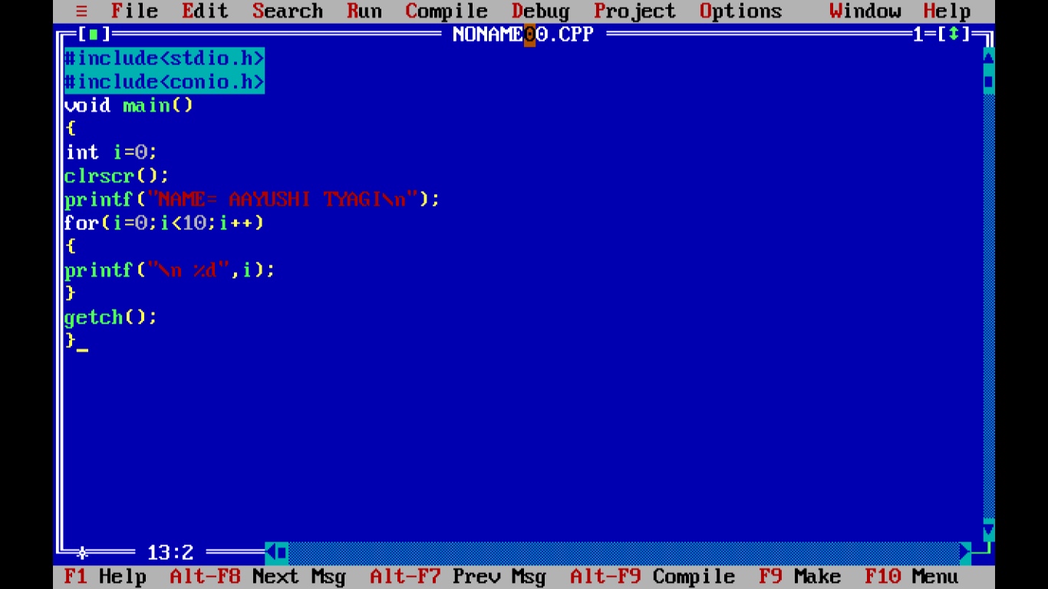

OUTPUT:

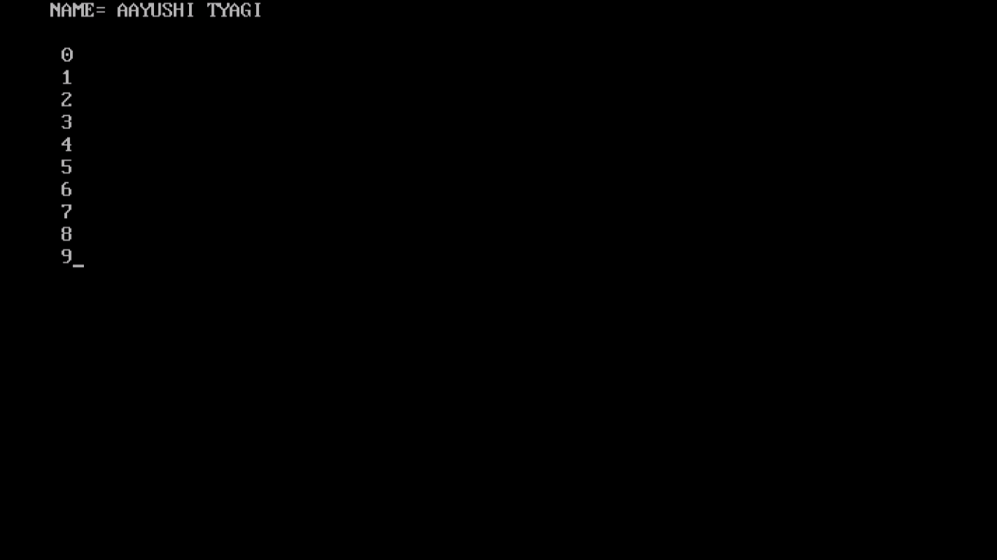

PROGRAM 34:

WRITE A PROGRAM USING WHILE LOOP.

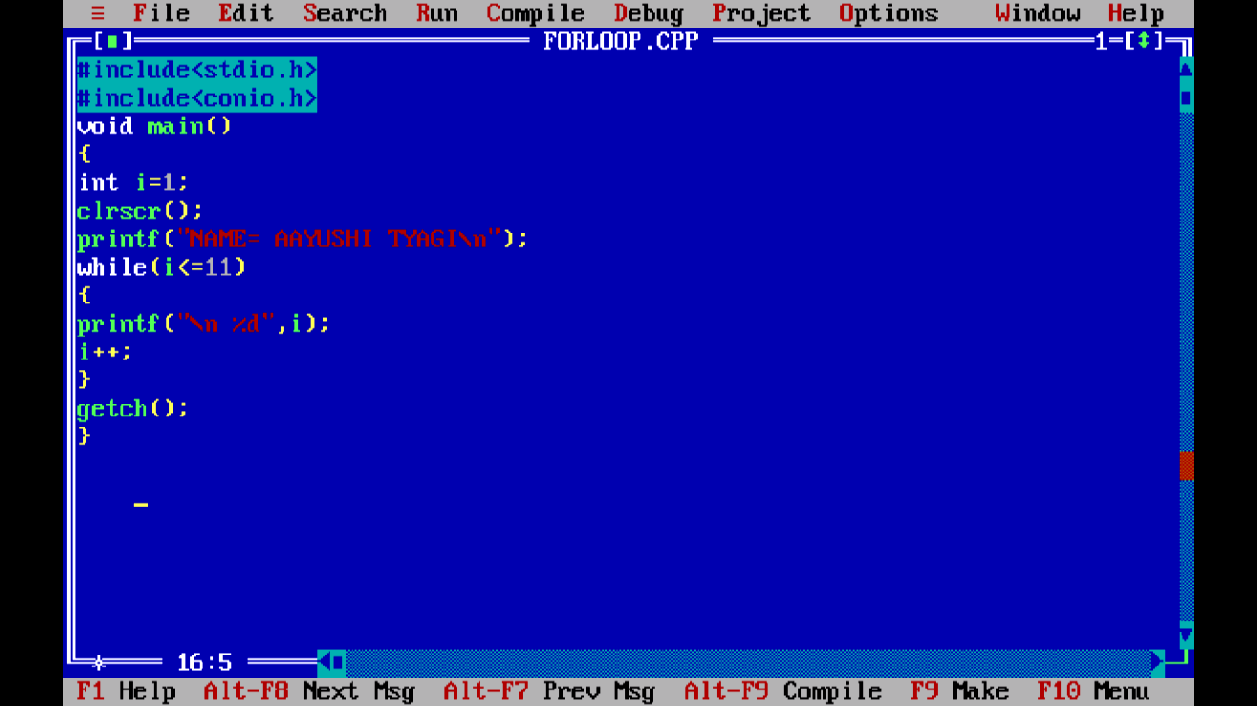

OUTPUT:

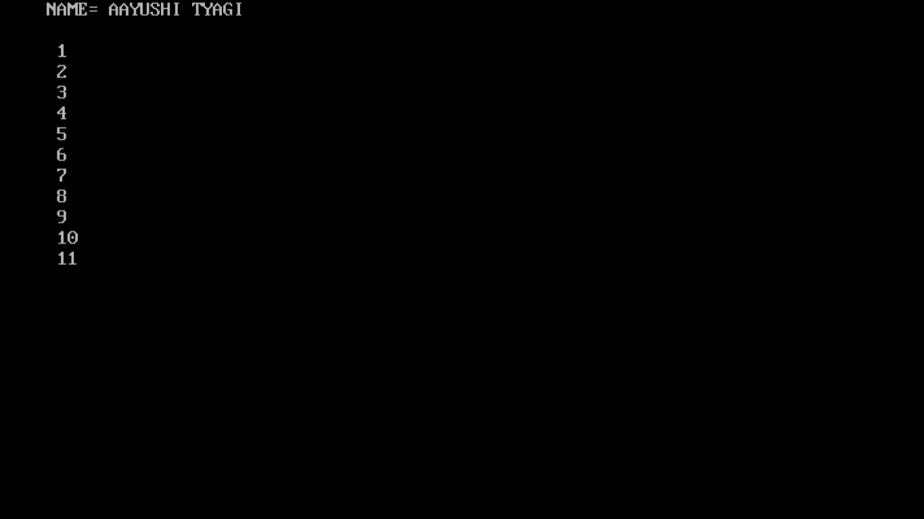

PROGRAM 35:

WRITE A PROGRAM USING NESTED LOOP.

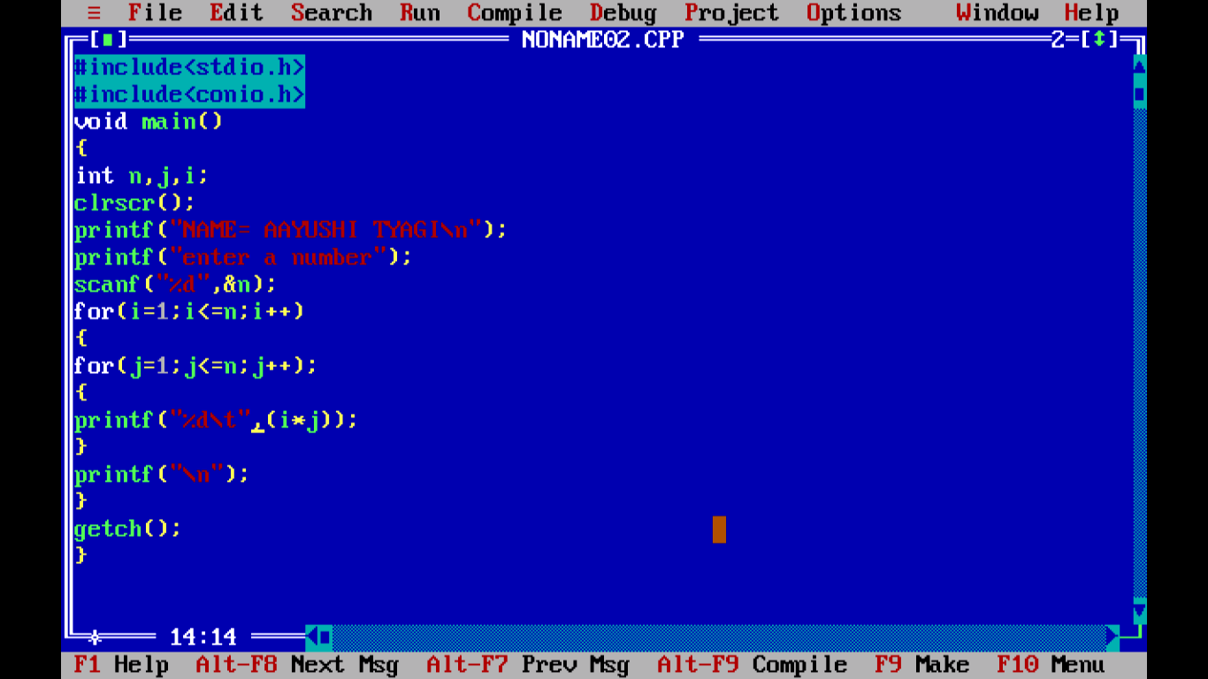

OUTPUT:

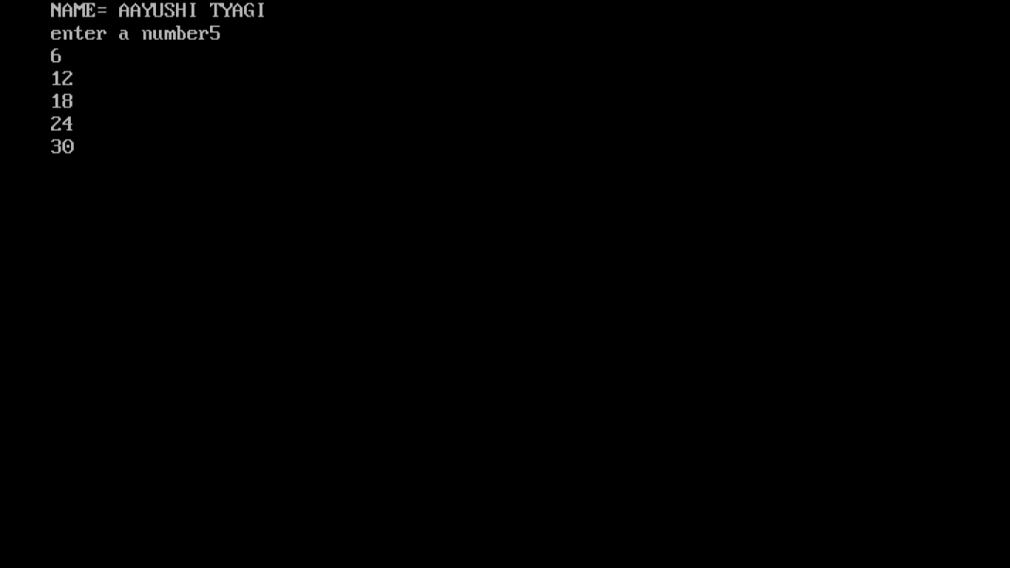

PROGRAM 36:

WRITE A PROGRAM USING DO WHILE LOOP.

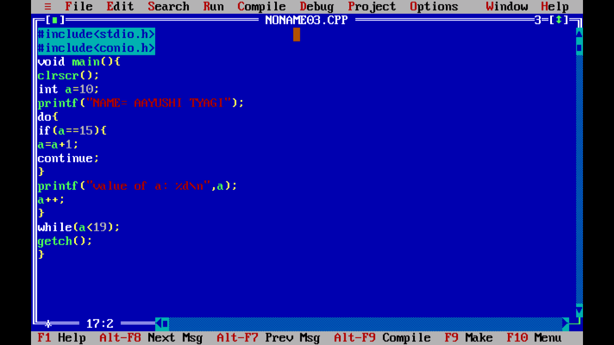

OUTPUT:

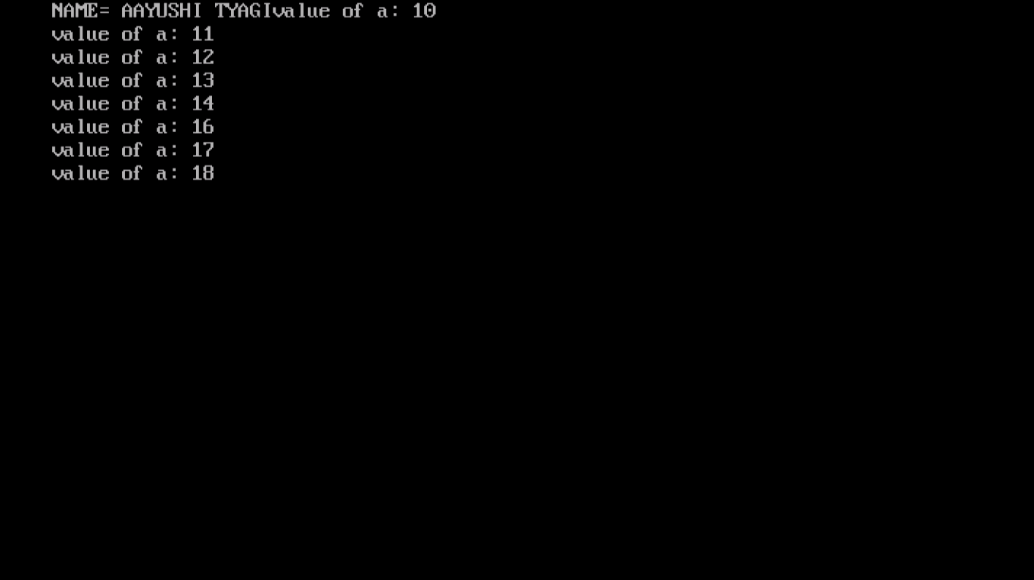

PROGRAM 37:

WRITE A PROGRAM TO PRINT REVERSE NO. 100-1 FROM FOR LOOP.

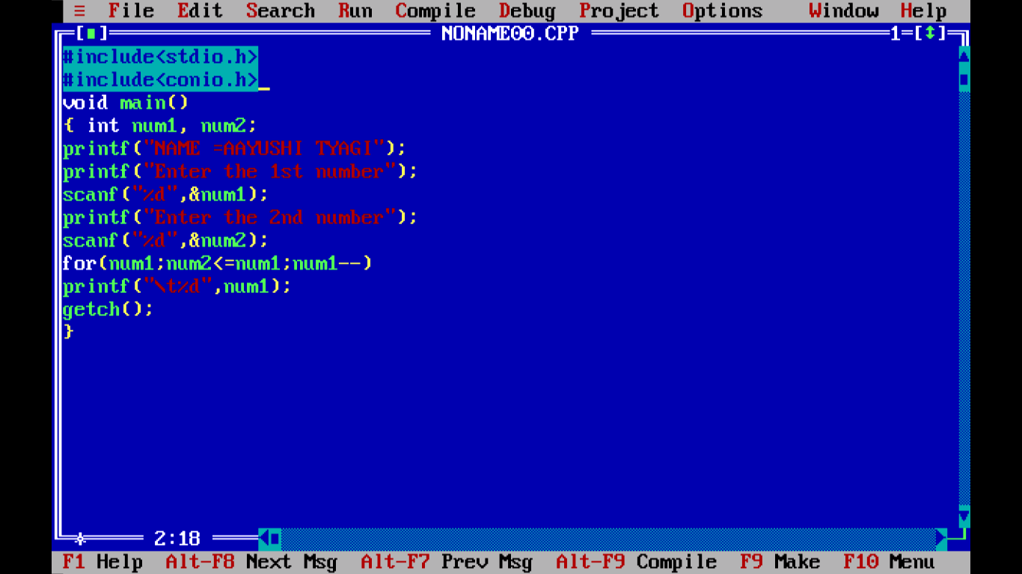

OUTPUT:

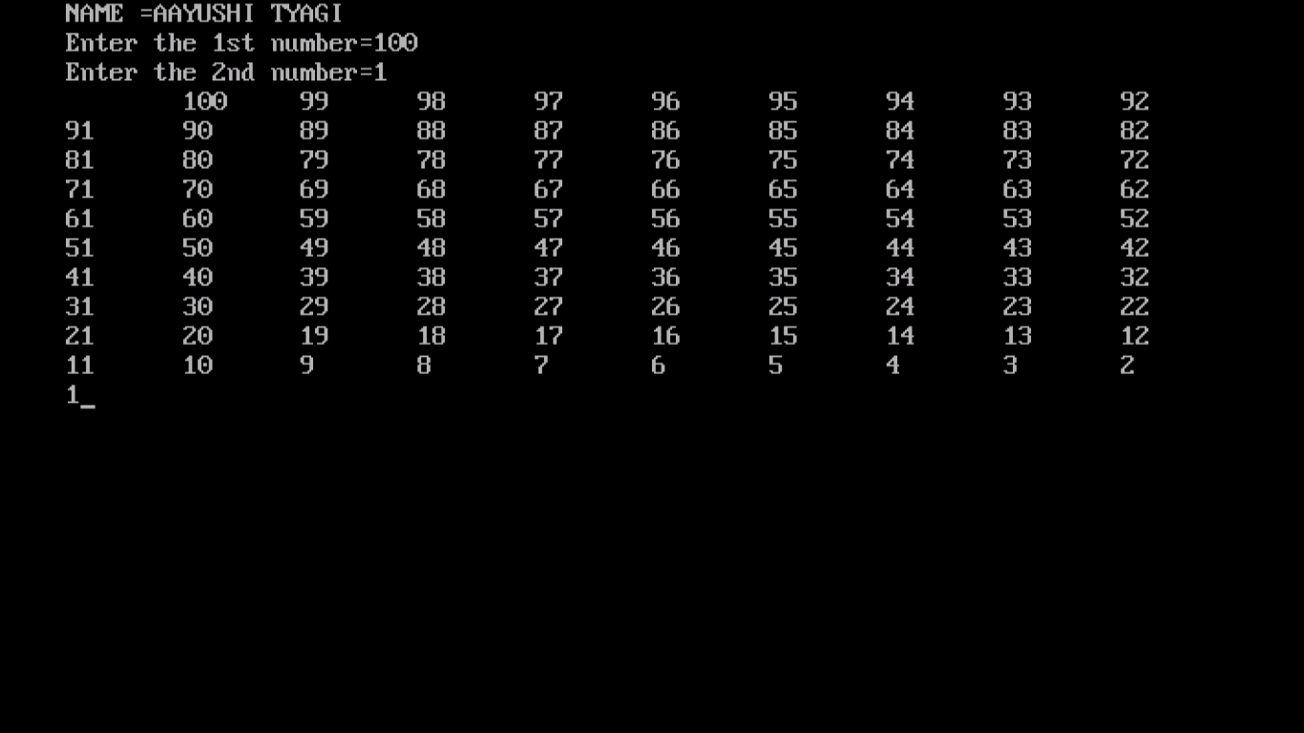

PROGRAM 38:

WRITE A PROGRAM TO PRINT REVERSE NO. 100-1 FROM DO WHILE LOOP.

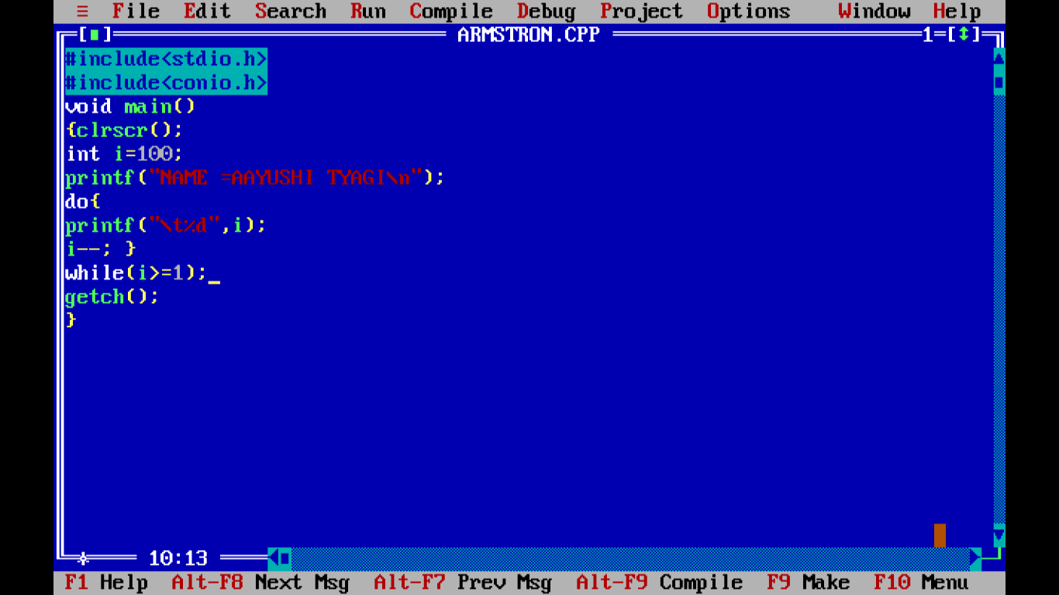

OUTPUT:

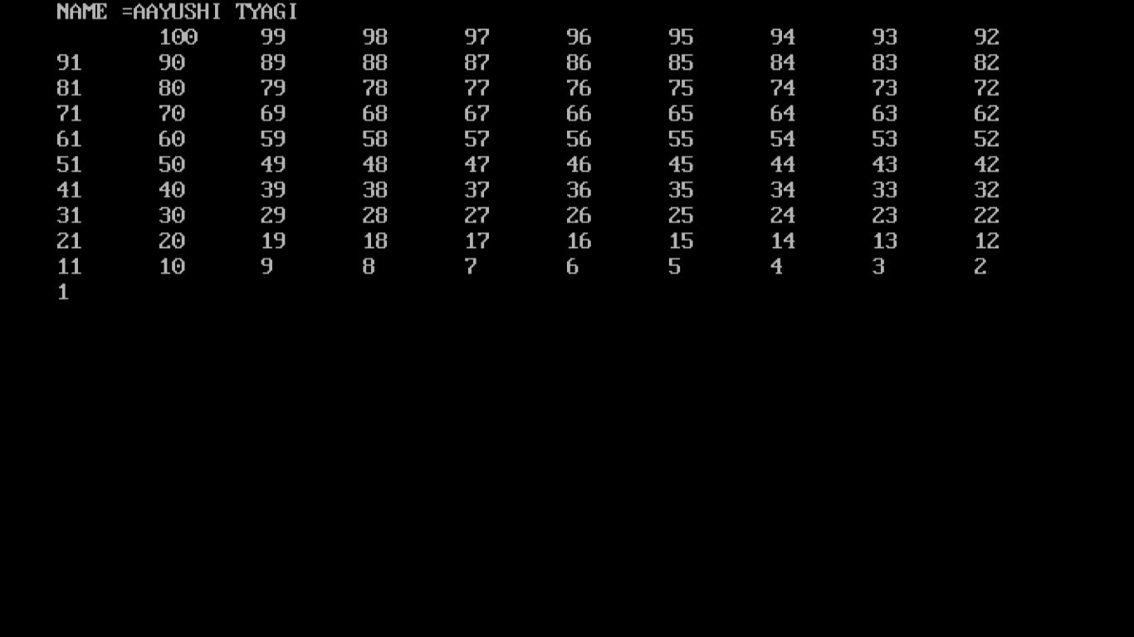

PROGRAM 39:

WRITE A PROGRAM TO DISPLAY FIBONACCI SERIES.

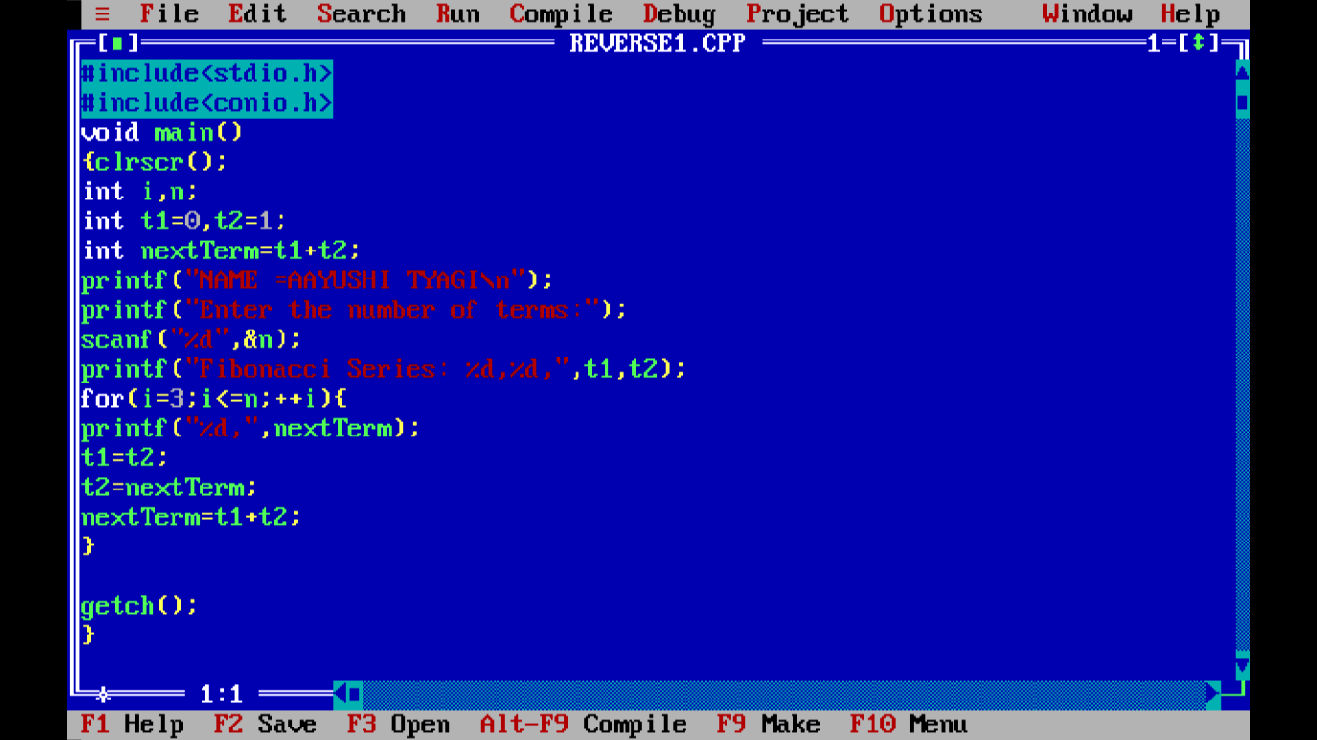

OUTPUT:

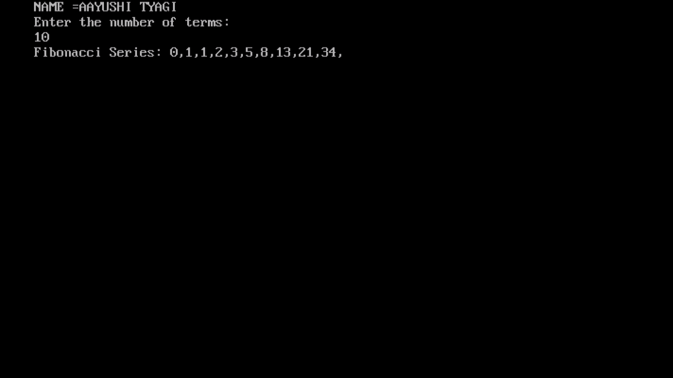

PROGRAM 40:

WRITE A PROGRAM TO PRINT PRIME NUMBER USING WHILE LOOP.

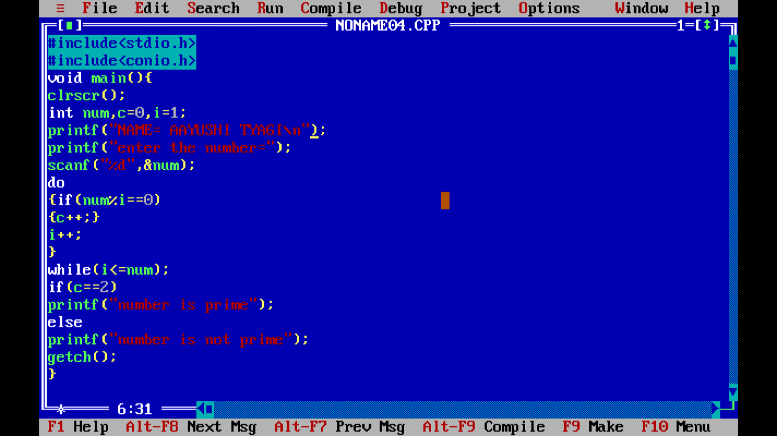

OUTPUT:

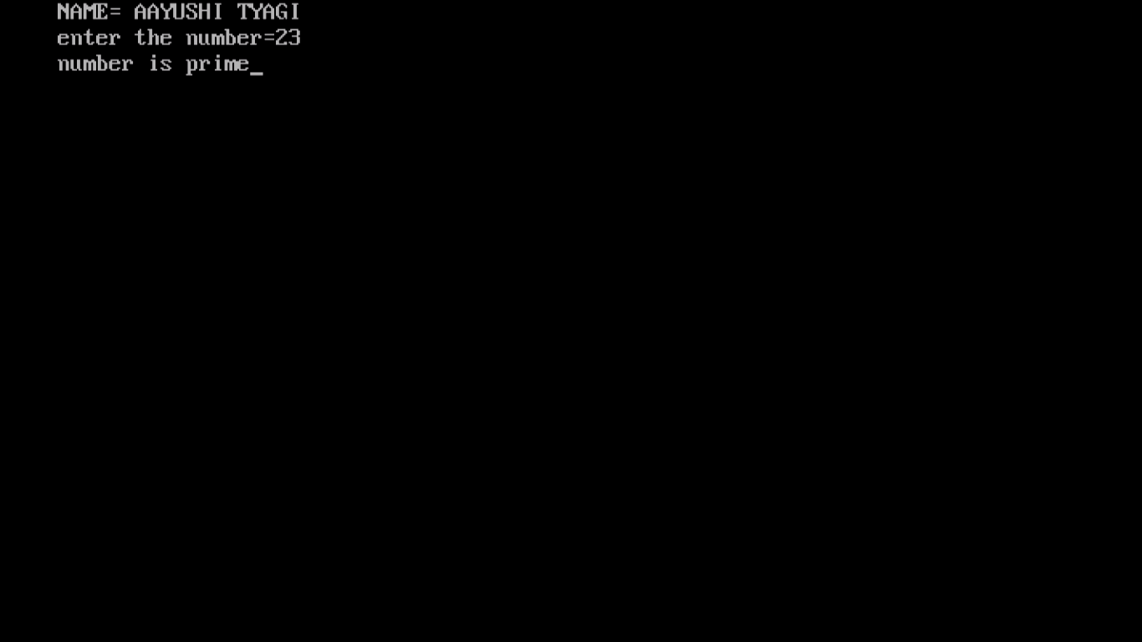

PROGRAM 41:

WRITE A PROGRAM TO PRINT WHETHER IT IS A LEAP YEAR OR NOT?

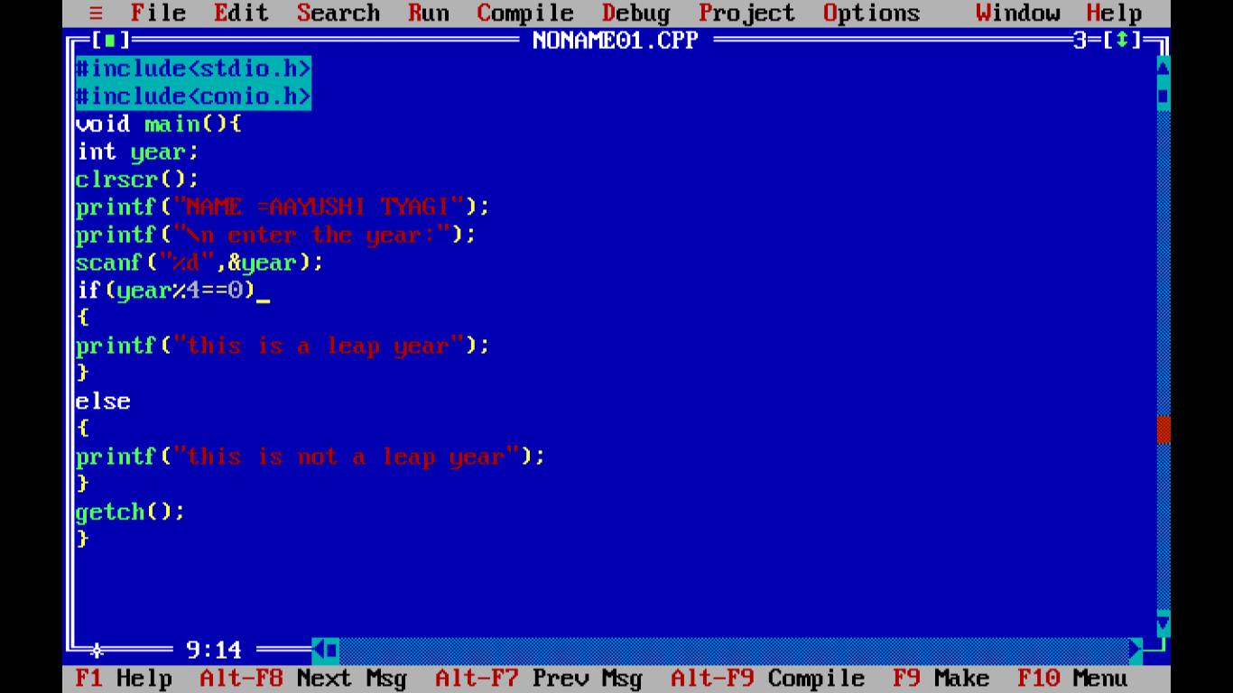

Output:

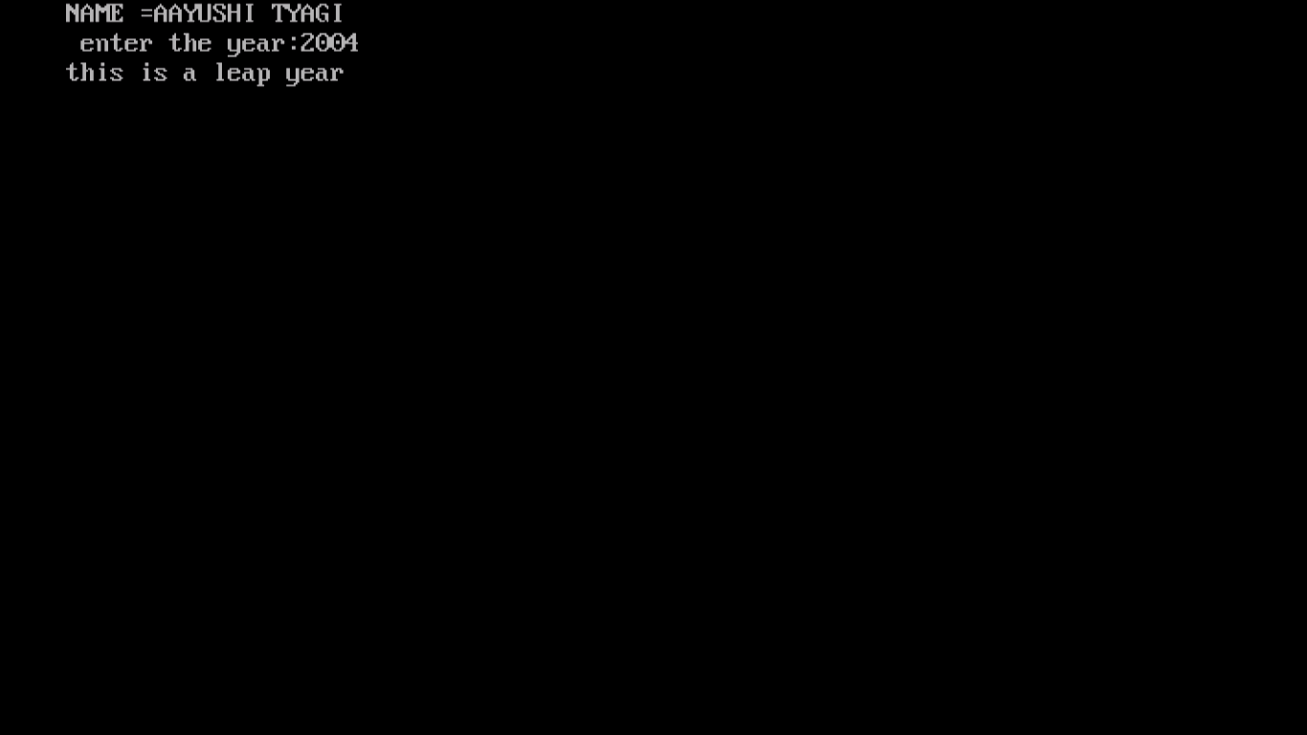

PROGRAM 42:

WRITE A PROGRAM TO PRINT 1-D ARRAY ELEMENTS.

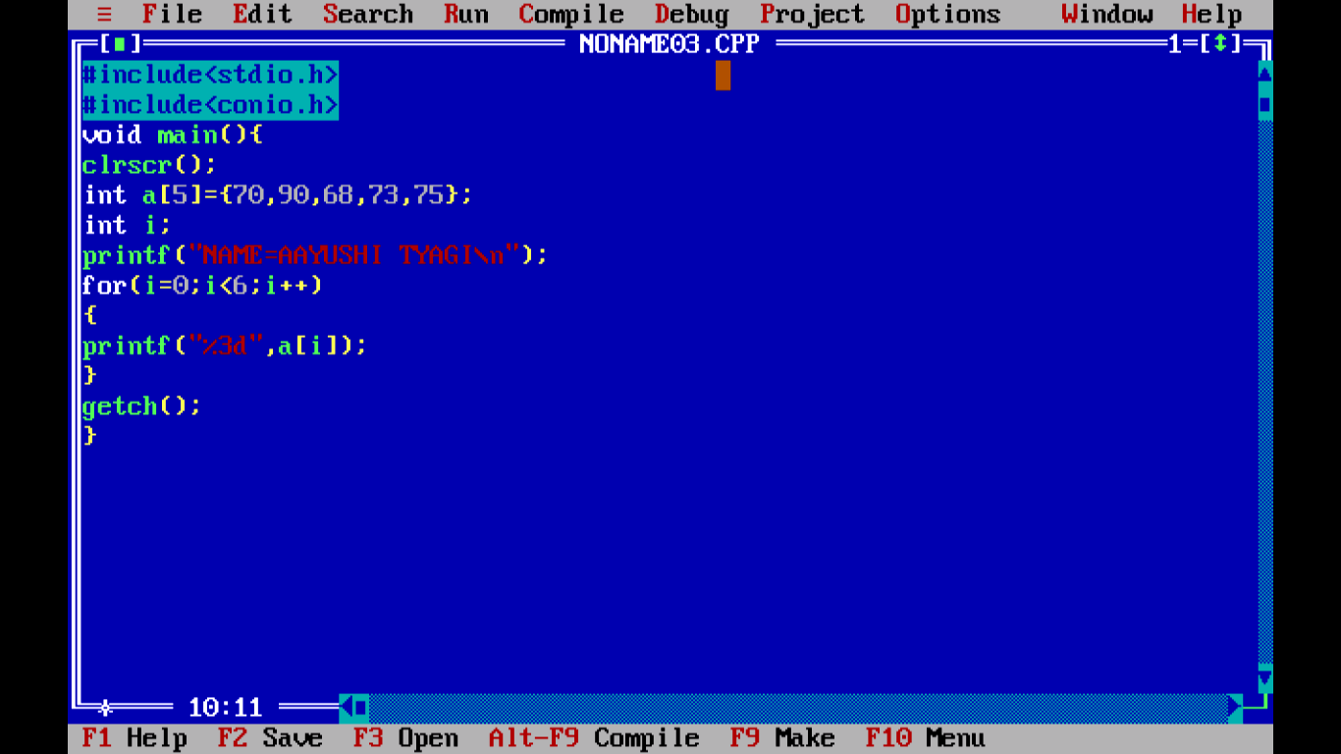

Output:

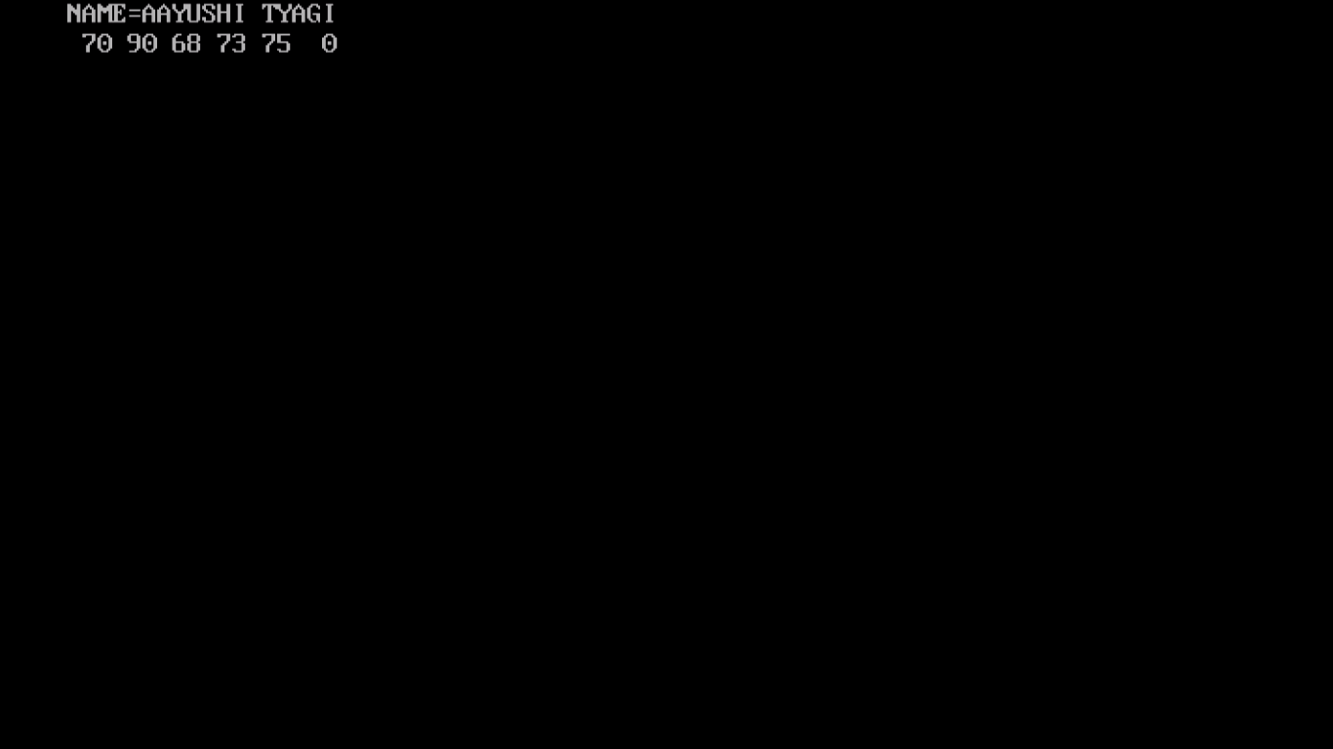

PROGRAM 43:

WRITE A PROGRAM TO PRINT MATRICES IN 2-D ARRAY.

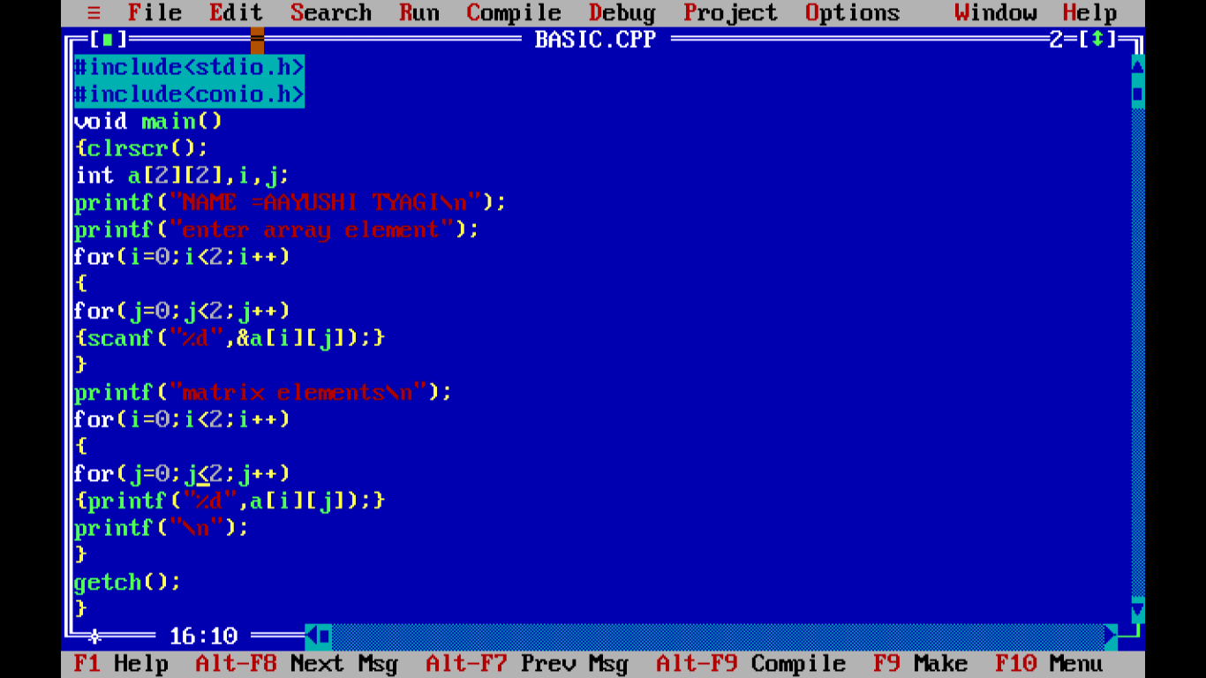

Output:

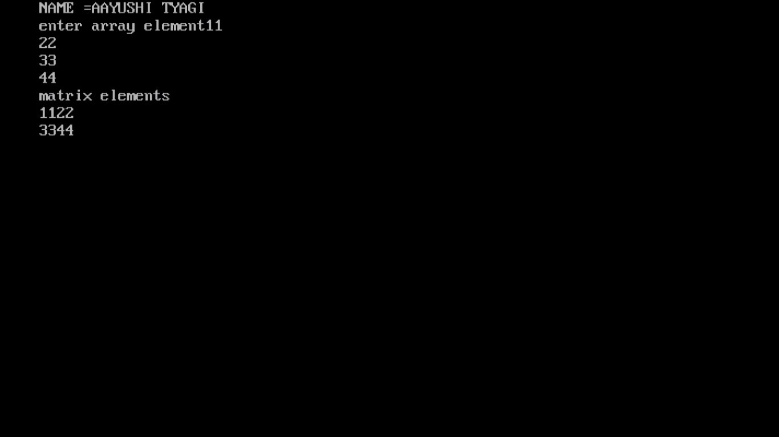

PROGRAM 44:

WRITE A PROGRAM TO PRINT SUM OF ARRAY.

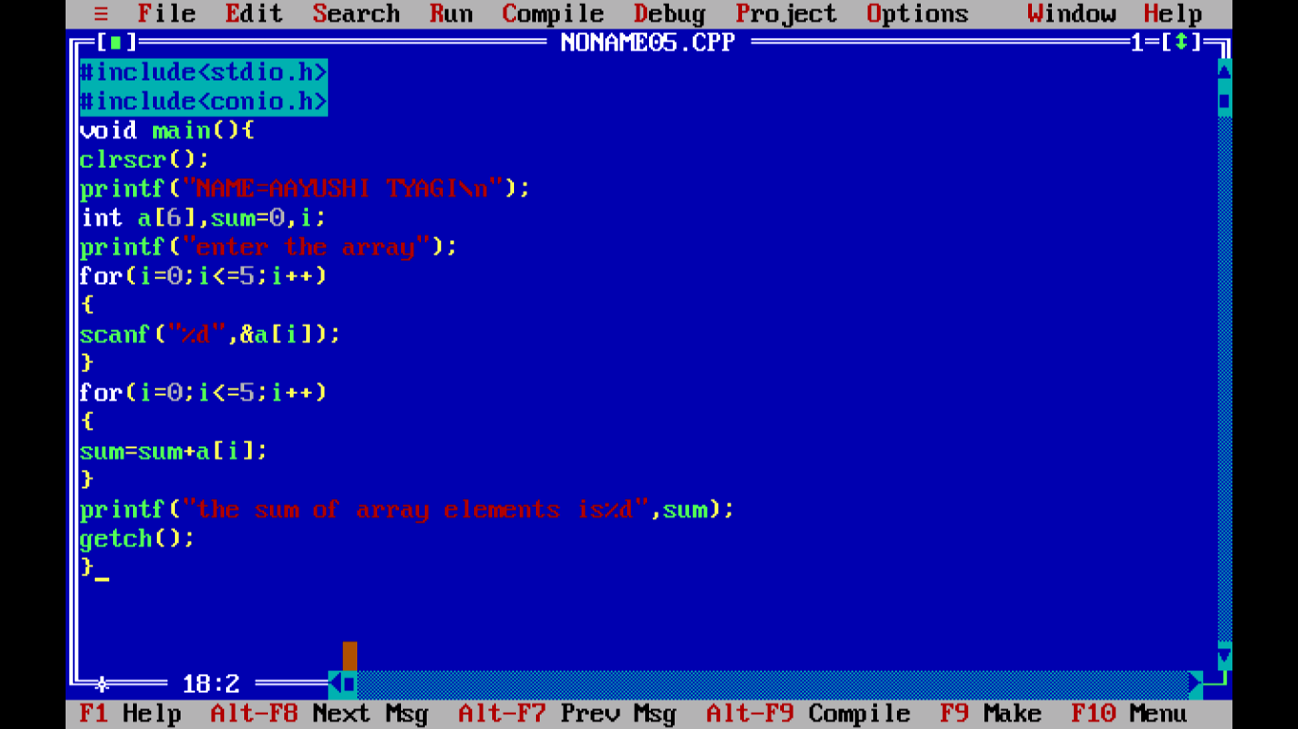

OUTPUT:

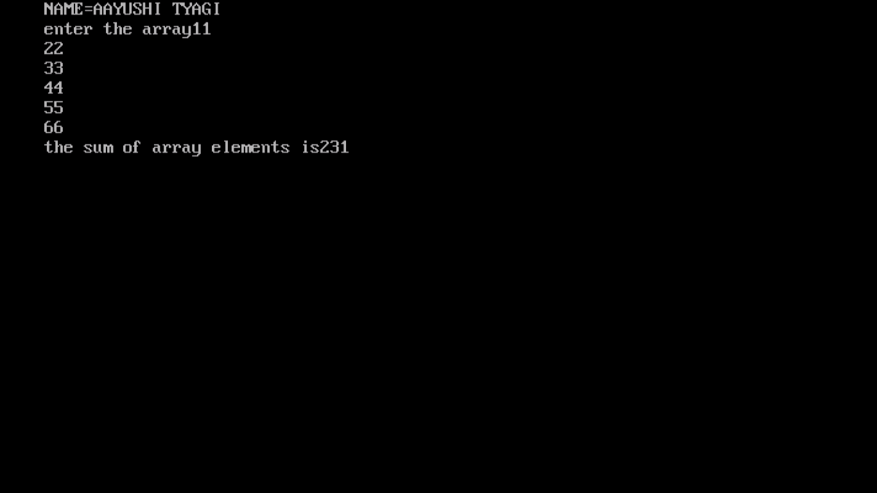

PROGRAM 45:

WRITE A PROGRAM TO PRINT MAXIMUM NUMBER BY USING ARRAY.

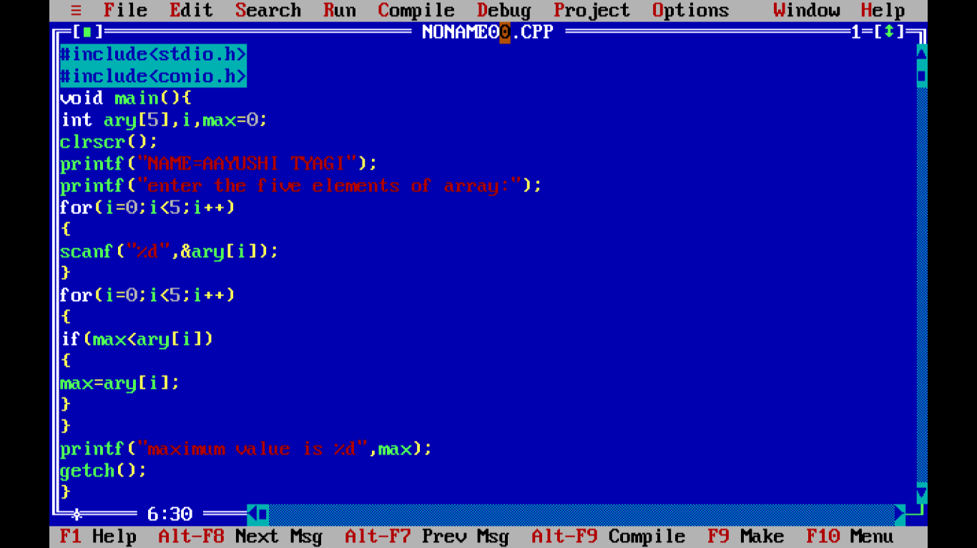

Output:

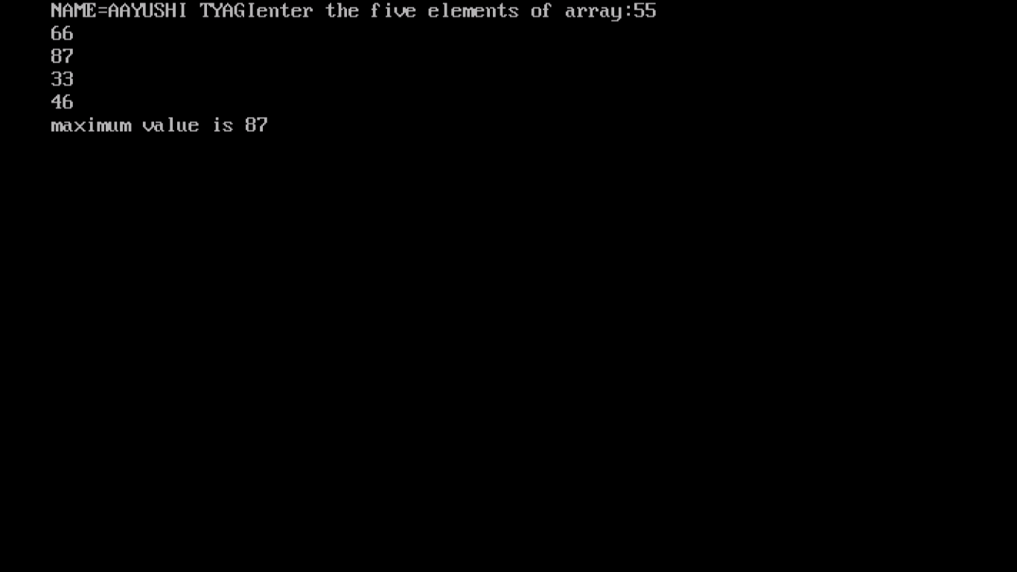

PROGRAM 46:

WRITE A PROGRAM TO CHECK WHETHER THE NUMBER IS ARMSTRONG.

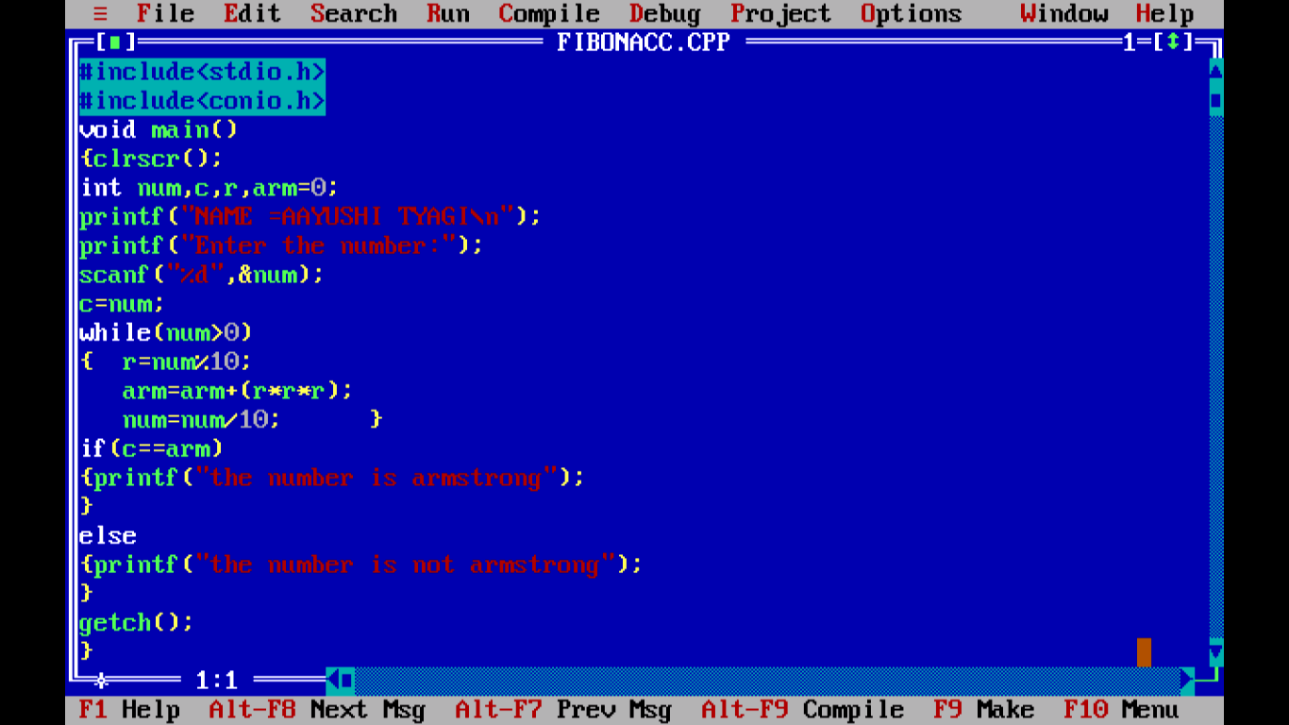

OUTPUT:

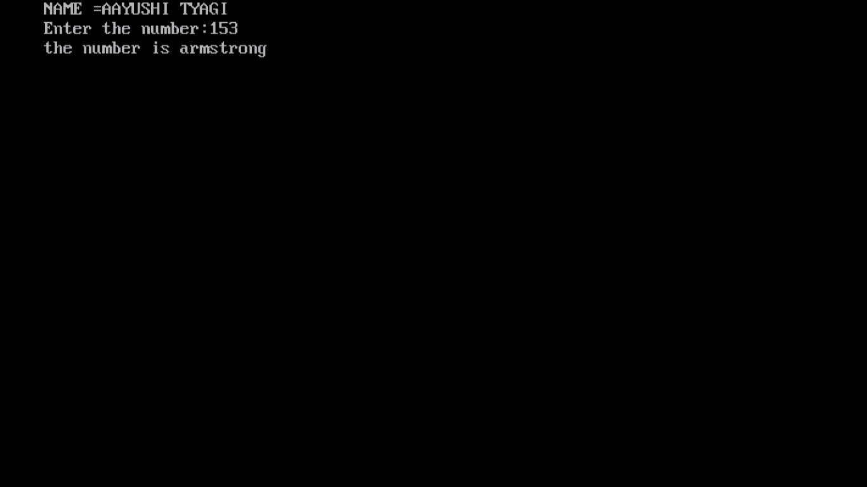

PROGRAM 47:

WRITE A PROGRAM TO CHECK A NUMBER IS PALINDROME OR NOT.

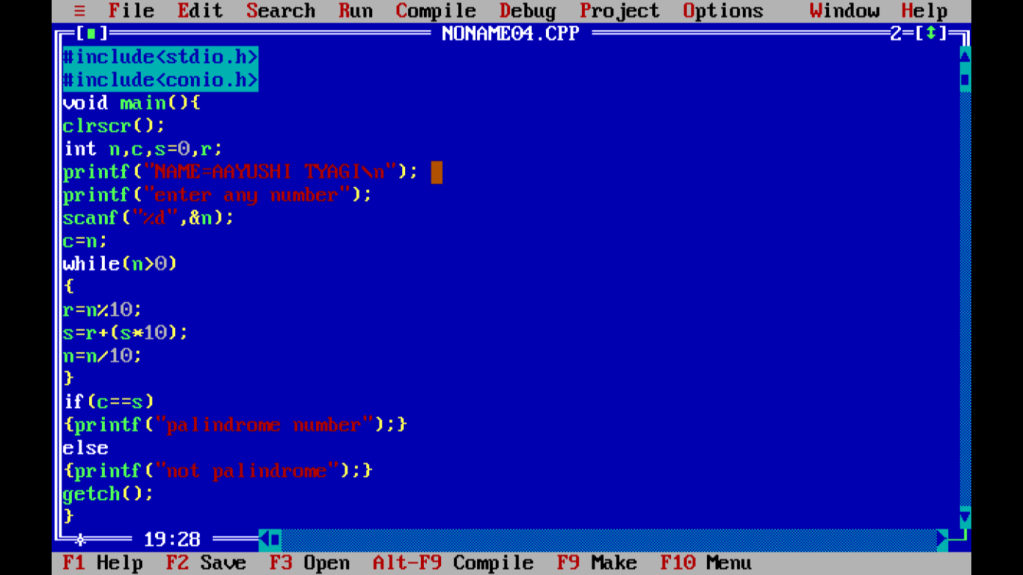

Output:

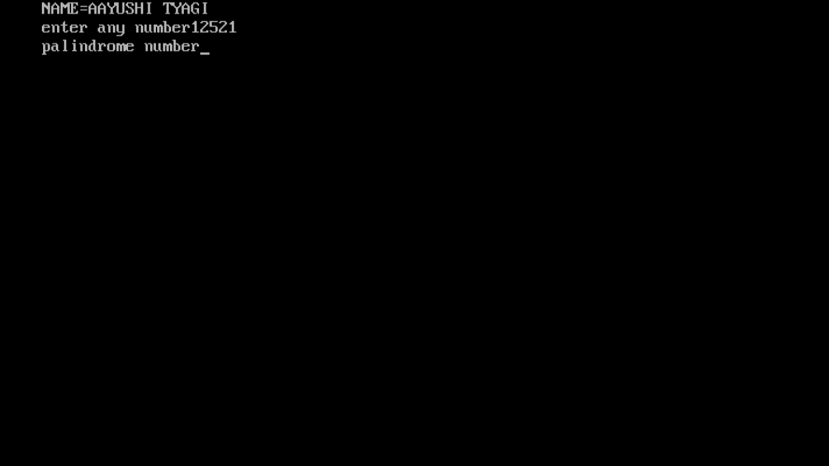

PROGRAM 48:

WRITE A PROGRAM TO COUNT THE NUMBER OF STUDENTS HAVING AGE LESS THAN 25 AND WEIGHT LASS THAN 50KG.

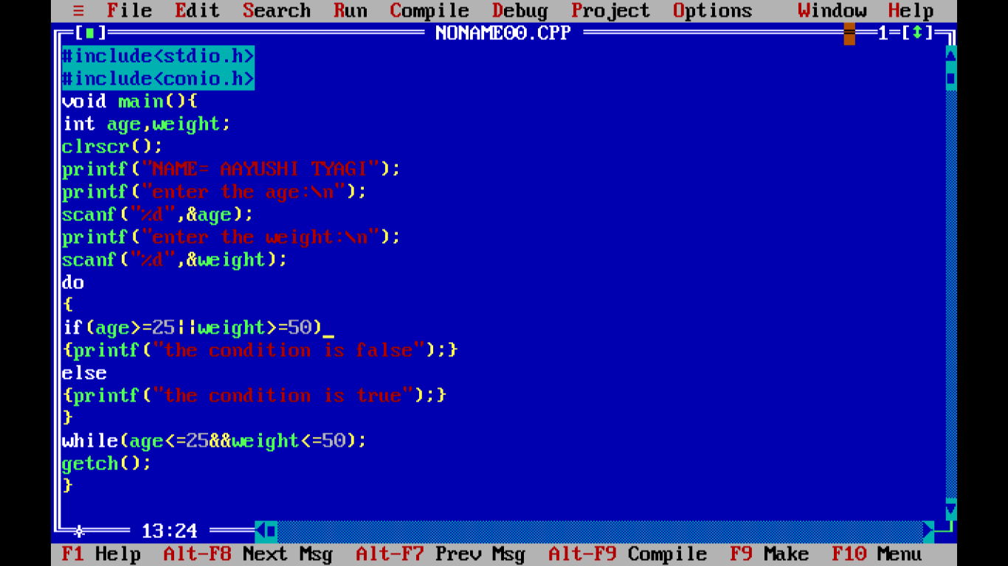

OUTPUT:

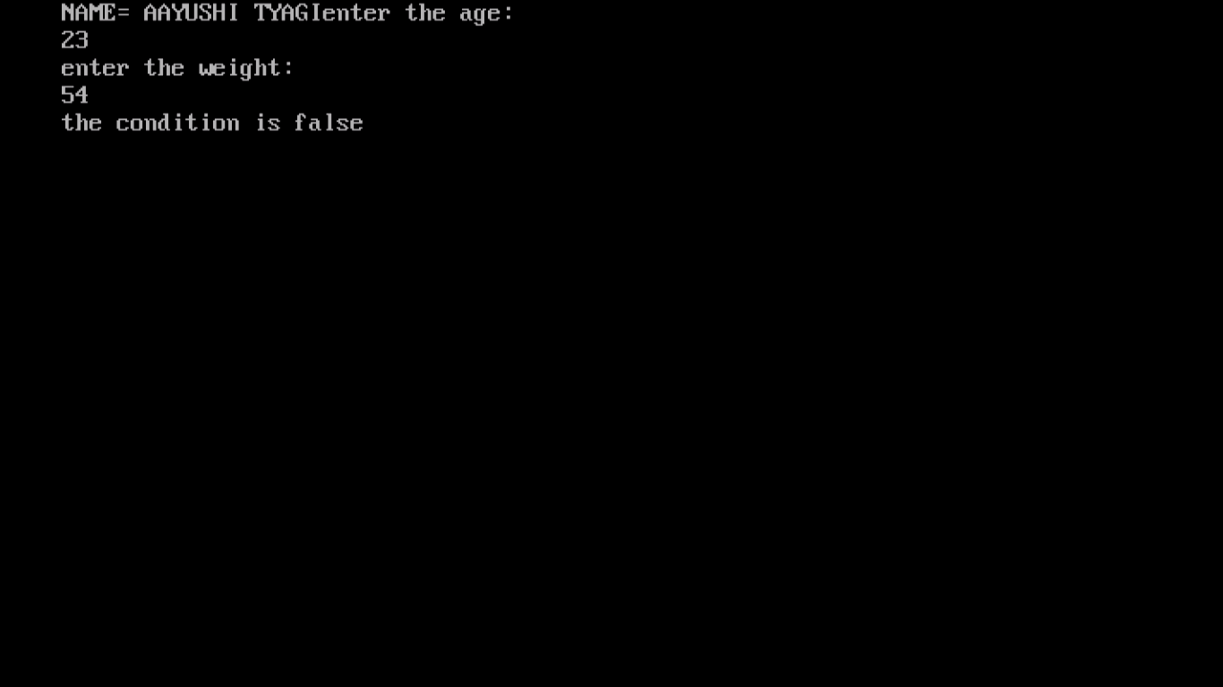

PROGRAM 49:

WRITE A PROGRAM TO SHOW GLOBAL VARIABLE AND LOCAL VARIABLE

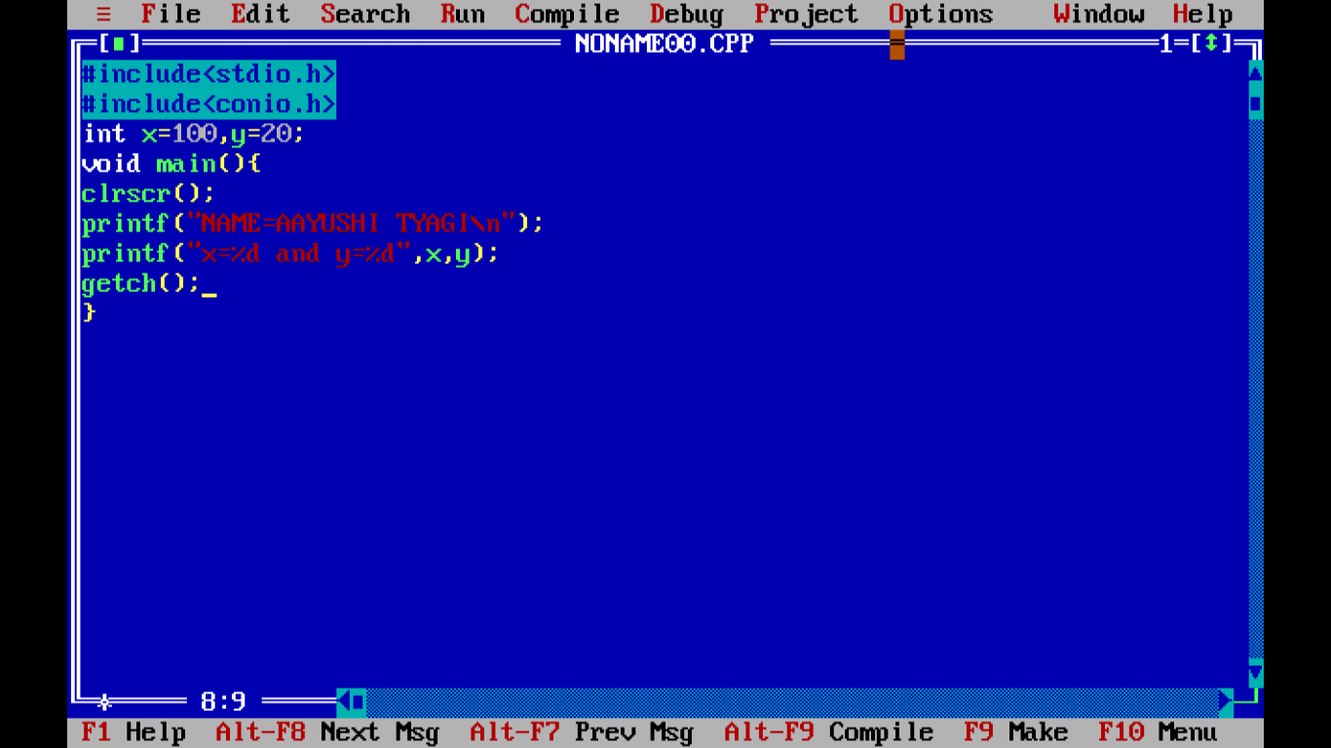

OUTPUT:

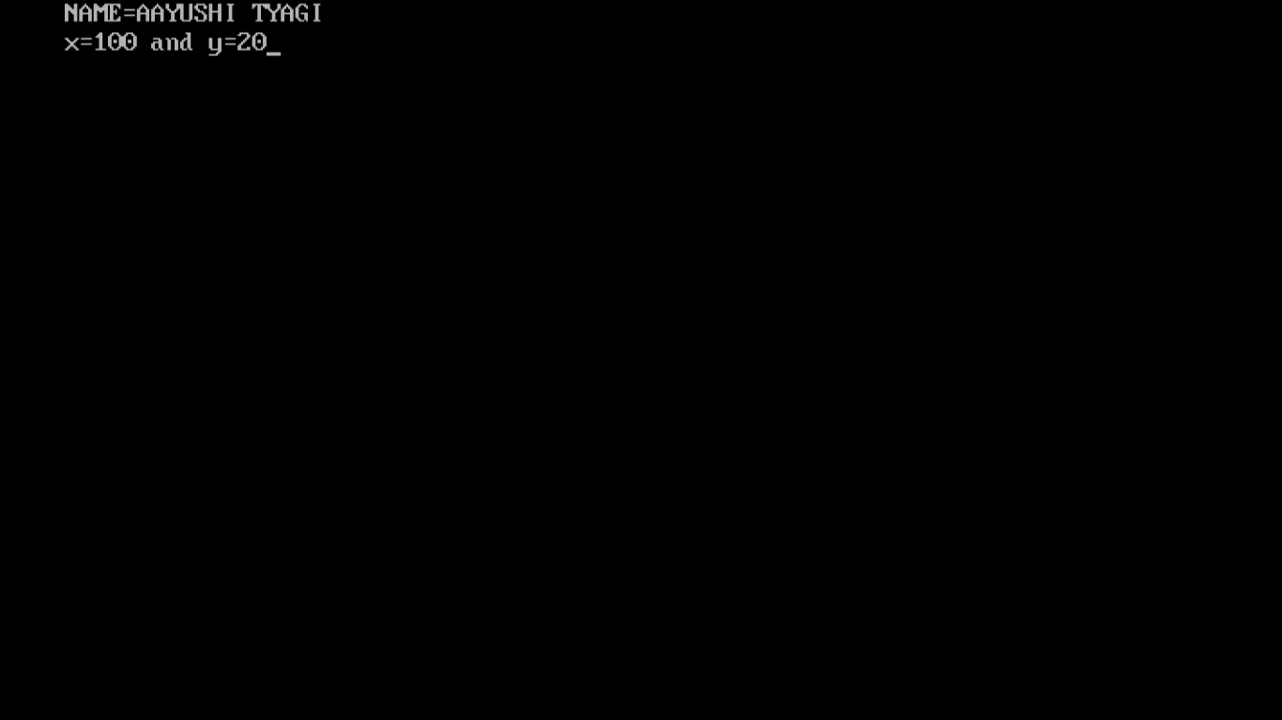

PROGRAM 50:

WRITE A PROGRAM TO SHOW INCREMENT.

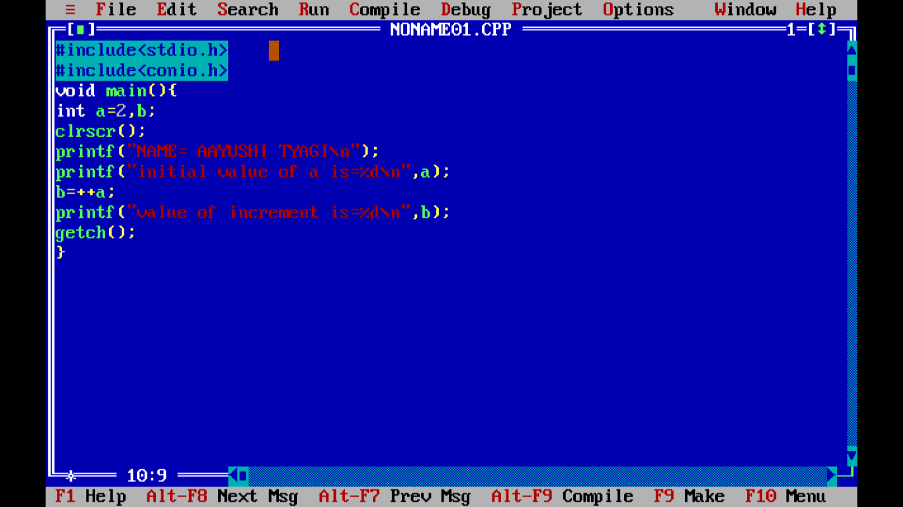

OUTPUT:

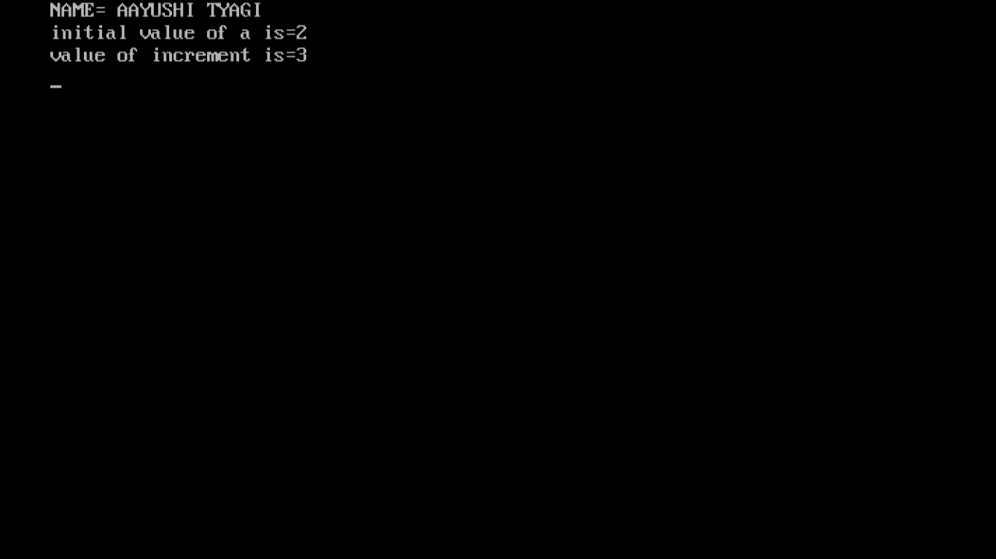

PROGRAM 51:

WRITE A PROGRAM TO SHOW DECREMENT.

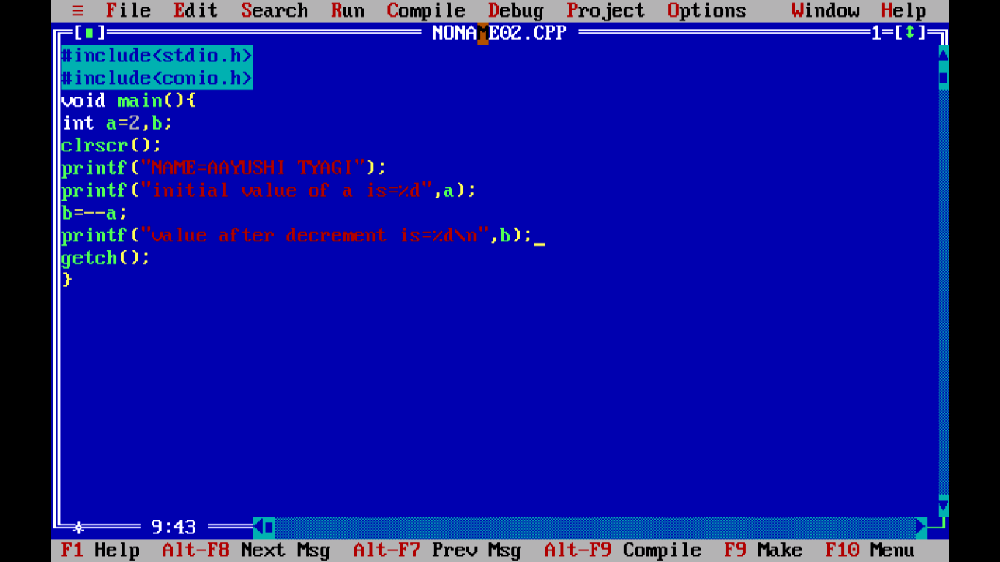

OUTPUT:

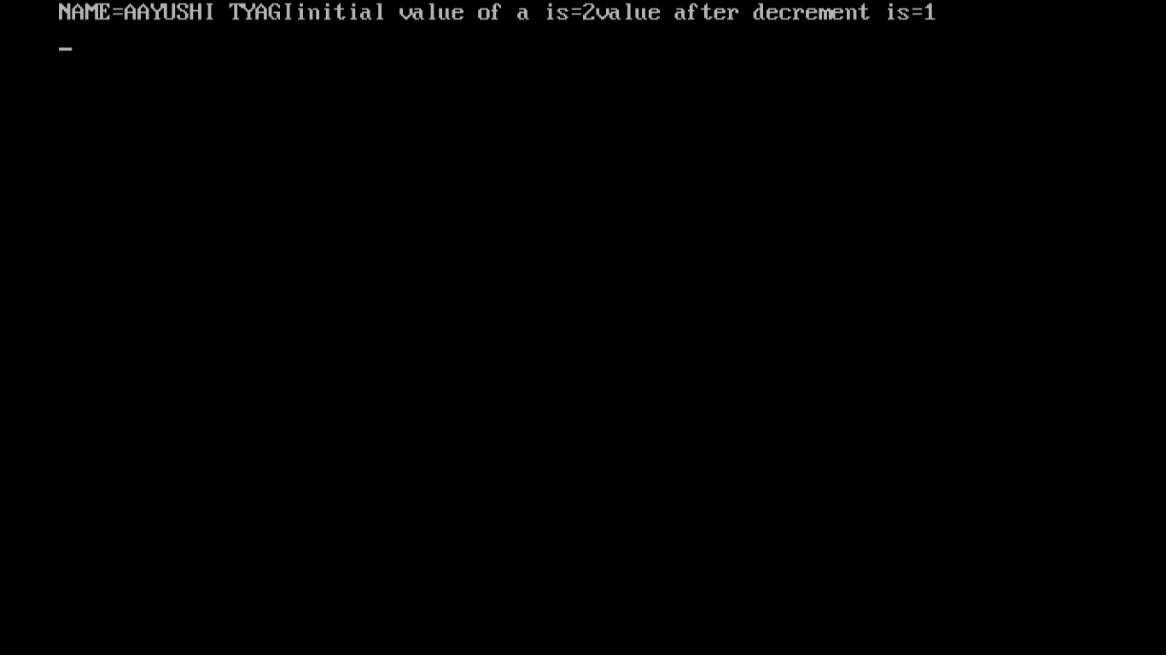

PROGRAM 52:

WRITE A PROGRAM TO DEMONSTRATE THE USE OF BREAK KEYWORD.

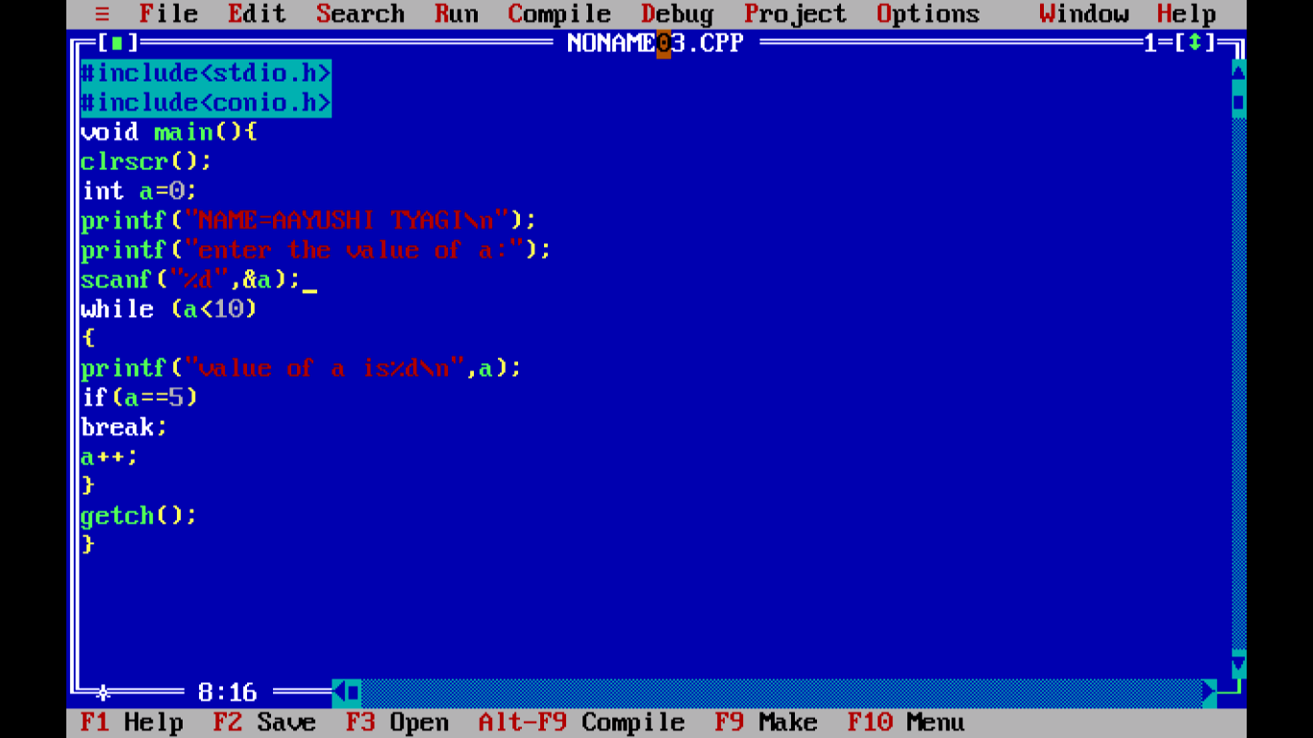

OUTPUT:

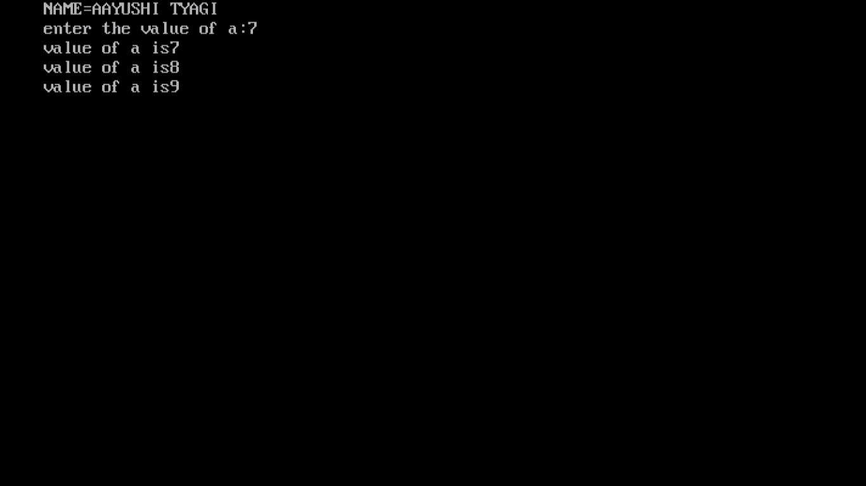

PROGRAM 53:

WRITE A PROGRAM TO DIAMOND PATTERN (TAKING NUMBER OF ROWS FROM THE USER).

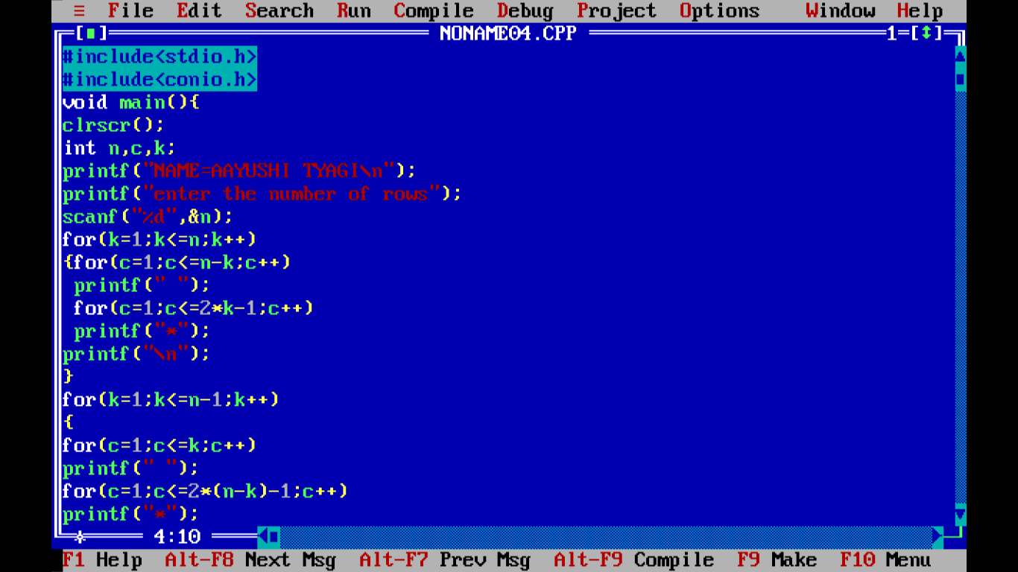

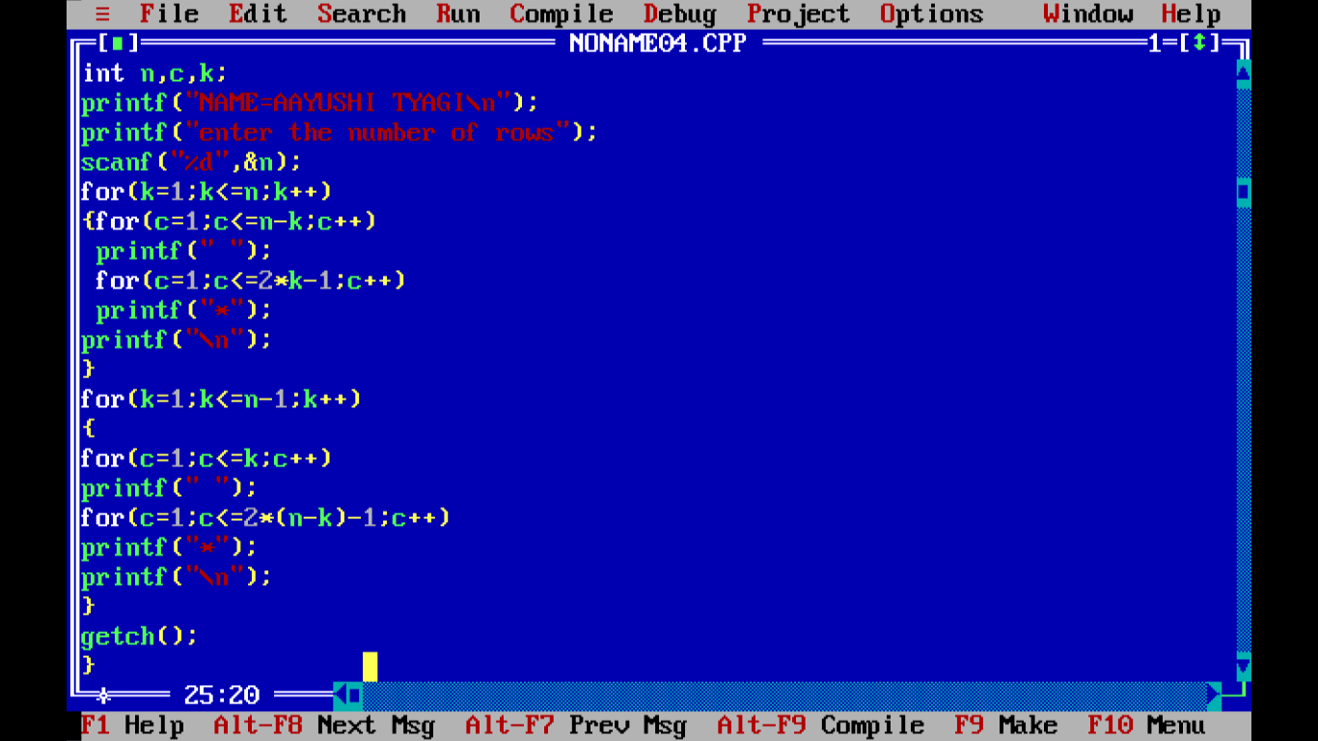

OUTPUT:

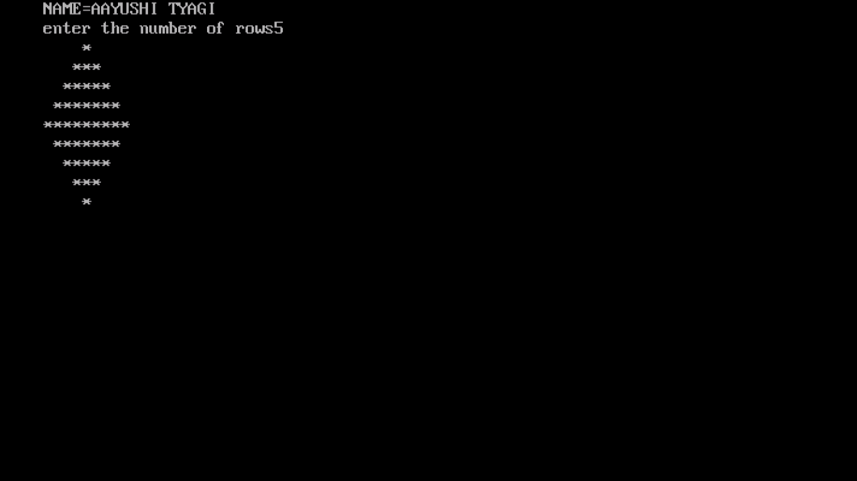

PROGRAM 54:

WRITE A PROGRAM TO PRINT GOOD MORNING, GOOD EVENING, GOOD NIGHT USING FUNCTIONS.

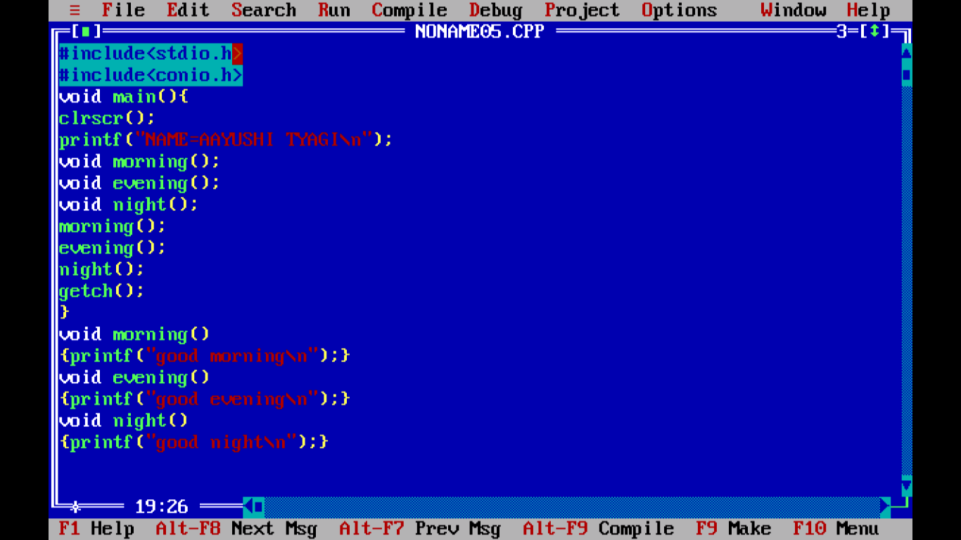

OUTPUT:

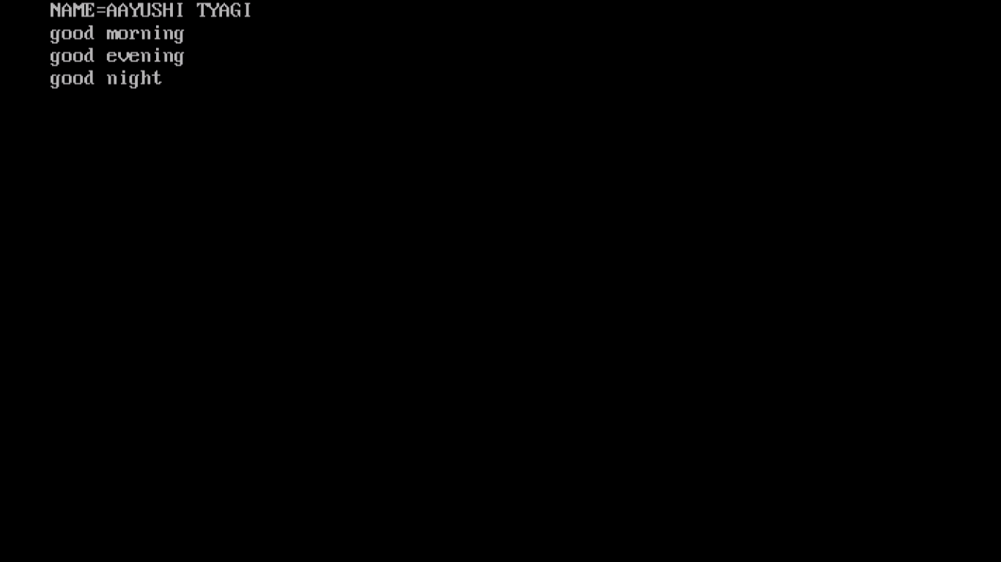

PROGRAM 55:

WRITE A PROGRAM TO FIND QUOTIENT AND REMAINDER.

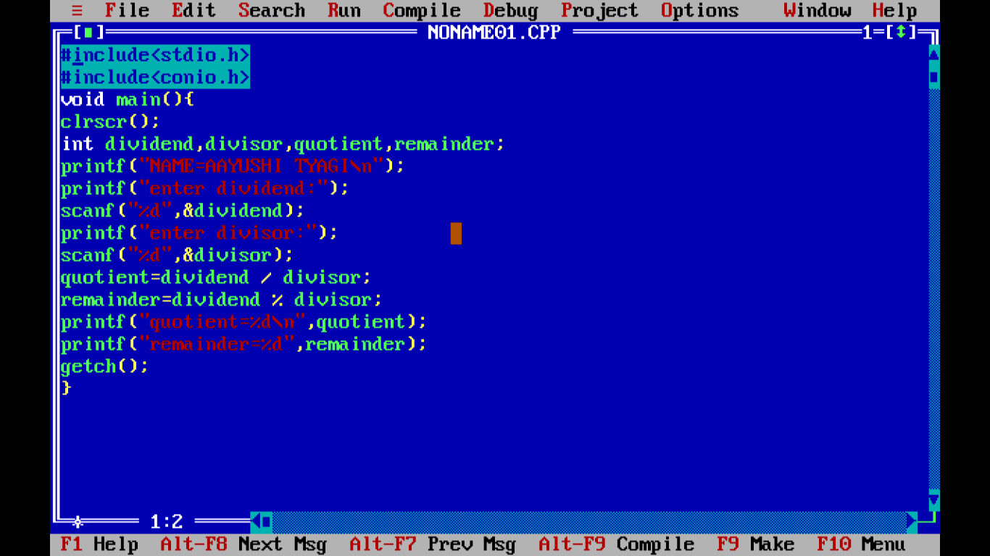

OUTPUT:

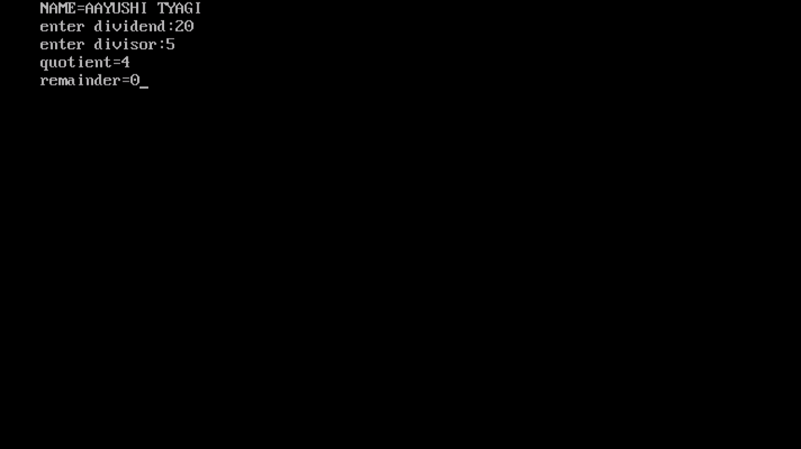

PROGRAM 56:

WRITE A PROGRAM TO CHECK WHETHER THE NUMBER IS GIVEN IS PRIME OR NOT, USING USER DEFINE FUNCTION (WITH ARGUMENT &WITH RETURN TYPE).

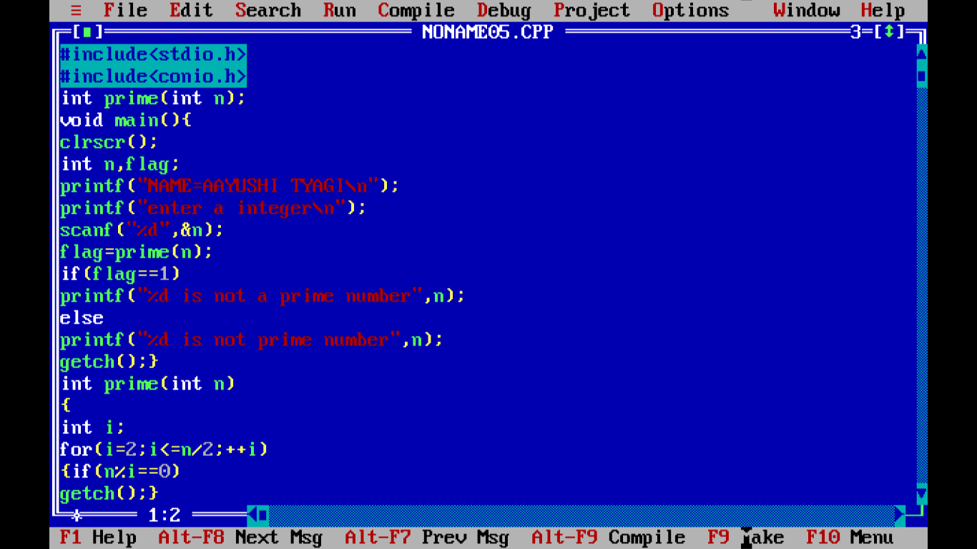

OUTPUT:

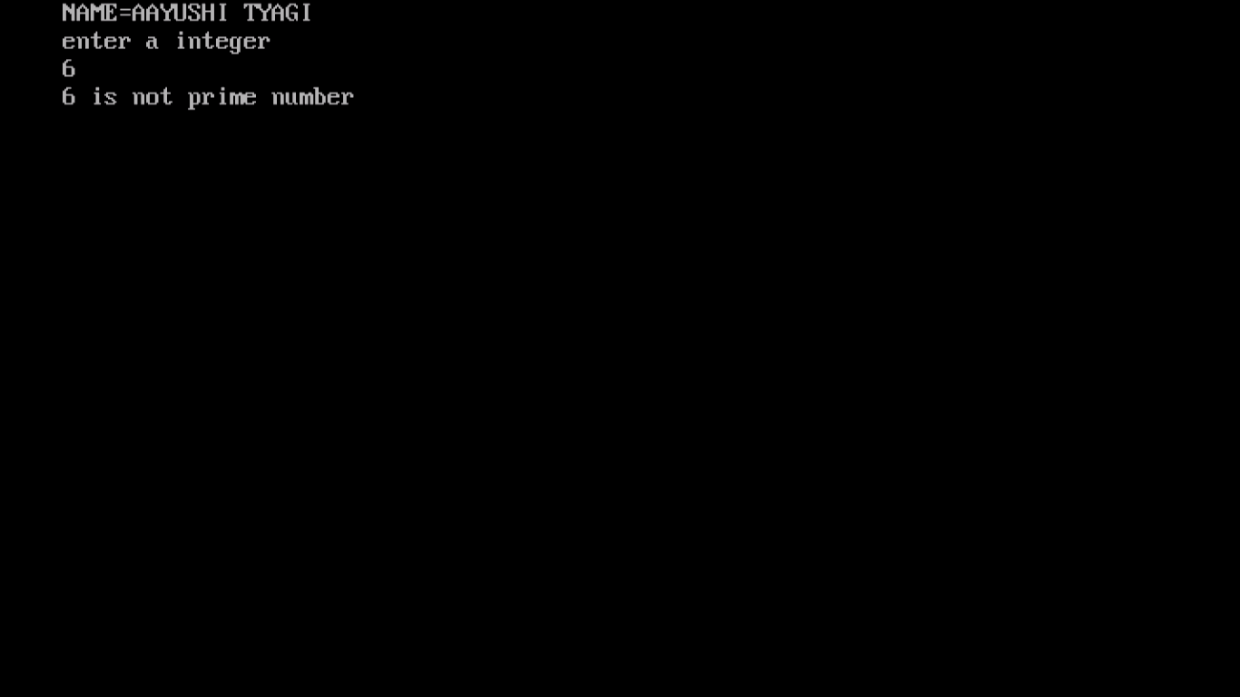

PROGRAM 57:

WRITE A PROGRAM TO CALCULATE THE SQUARE OF NUMBERS FROM 1-5 USING A USER DEFINED FUNCTION. (WITH ARGUMENT & WITHOUT RETURN VALUE).

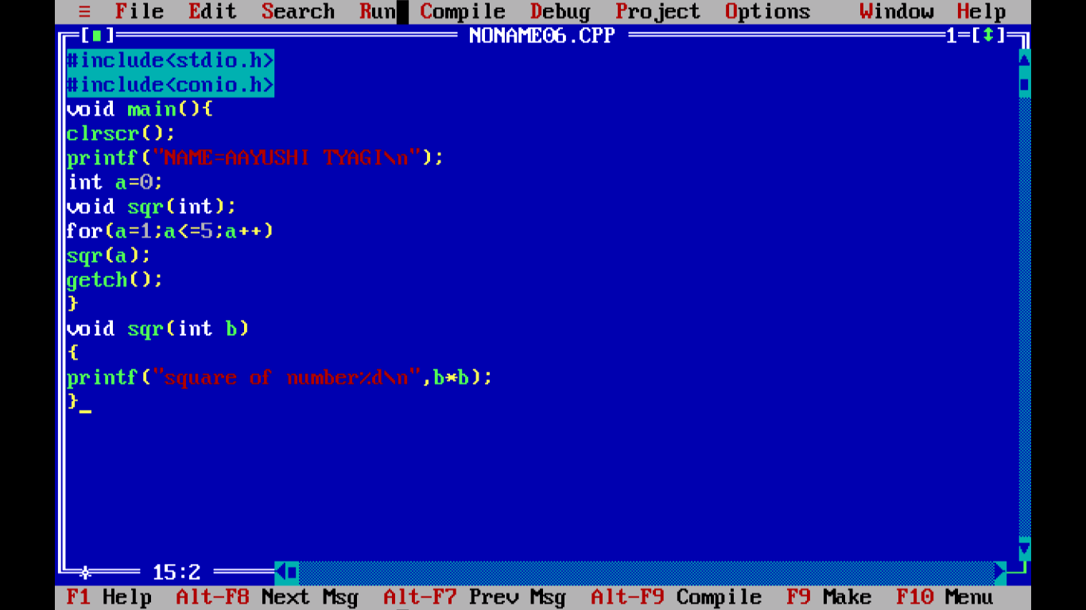

OUTPUT:

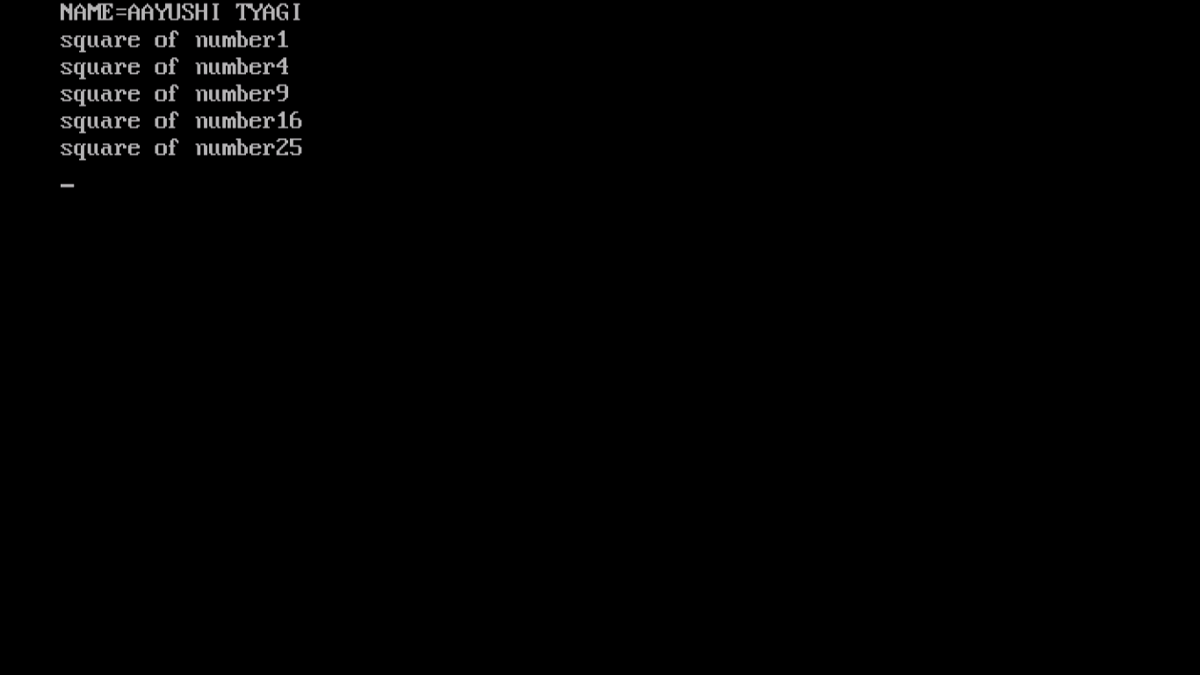

PROGRAM 58:

WRITE A PROGRAM TO CALCULATE THE AVERAGE OF THREE NUMBERS USING FUNCTIONS. (WITH ARGUMENT & WITH RETURN VALUE).

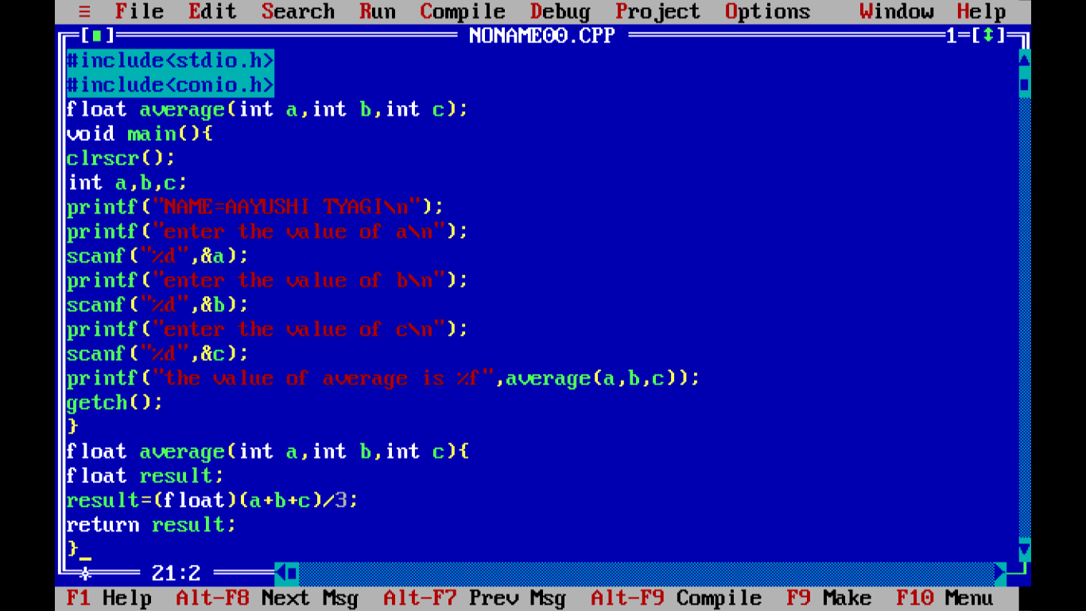

OUTPUT:

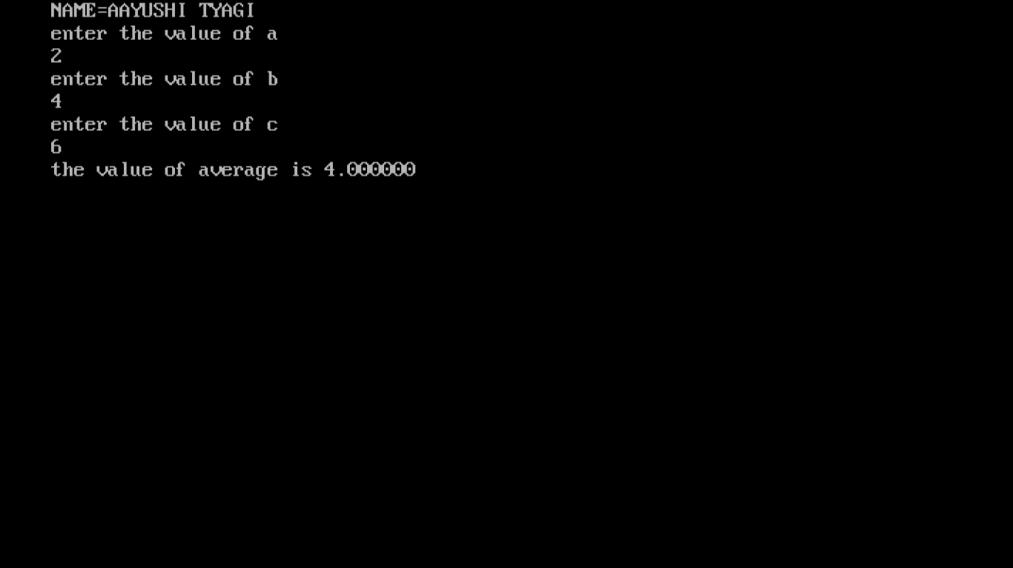

PROGRAM 59:

WRITE A PROGRAM TO DESCRIBE THE CALL BY REFERENCE CONCEPT IN FUNCTIONS BY SWAPPING TWO VARIABLES WITH THE HELP OF THIRD.

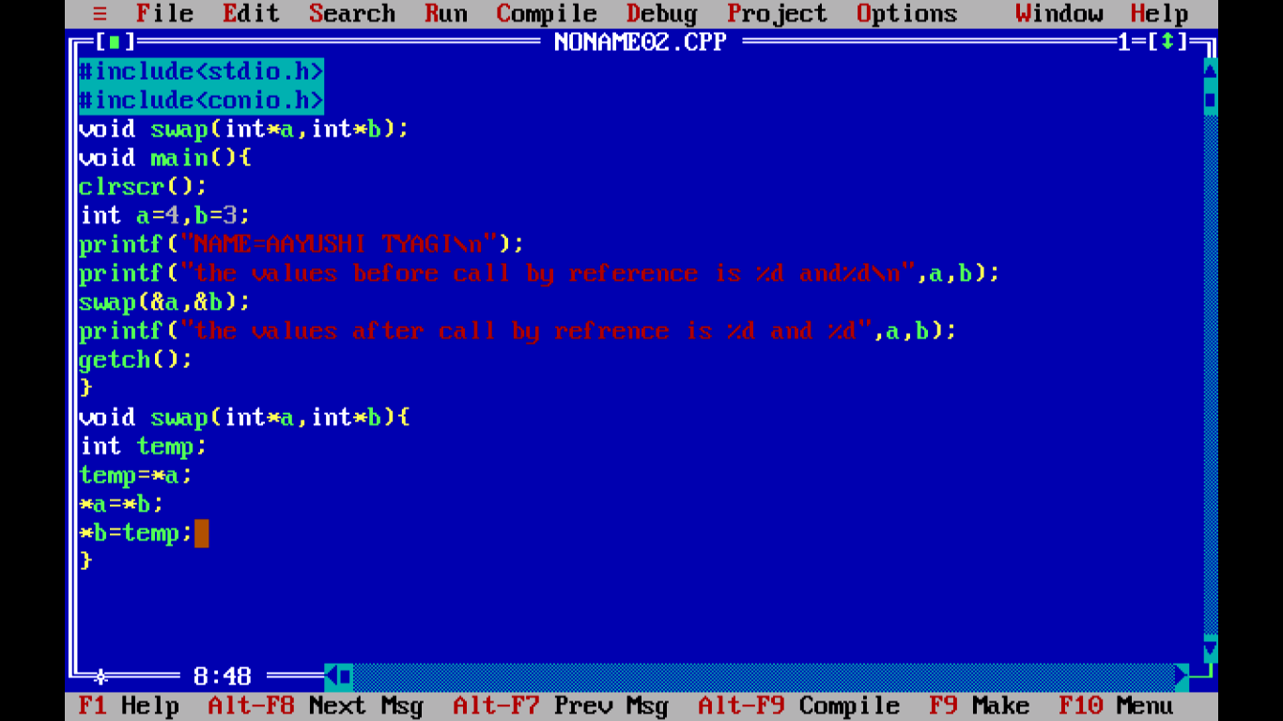

OUTPUT:

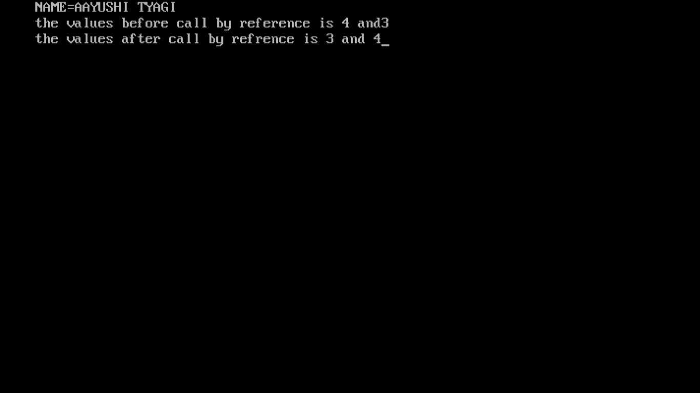

PROGRAM 60:

WRITE A PROGRAM TO SKIP A NUMBER IN SERIES USING CONTINUE.

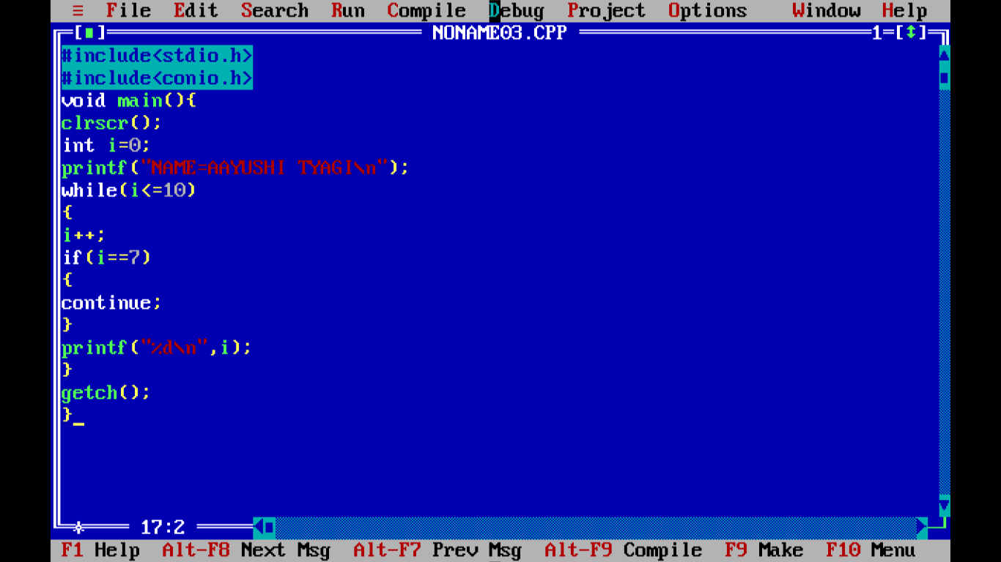

OUTPUT:

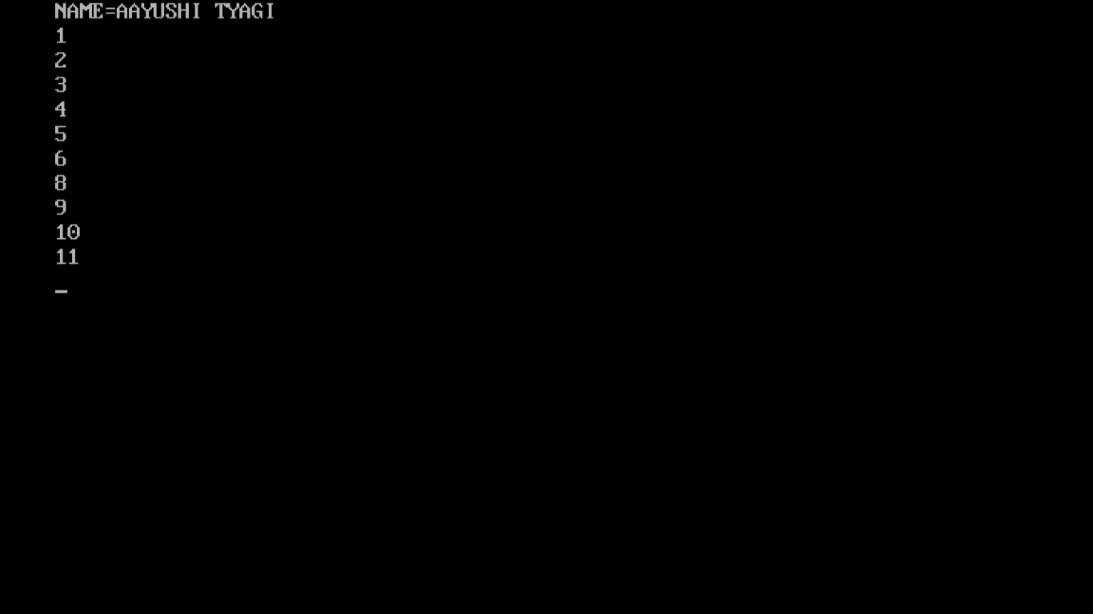

PROGRAM 61:

WRITE A PROGRAM TO DISPLAY THE FOLLOWING PATTERN N ROWS AND ROWS TAKING THE VALUE OF N FROM THE USER.

/*1

2 3

4 5 6

7 8 9 10

11 12 13 14 15*/

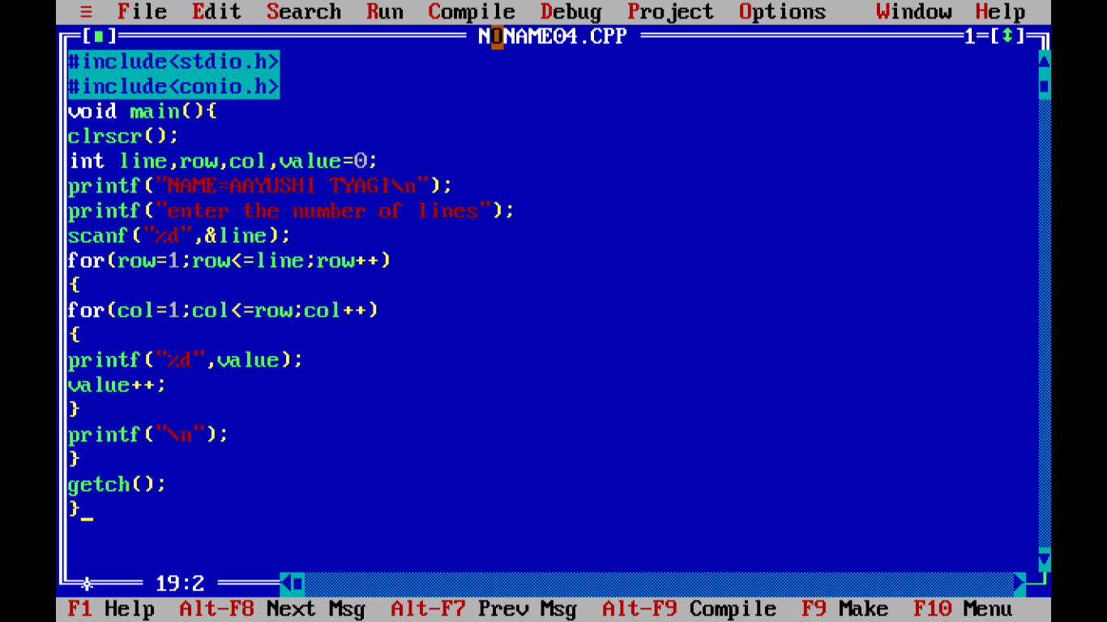

OUTPUT:

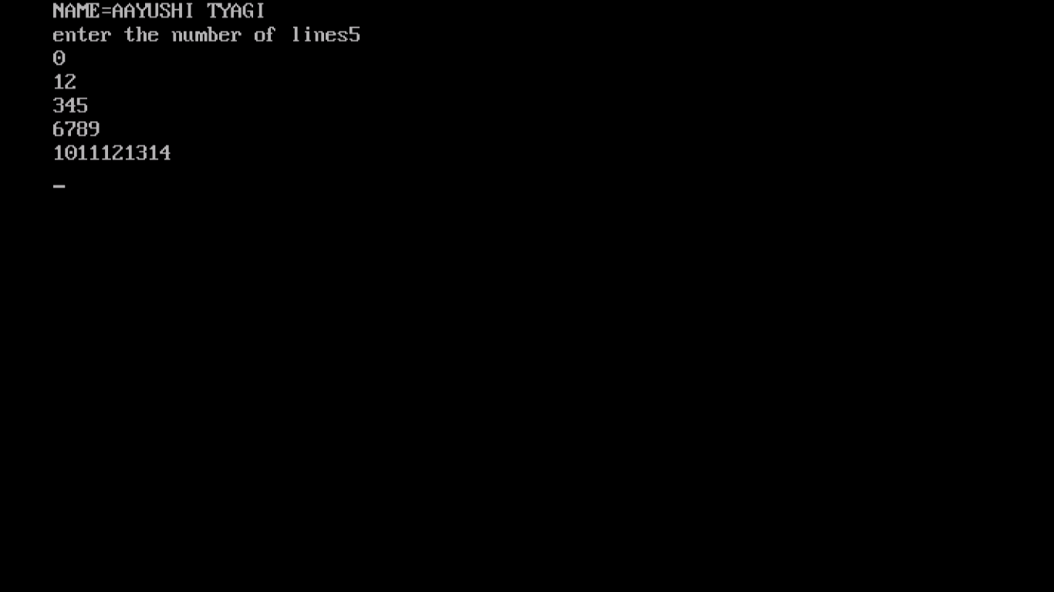

PROGRAM 62:

WRITE A PROGRAM TO EXCHANGE THE VALUE OF TWO VARIABLE BY CALL BY REFERENCE OF THE FUNCTION.

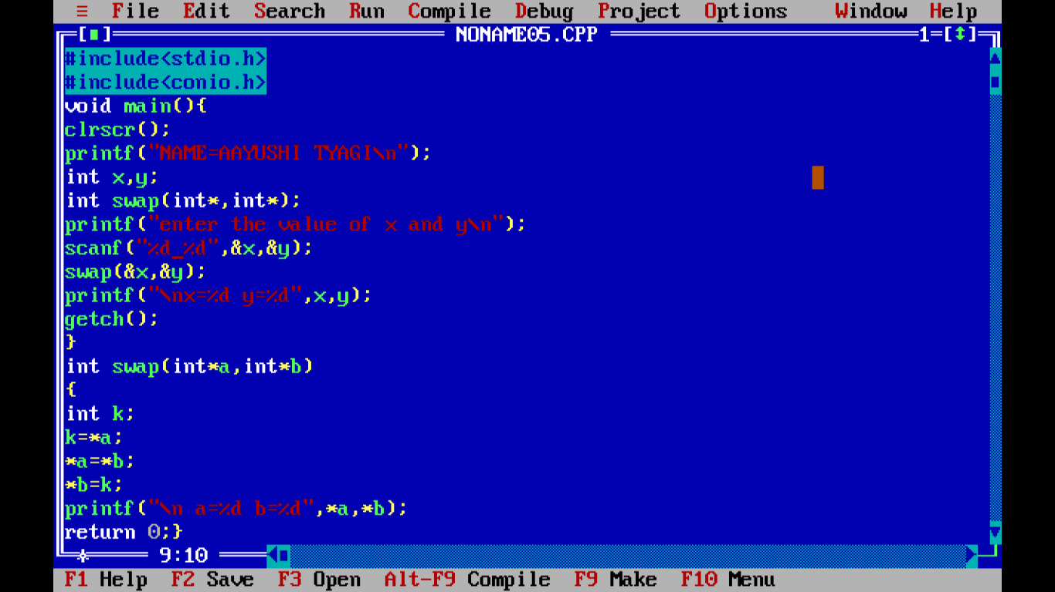

OUTPUT:

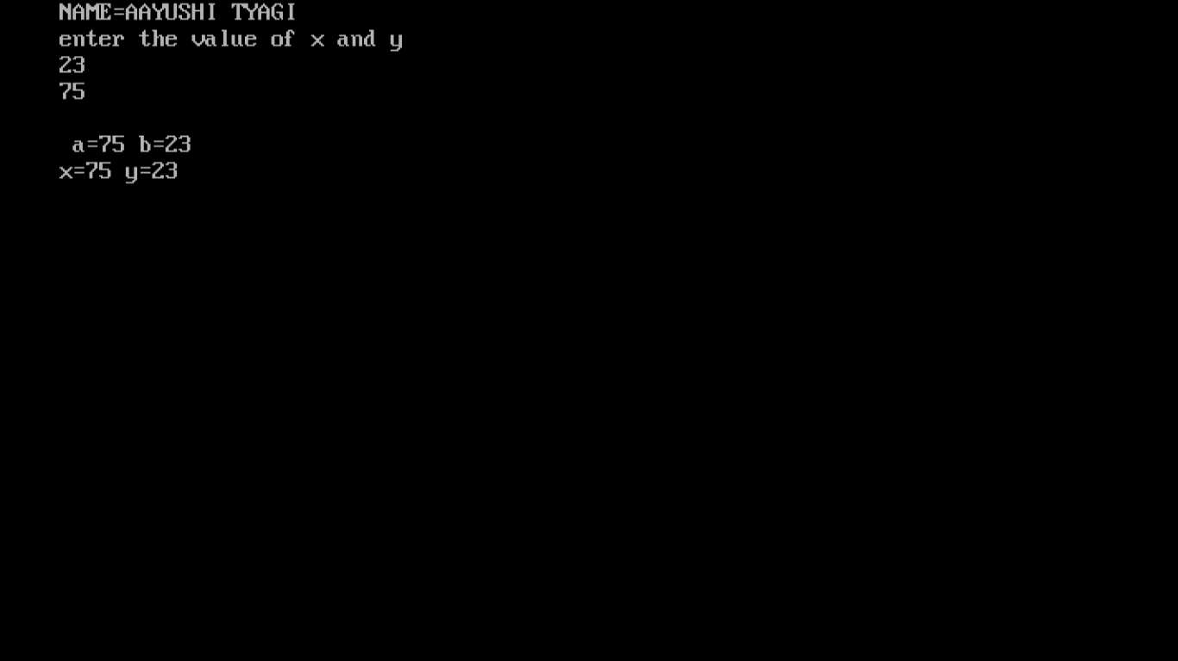

PROGRAM 63:

WRITE A PROGRAM TO INITIALIZE ARRAY AND PRINT ADDRESS INDEX VALUE.

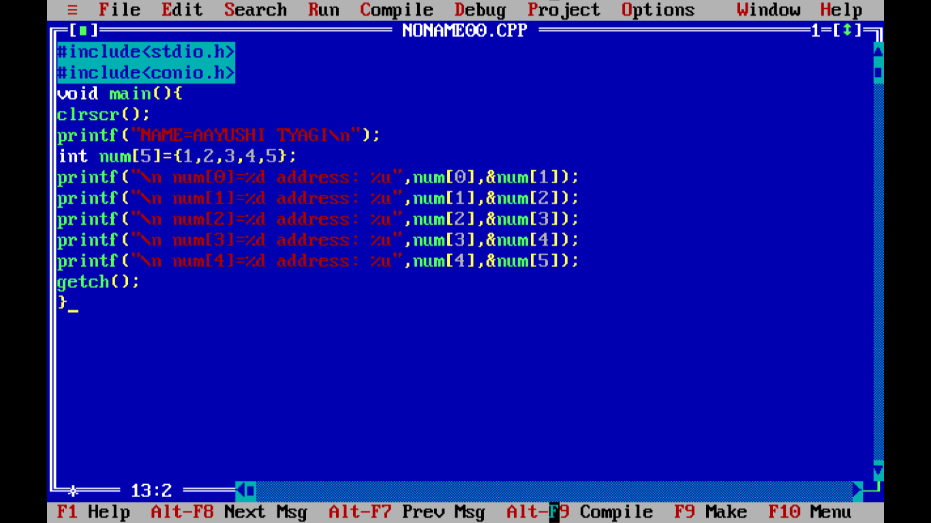

Output:

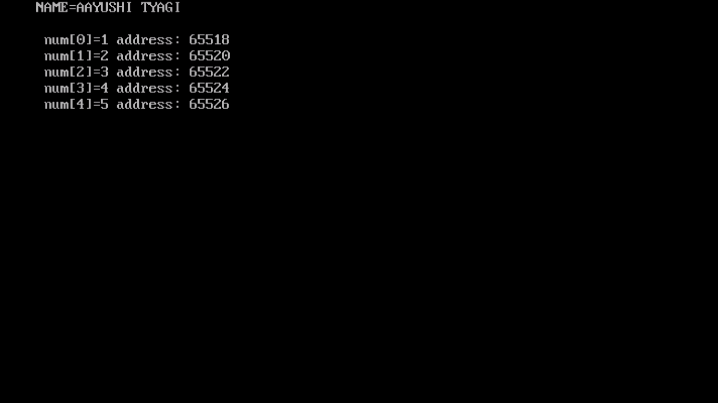

PROGRAM 64:

WRITE A PROGRAM TO PRINT SIZE OF ARRAY.

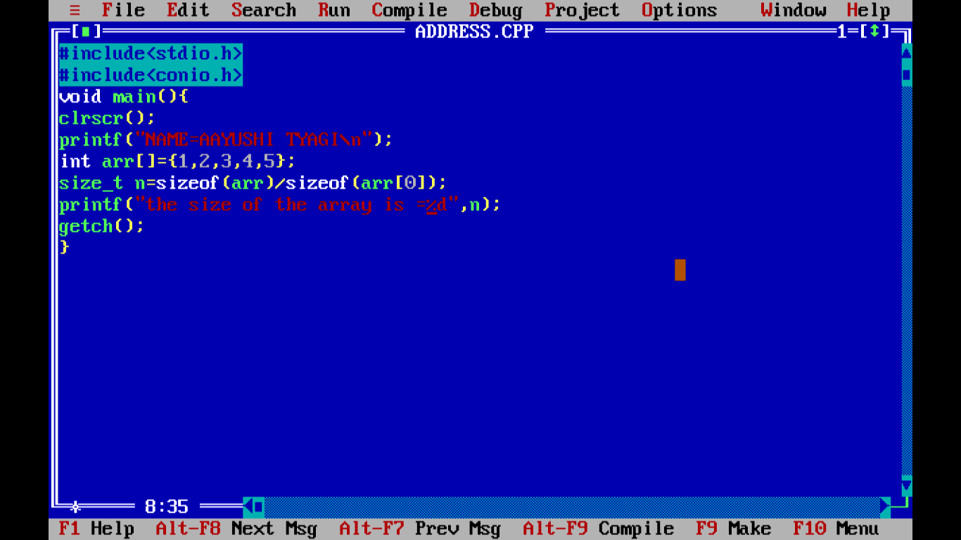

OUTPUT:

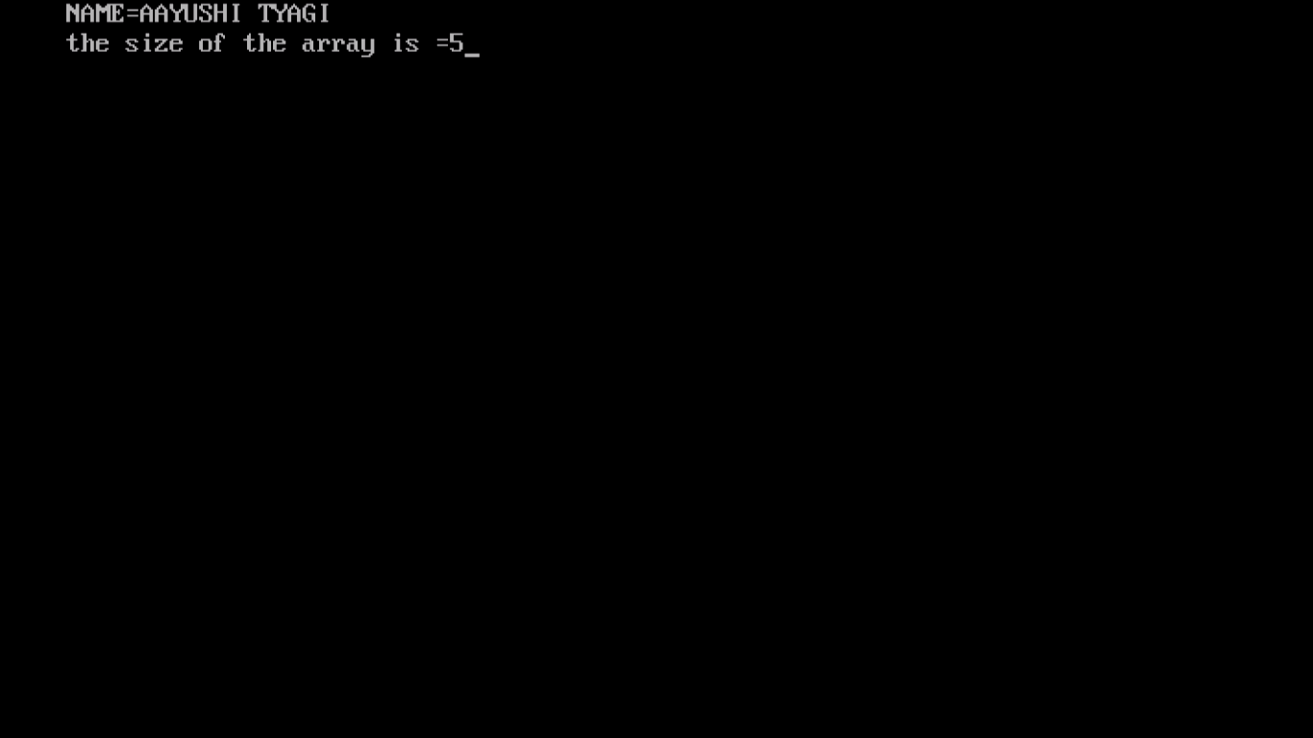

PROGRAM 65:

WRITE A PROGRAM TO BY TAKING USER INPUT FOR ARRAY INDEX LOOPS ELEMENT LOOP.

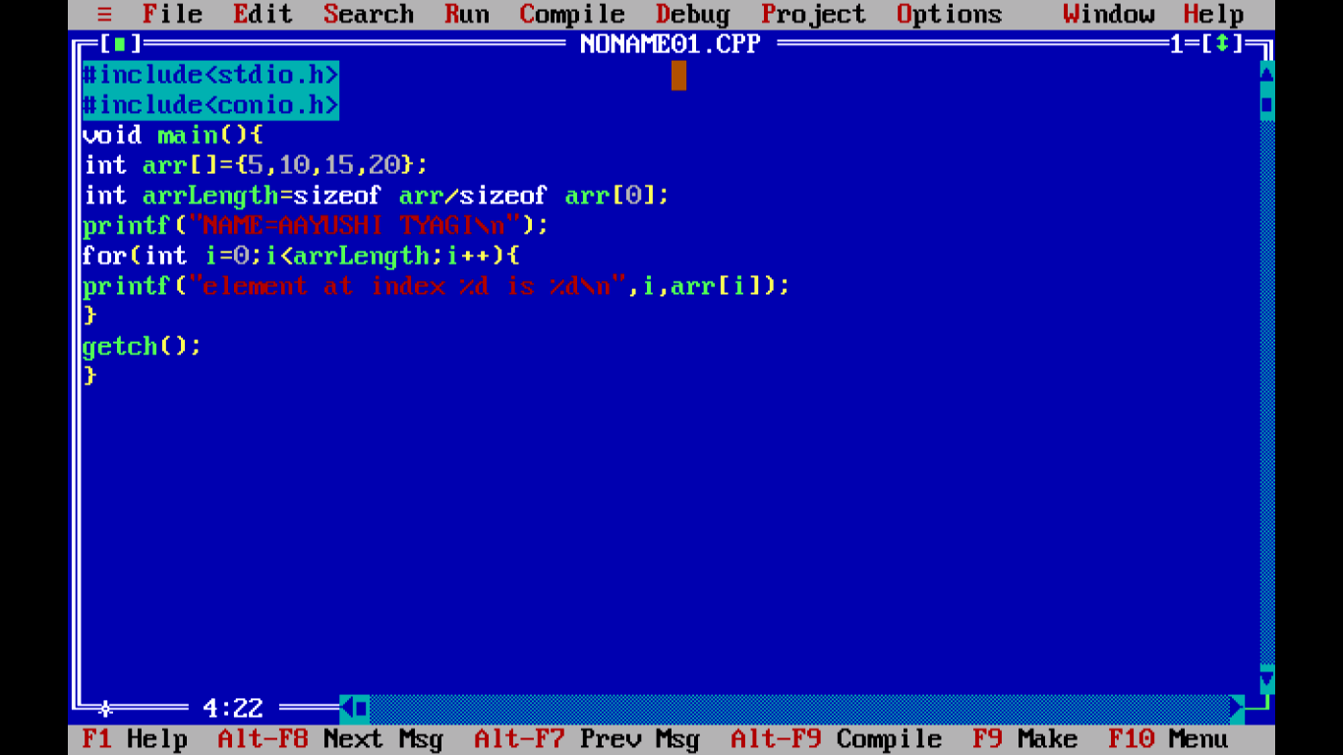

Output:

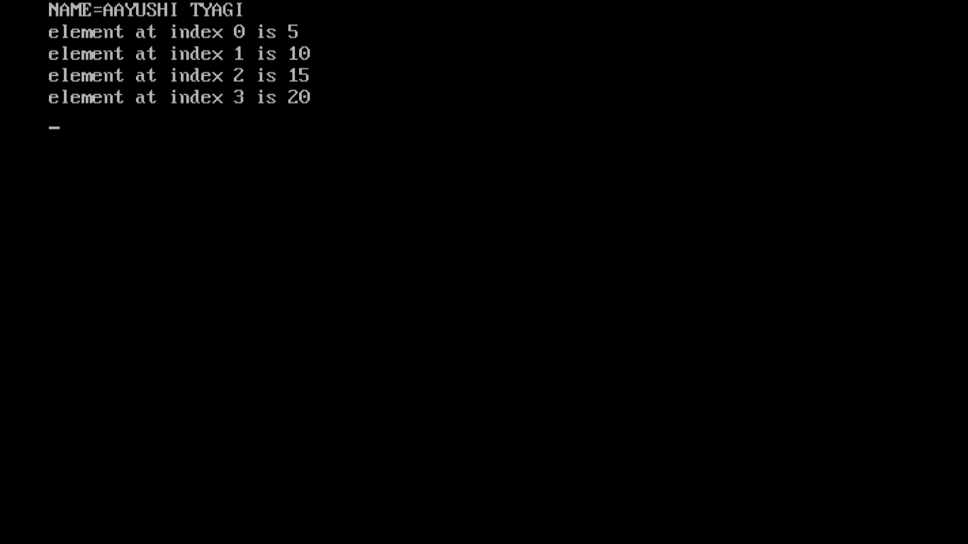

PROGRAM 66:

WRITE A PROGRAM TO ADD EVEN AND ODD NUMBERS FROM ONE TO TEN STORE THEM AND DISPLAY THEM IN 2 SEPARATE ERASE INPUT NUMBER FROM THE USER.

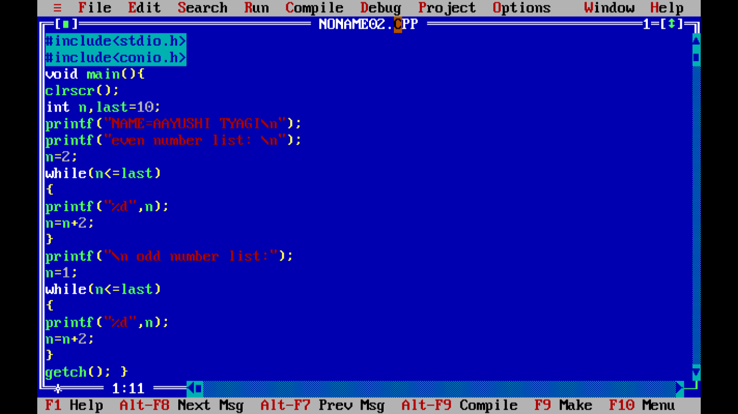

Output:

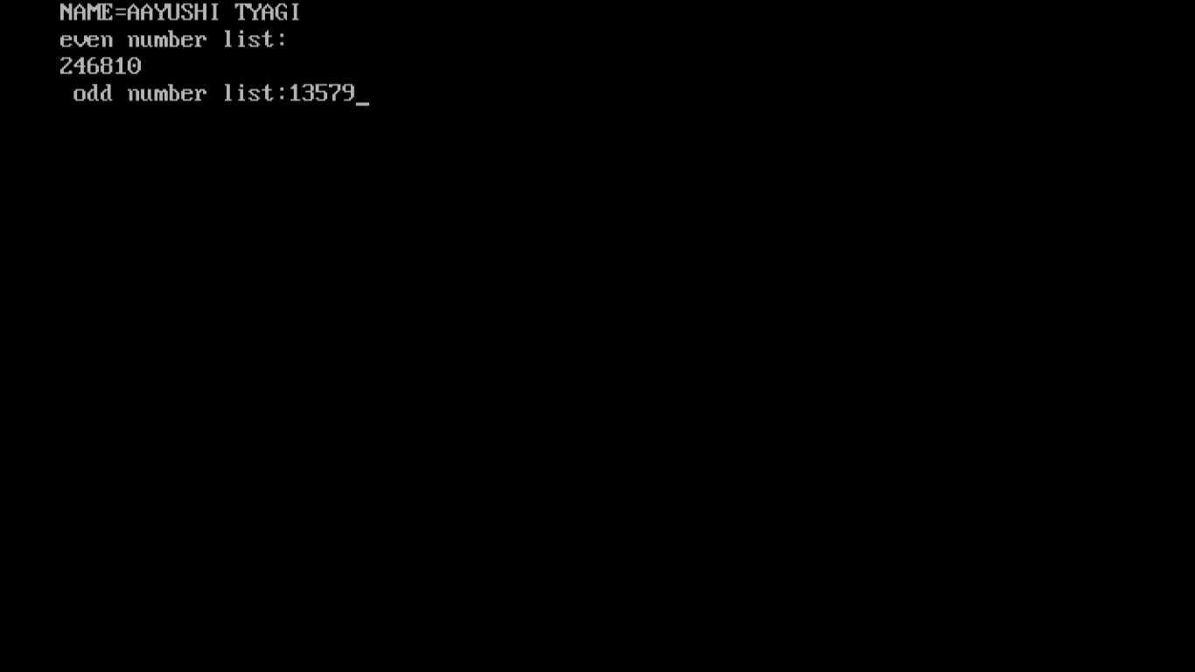

PROGRAM 67:

WRITE A PROGRAM USING POINTER.

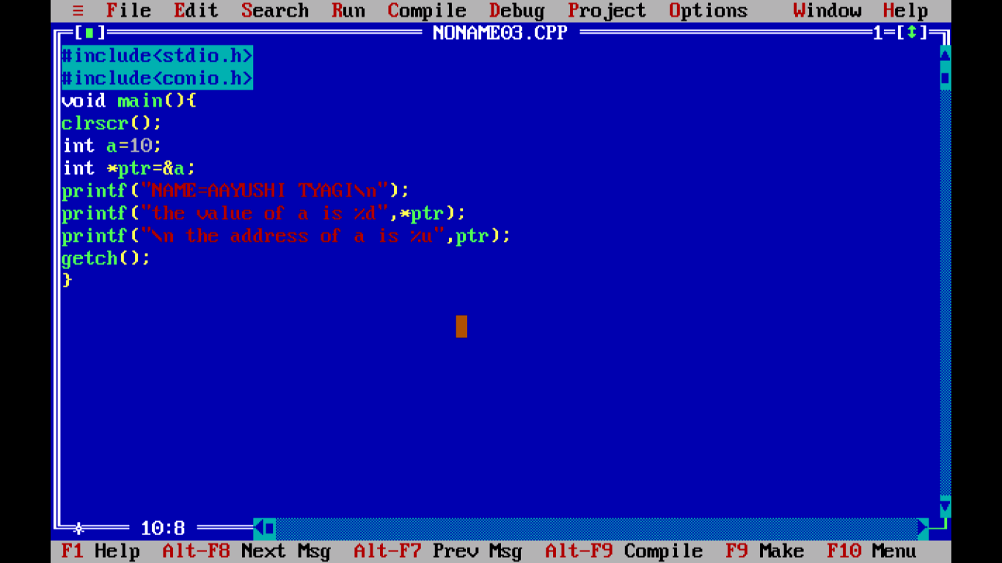

Output: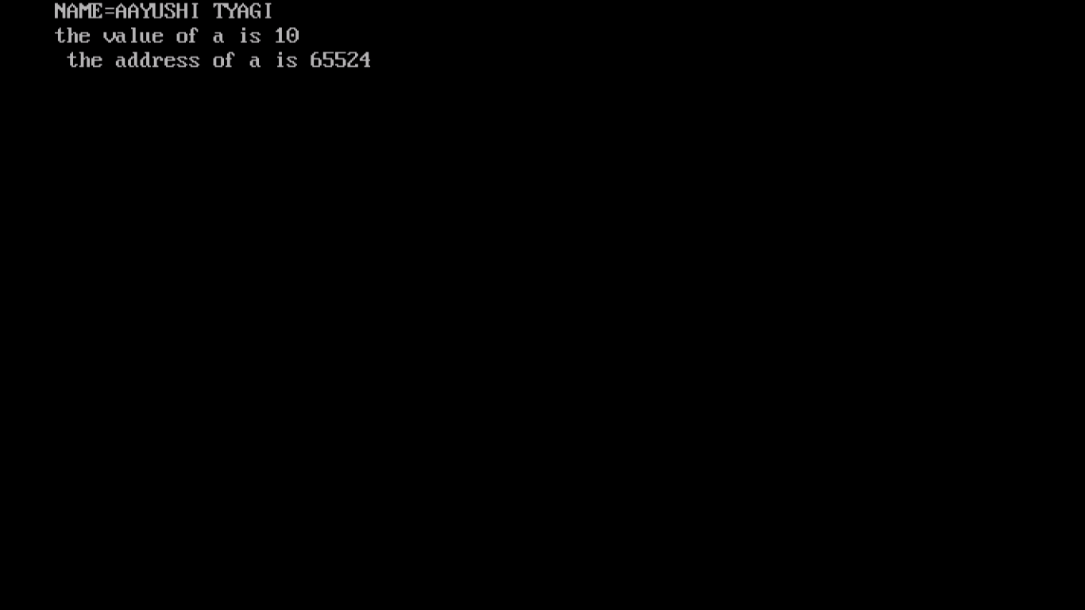

PROGRAM 68:

WRITE A PROGRAM OF POINTER TO A POINTER.

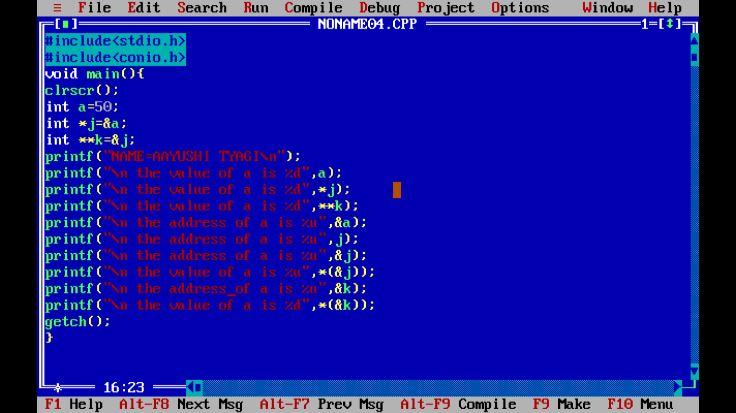

OUTPUT:

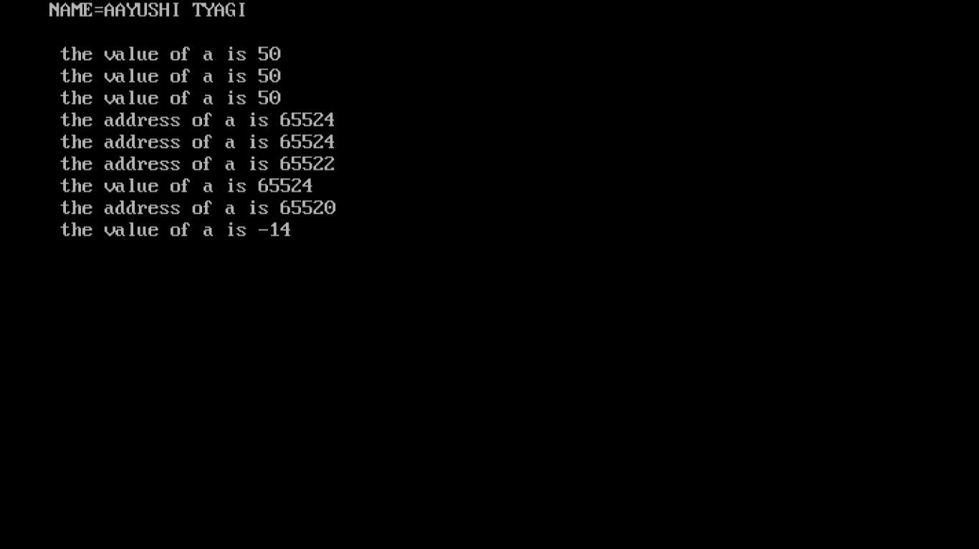

PROGRAM 69:

WRITE A PROGRAM OF NULL POINTER.

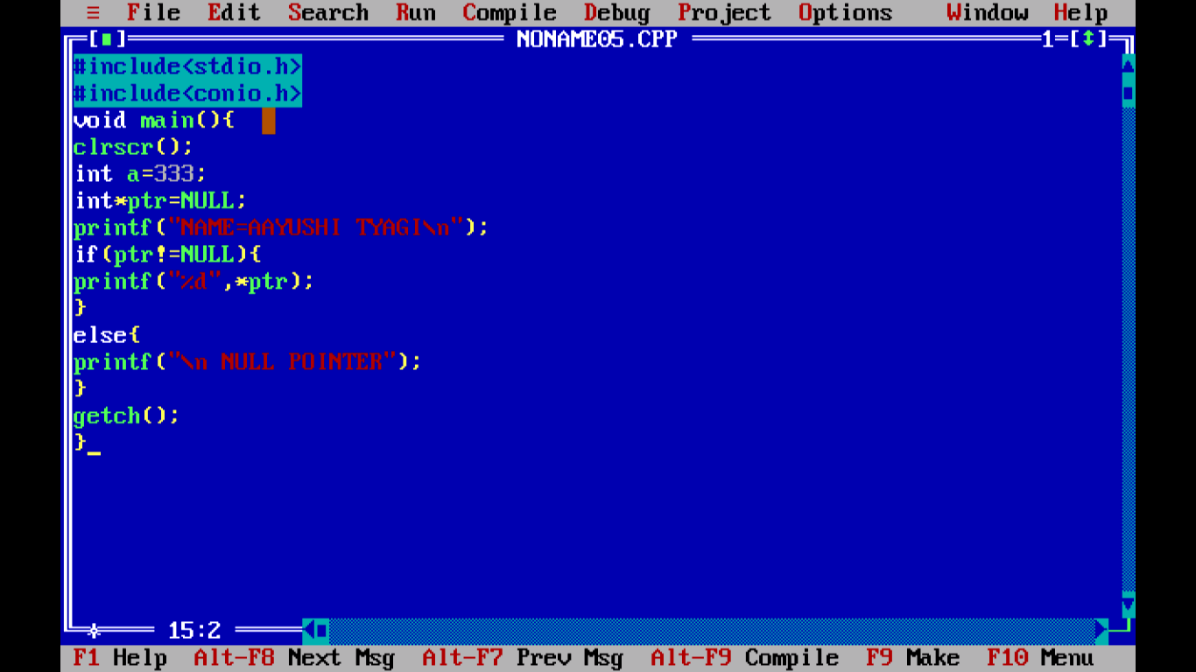

OUTPUT:

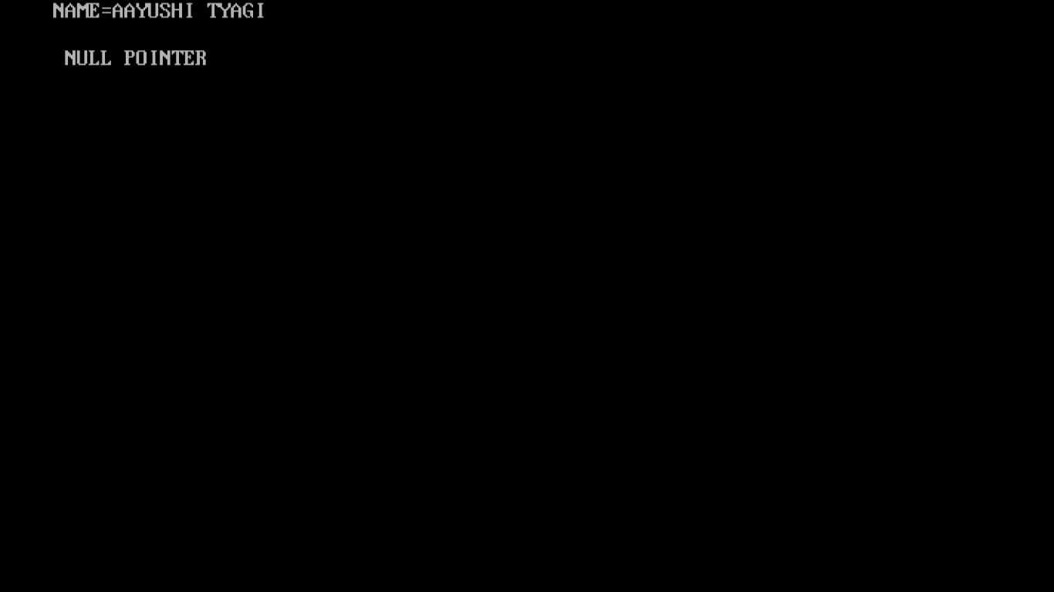

PROGRAM 70:

WRITE A PROGRAM TO SHOW VOID POINTER.

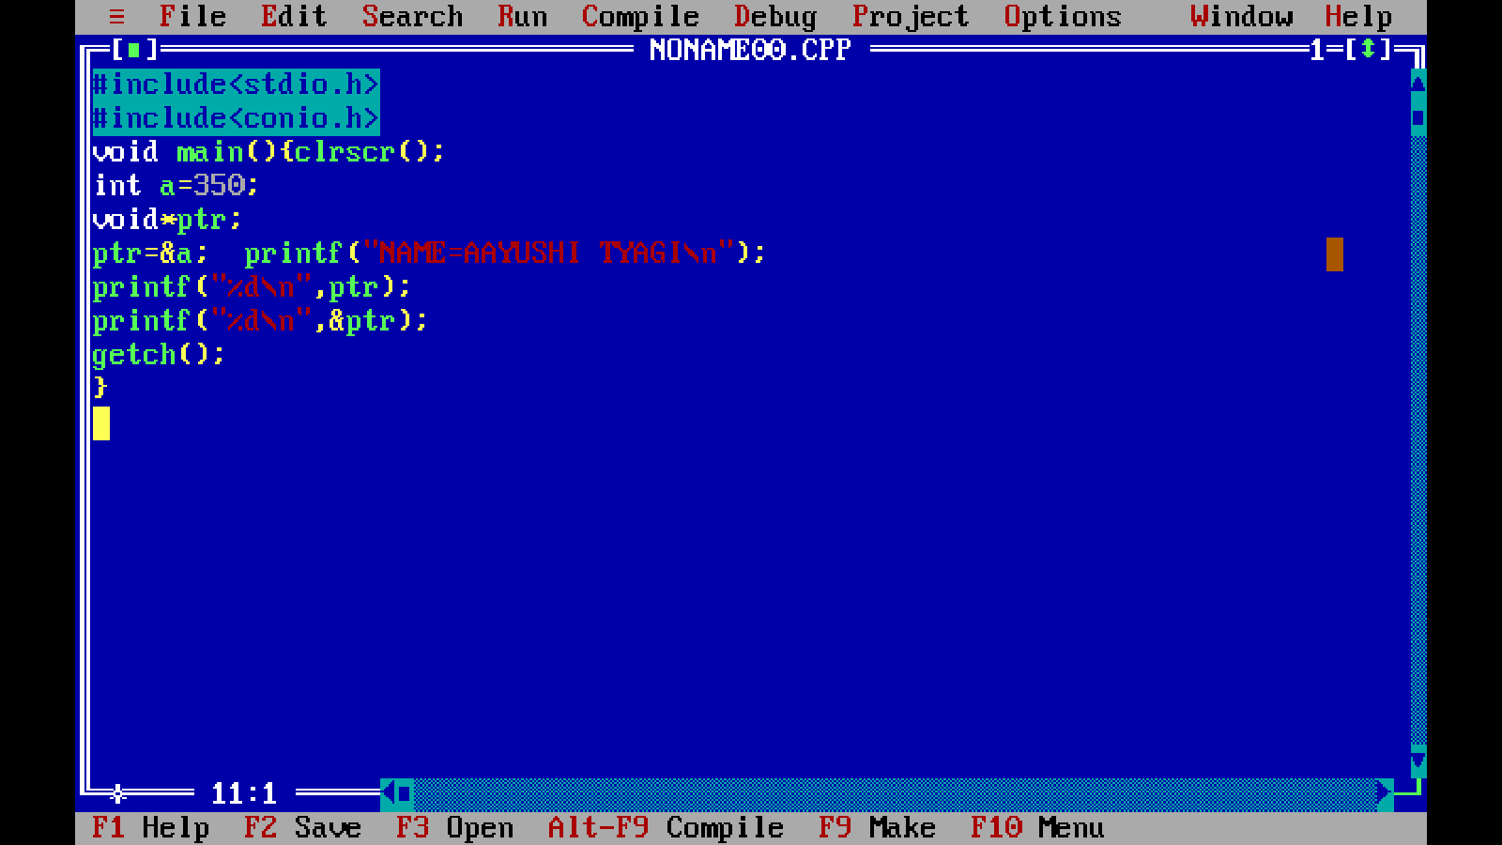

OUTPUT:

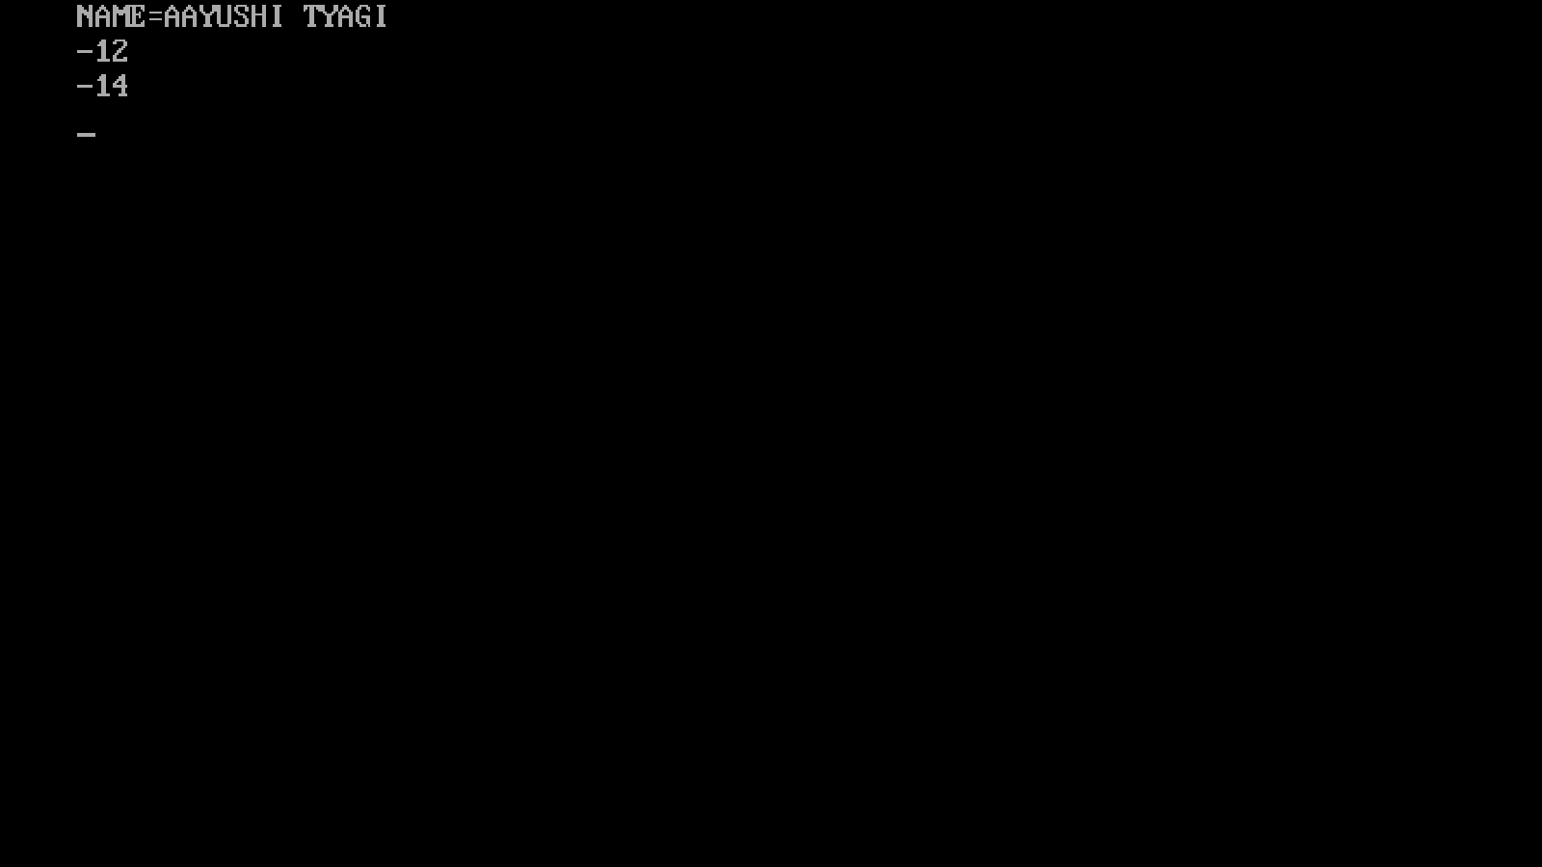

PROGRAM 71:

WRITE A PROGRAM OF MALLOC.

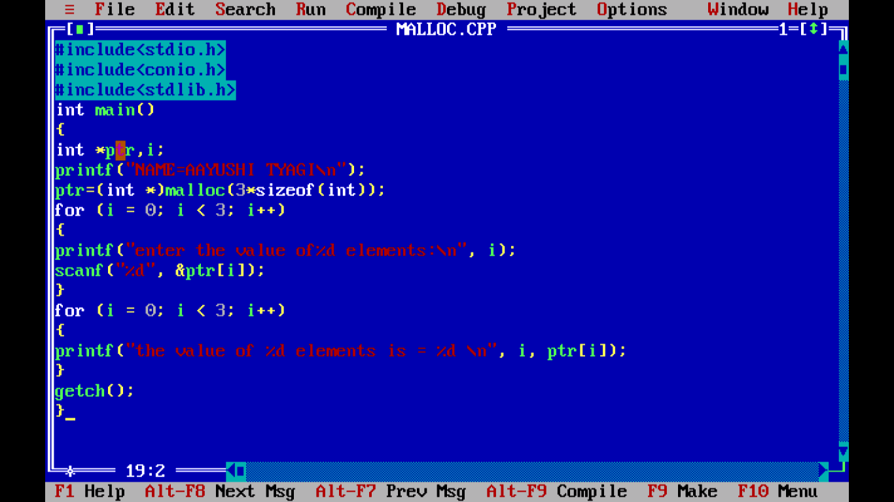

OUTPUT:

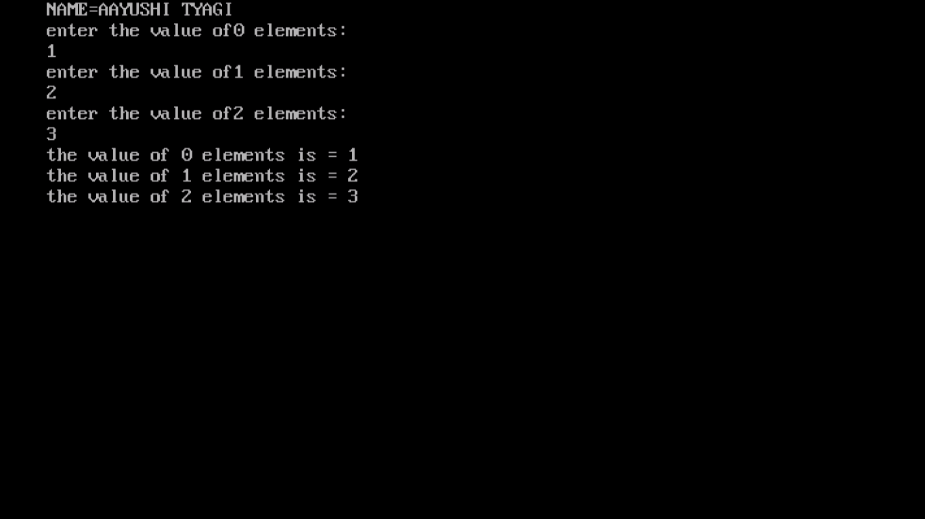

PROGRAM 72:

WRITE OF CALLOC:

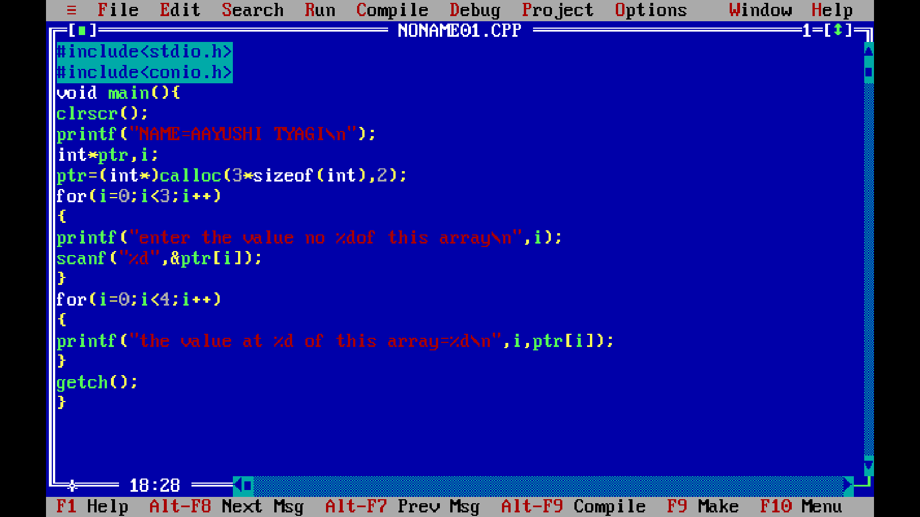

q

PROGRAM 73:

WRITE A PROGRAM TO INPUT MARKS OF 50 STUDENTS USING AN ARRAY AND DISPLAY THE AVERAGE MARKS OF THE CLASS:

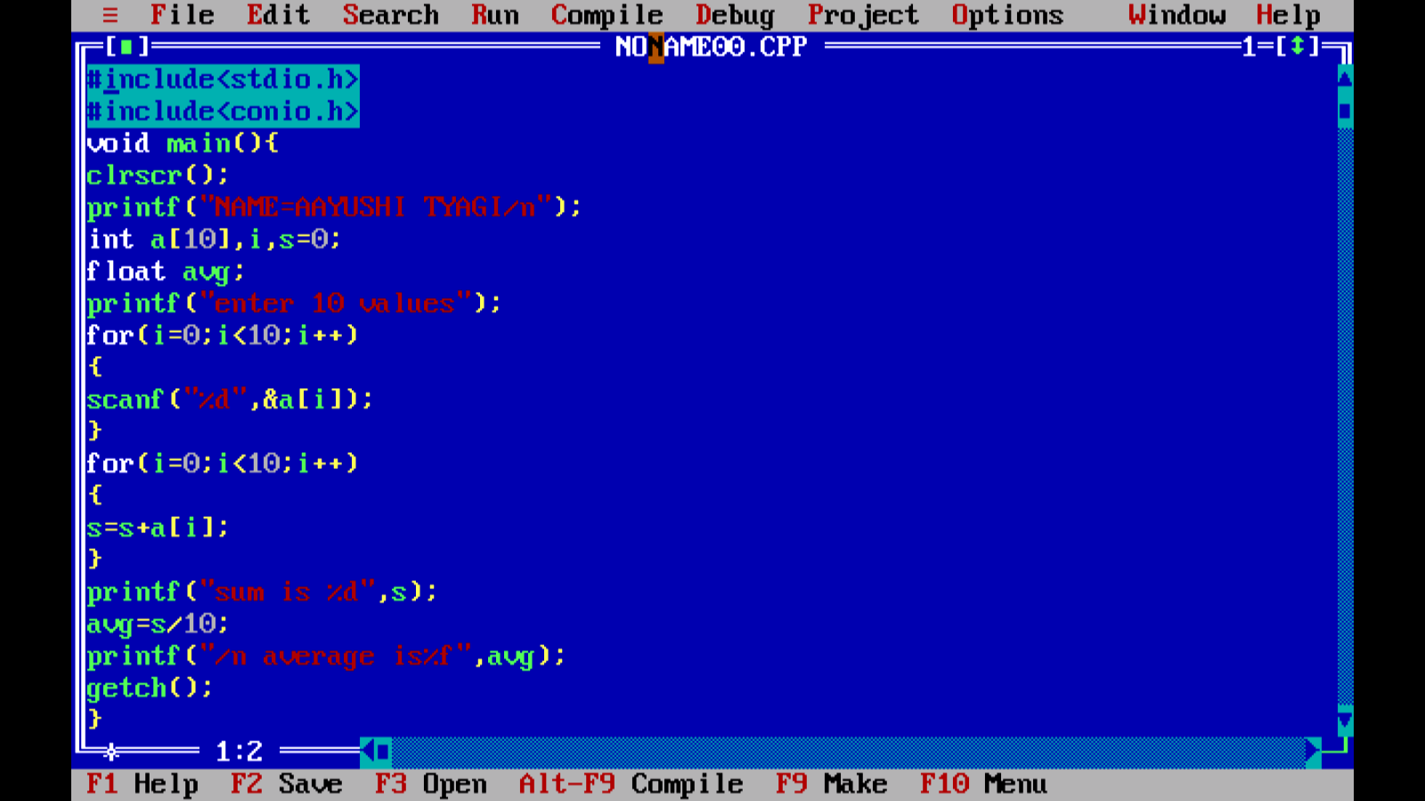

OUTPUT:

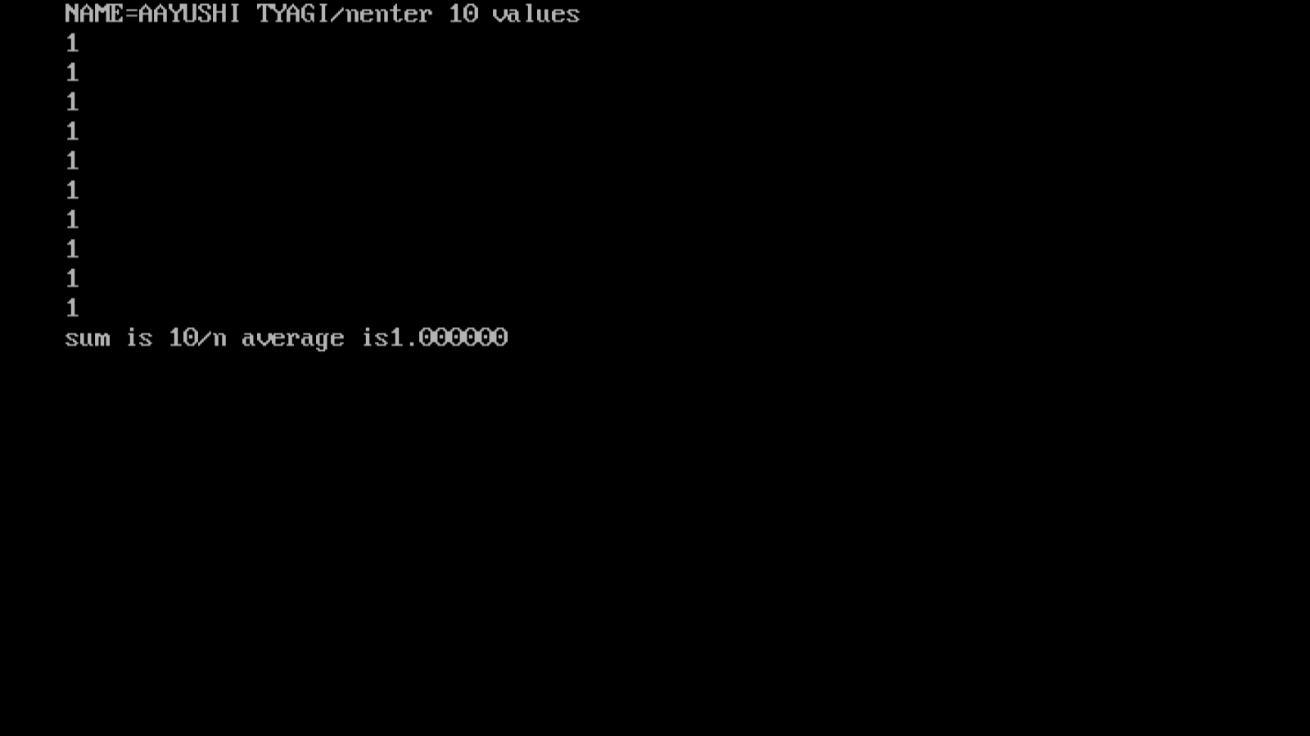

PROGRAM 74:

WRITE A PROGRAM TO SEARCH FOR A NUMBER ENTERED BY THE USER IN A GIVEN ARRAY AND DISPLAY THE ARRAY IN ASCENDING ORDER:

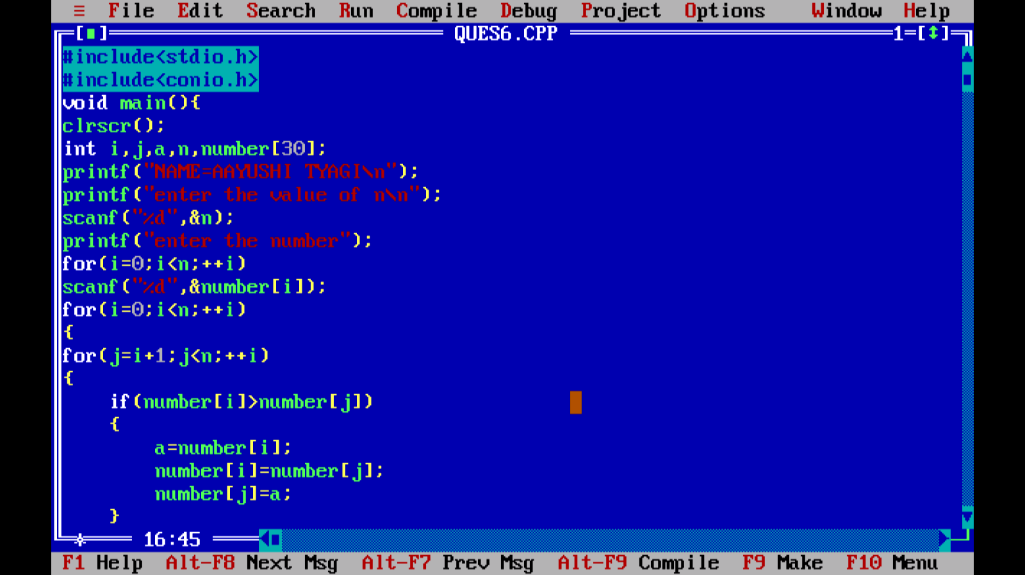

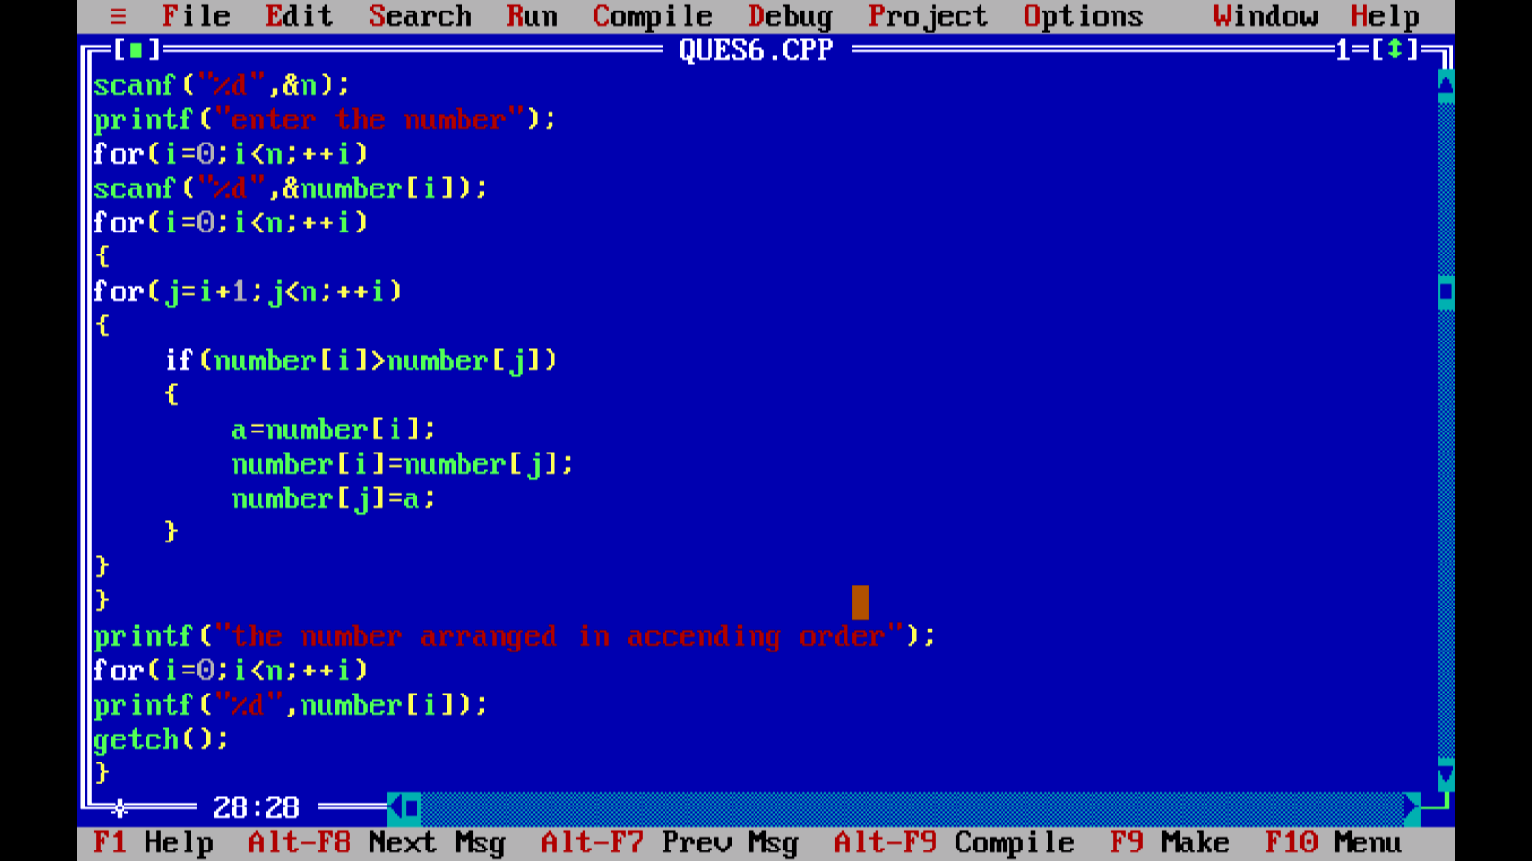

OUTPUT:

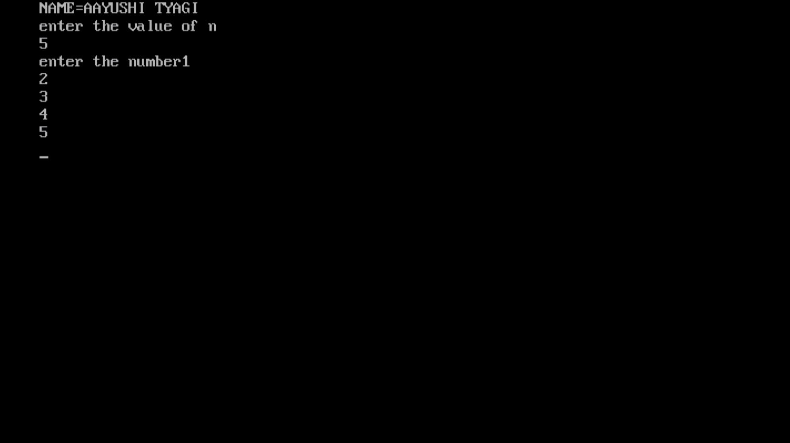

PROGRAM 75:

WRITE A PROGRAM TO CHECK IF A STRING IS PALINDROME OR NOT:

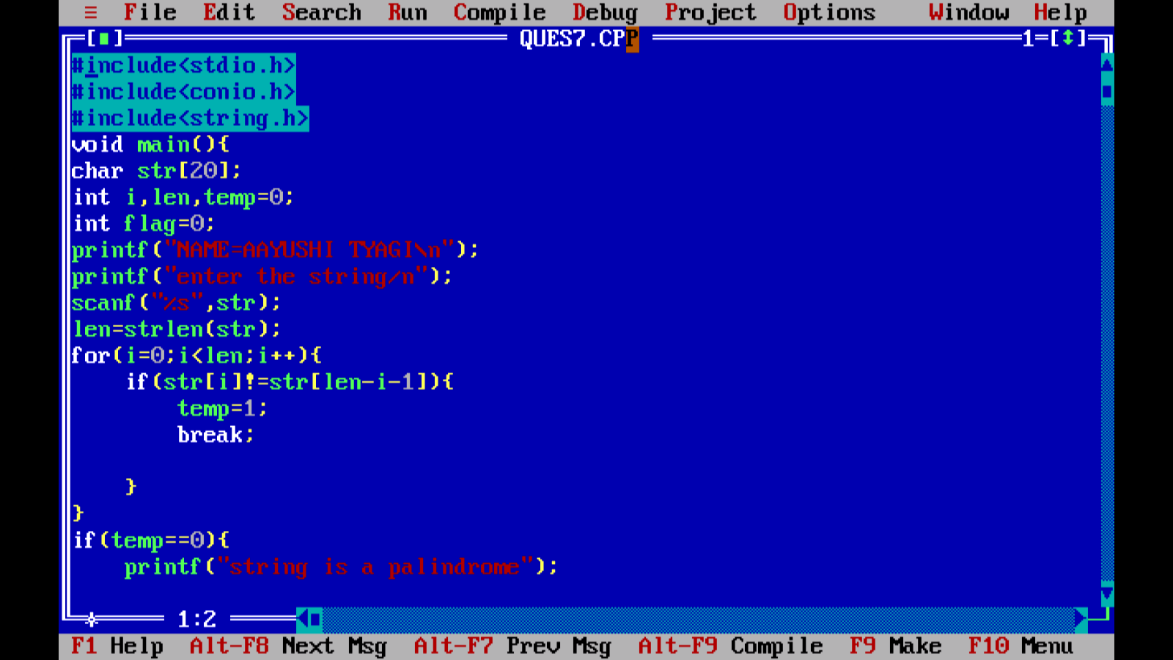

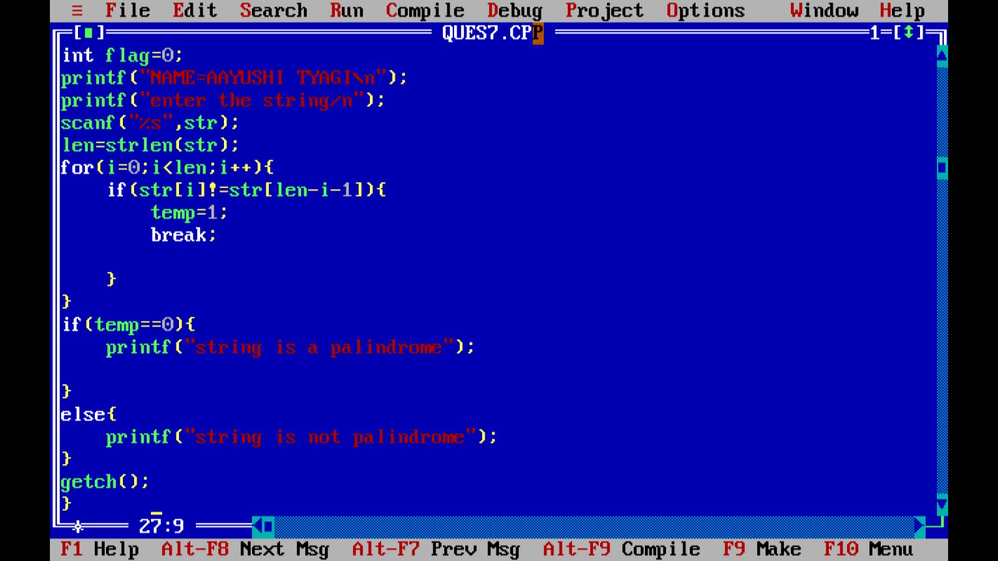

OUTPUT:

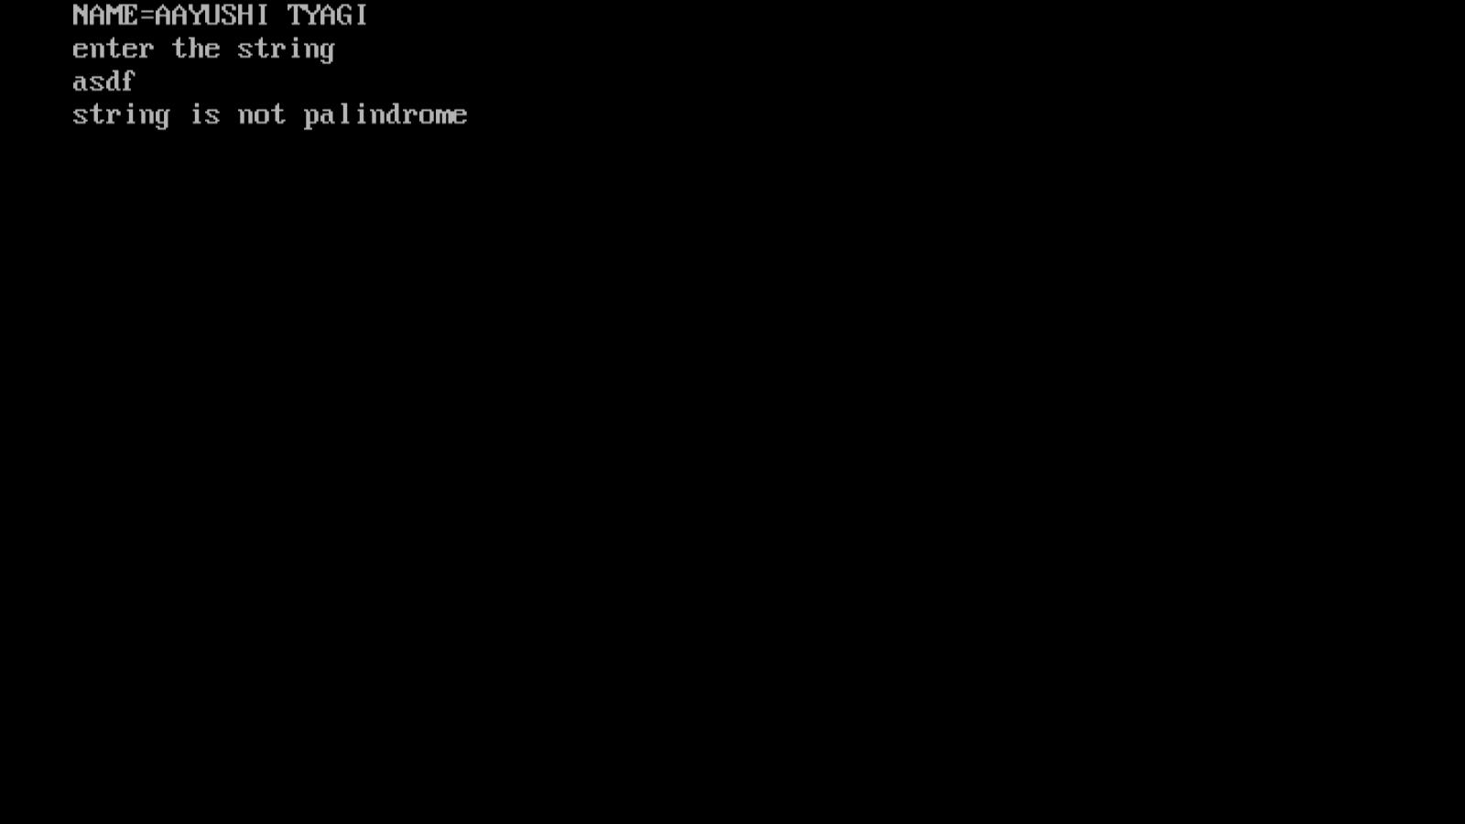

PROGRAM 76:

WRITE A PROGRAM TO ADD,MULTIPLY,AND DIVIDE TWO NUMBERS USING POINTERS:

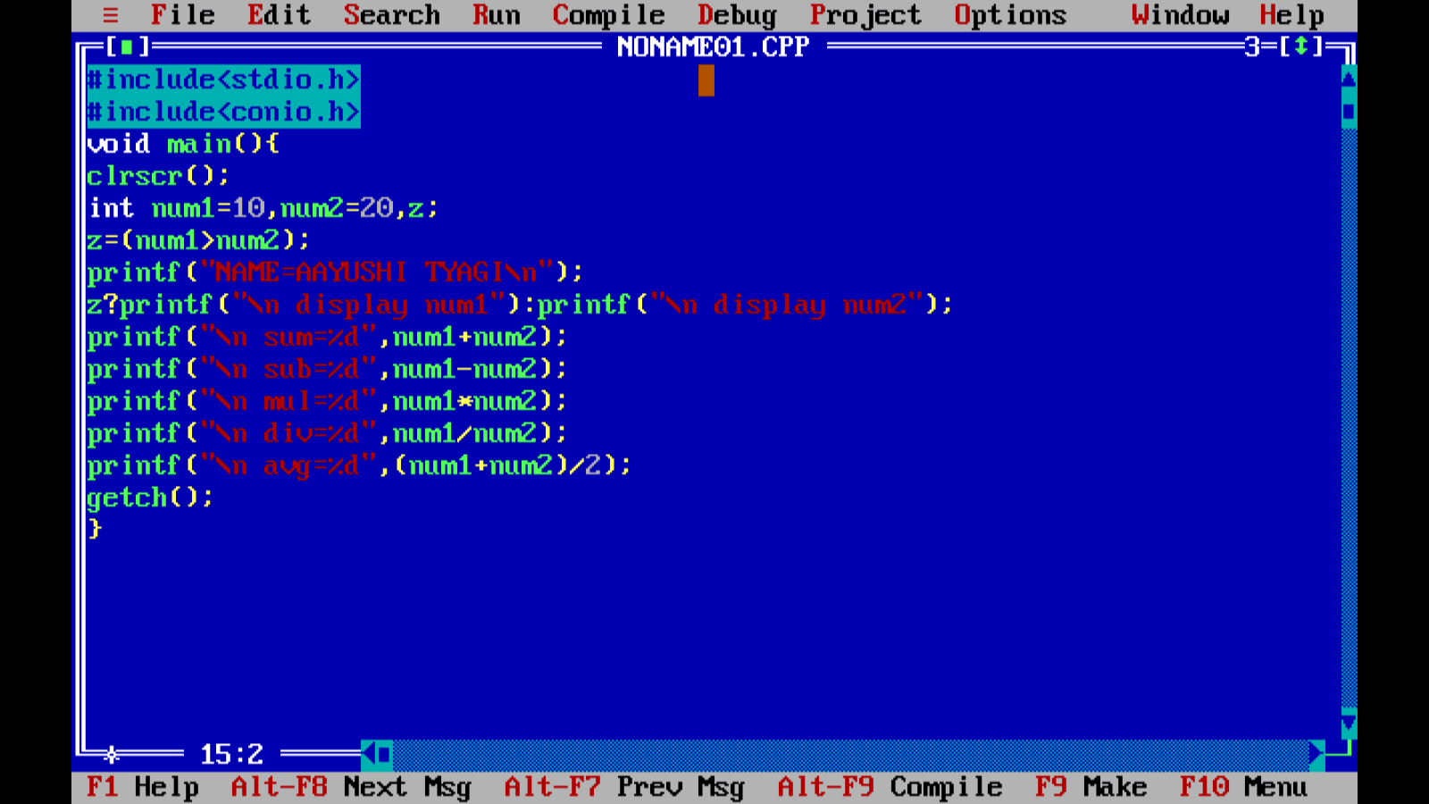

Output:

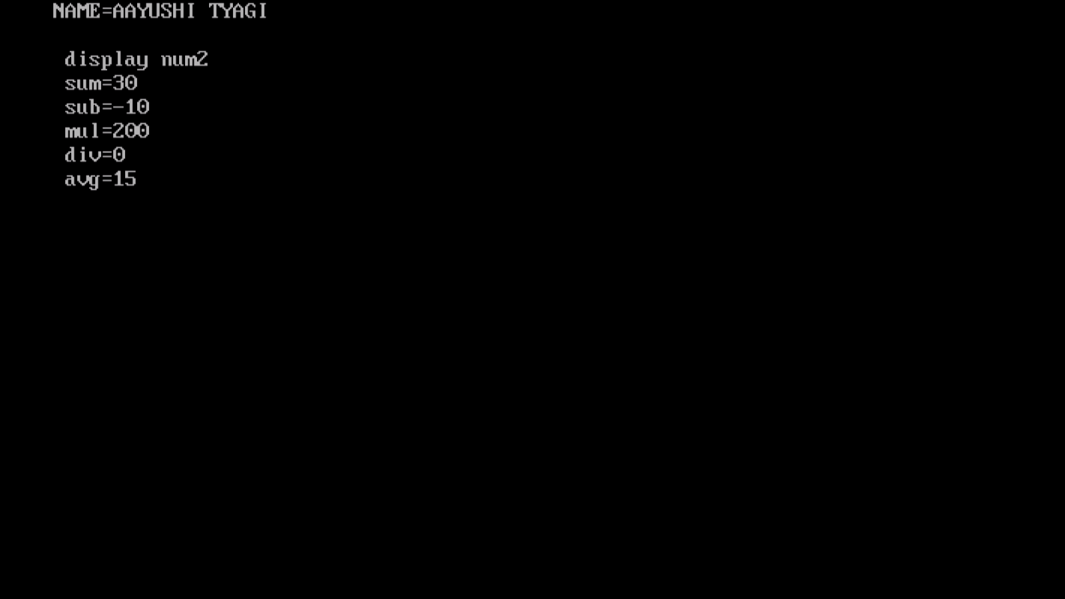

PROGRAM 77:

WRITE A PROGRAM TO CREATE A STRUCTURE FOR EMPLOYEES CONTAINING THE FOLLOWING DATA MEMBERS : EMPLOYEE ID ,EMPLOYEE NAME,AGE,ADDRESS,DEPARTMENT AND SALARY.INPUT DATA FOR 10 EMPLOYEESAND DISPLAY THE DETAILS OF THE EMPLOYEE FROM THE EMPLOYEE ID GIVEN BY THE USER:

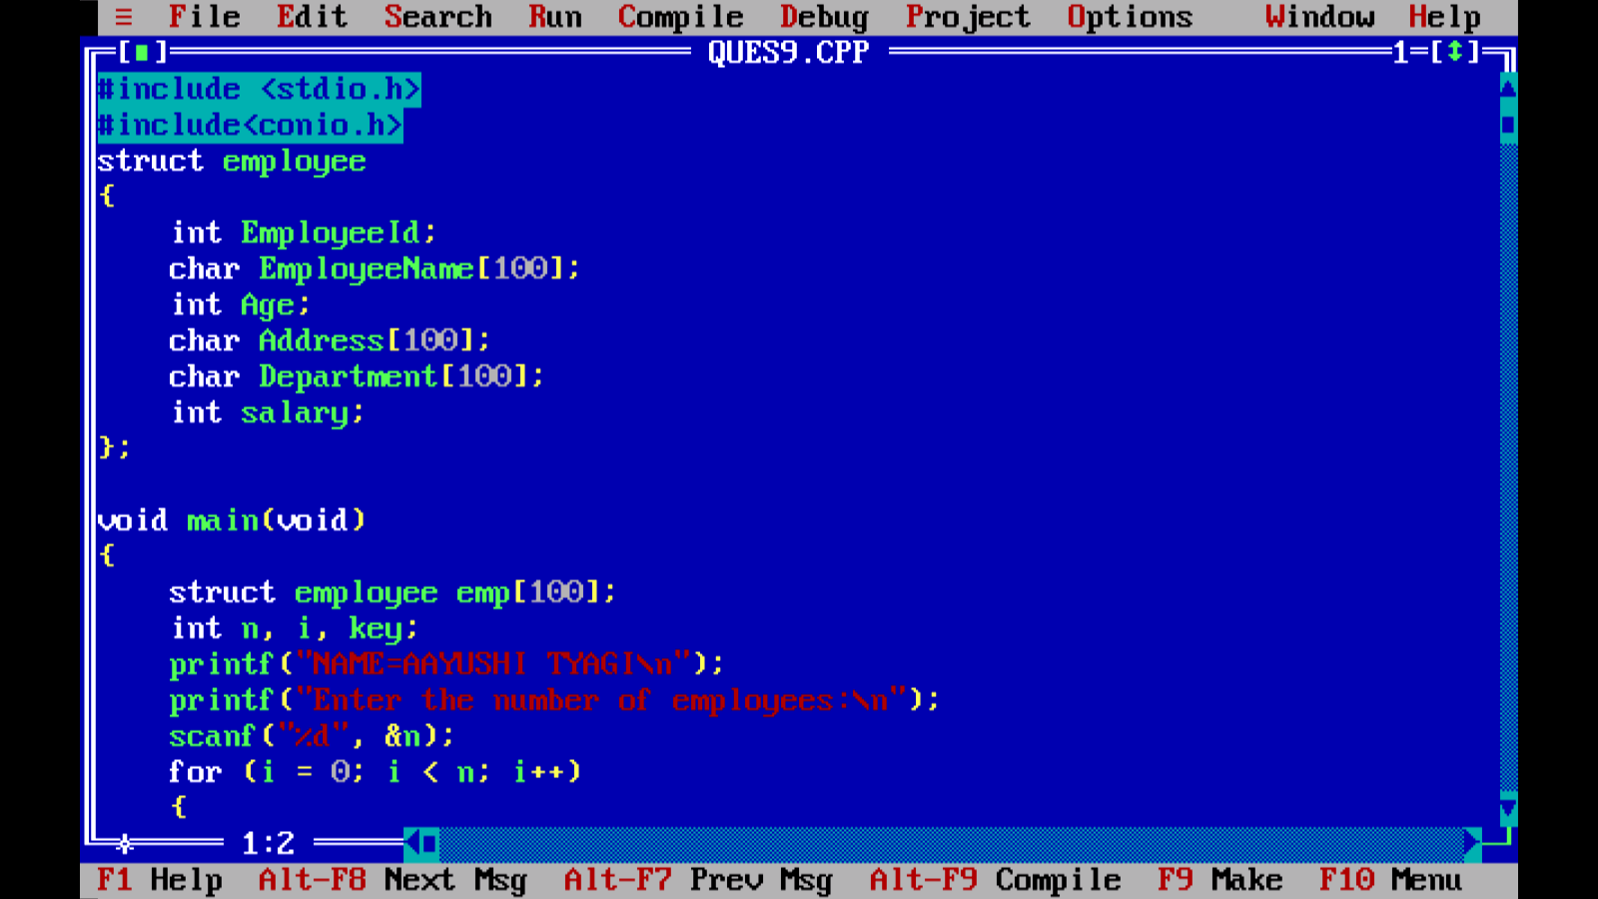

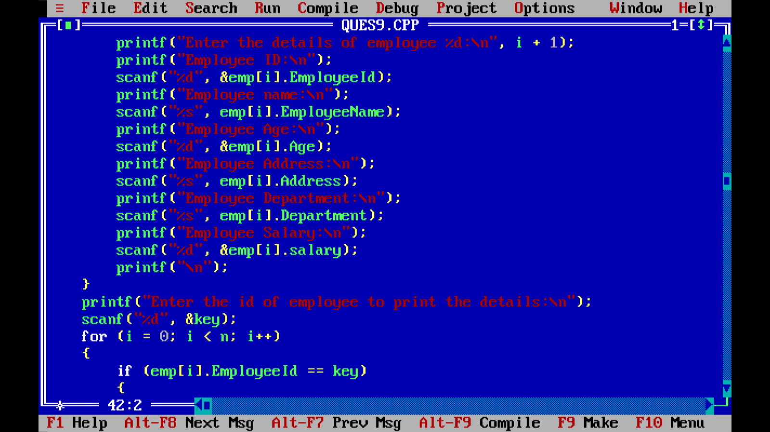

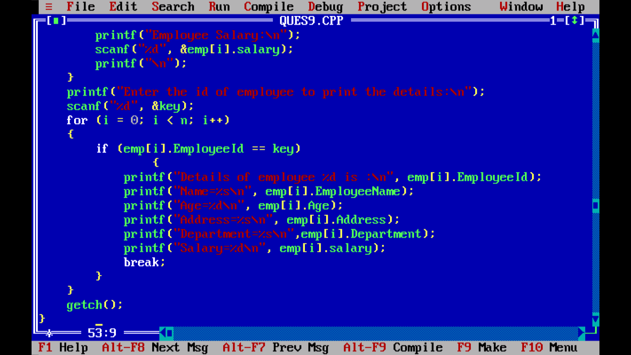

Output:

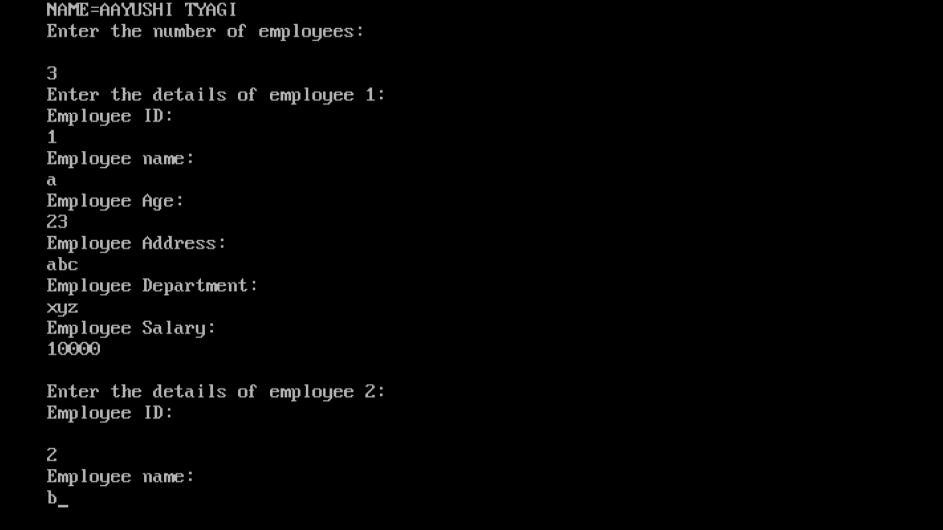

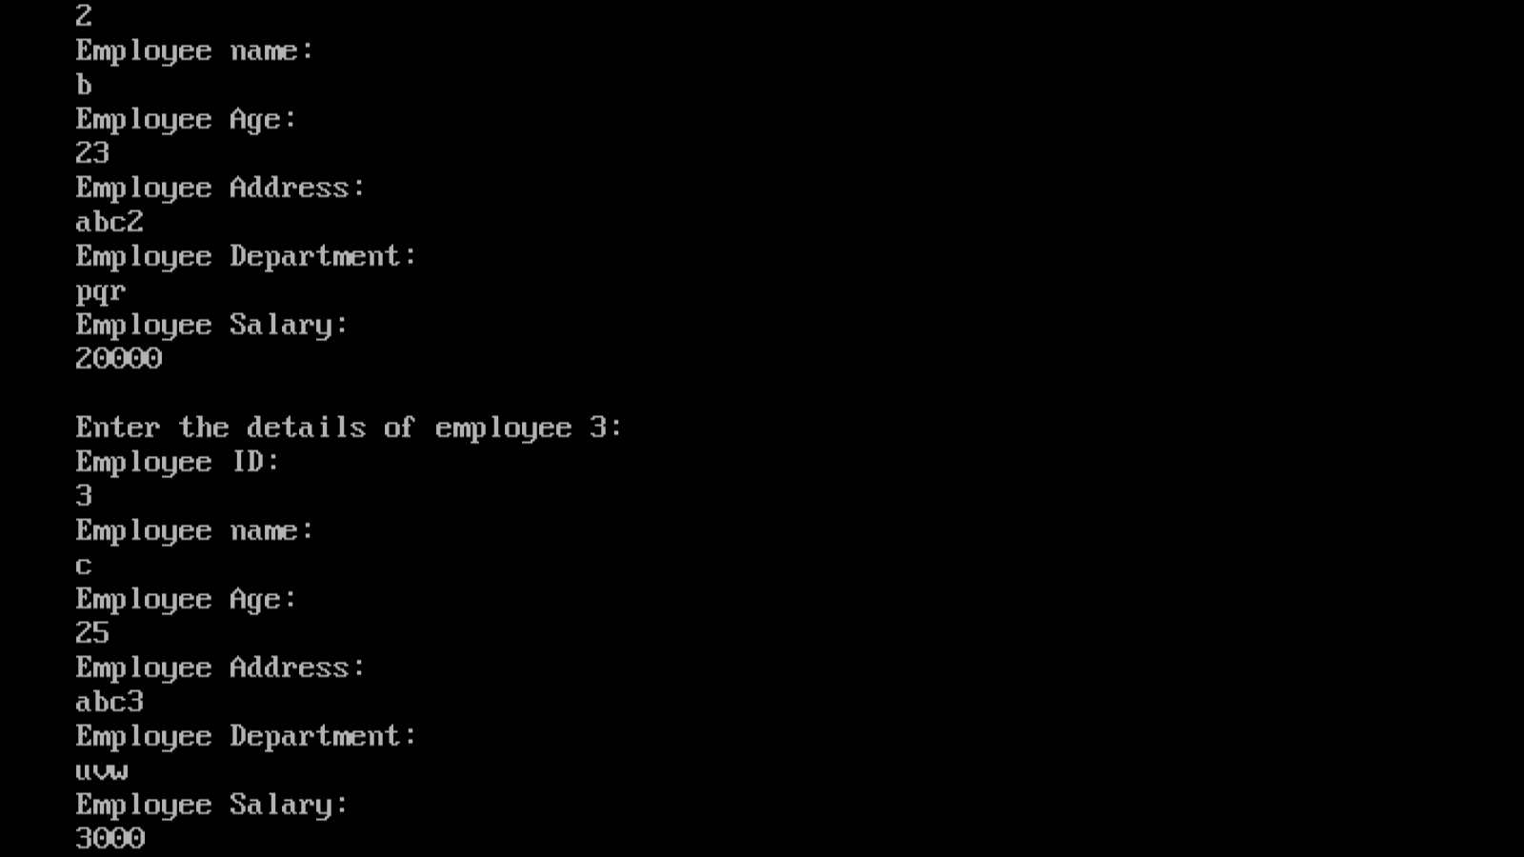

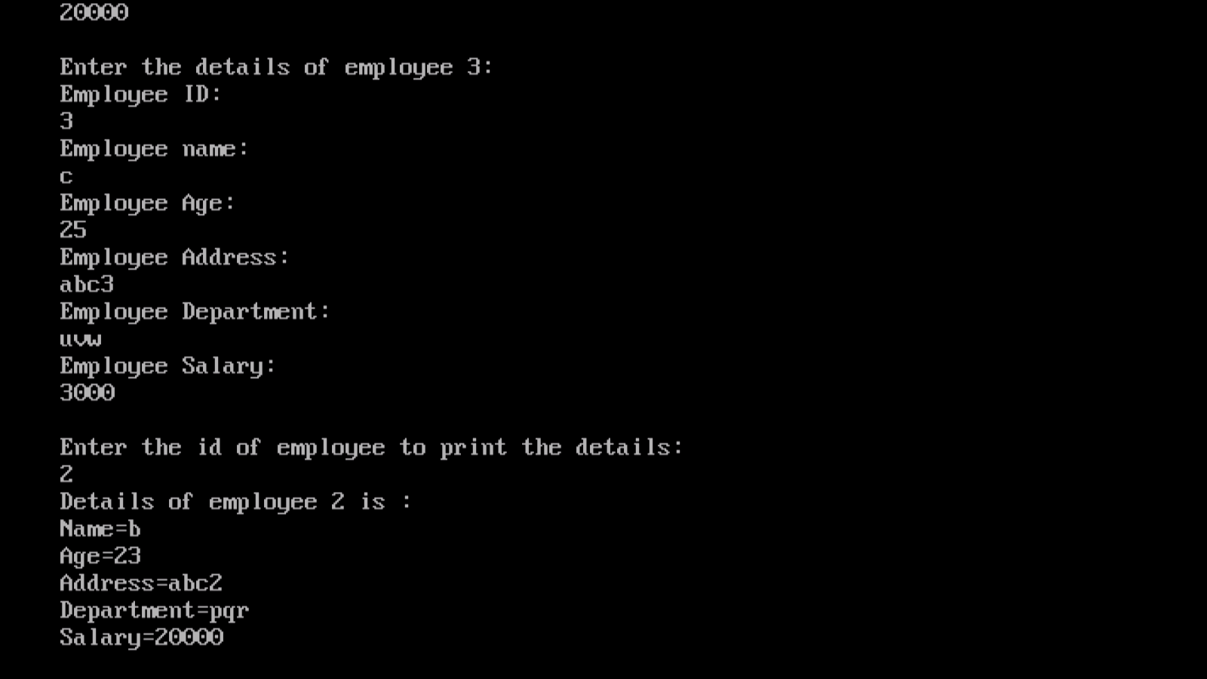

PROGRAM 78:

WRITE A PROGRAM TO CREATE TWO FILES WITH NAMES EVENFILE AND ODDFILE.INPUT 20 NUMBERS FROM THE USER AND SAVE EVEN NUMBERS IN EVENFILE AND ODDNUMBERS IN ODDFILE.

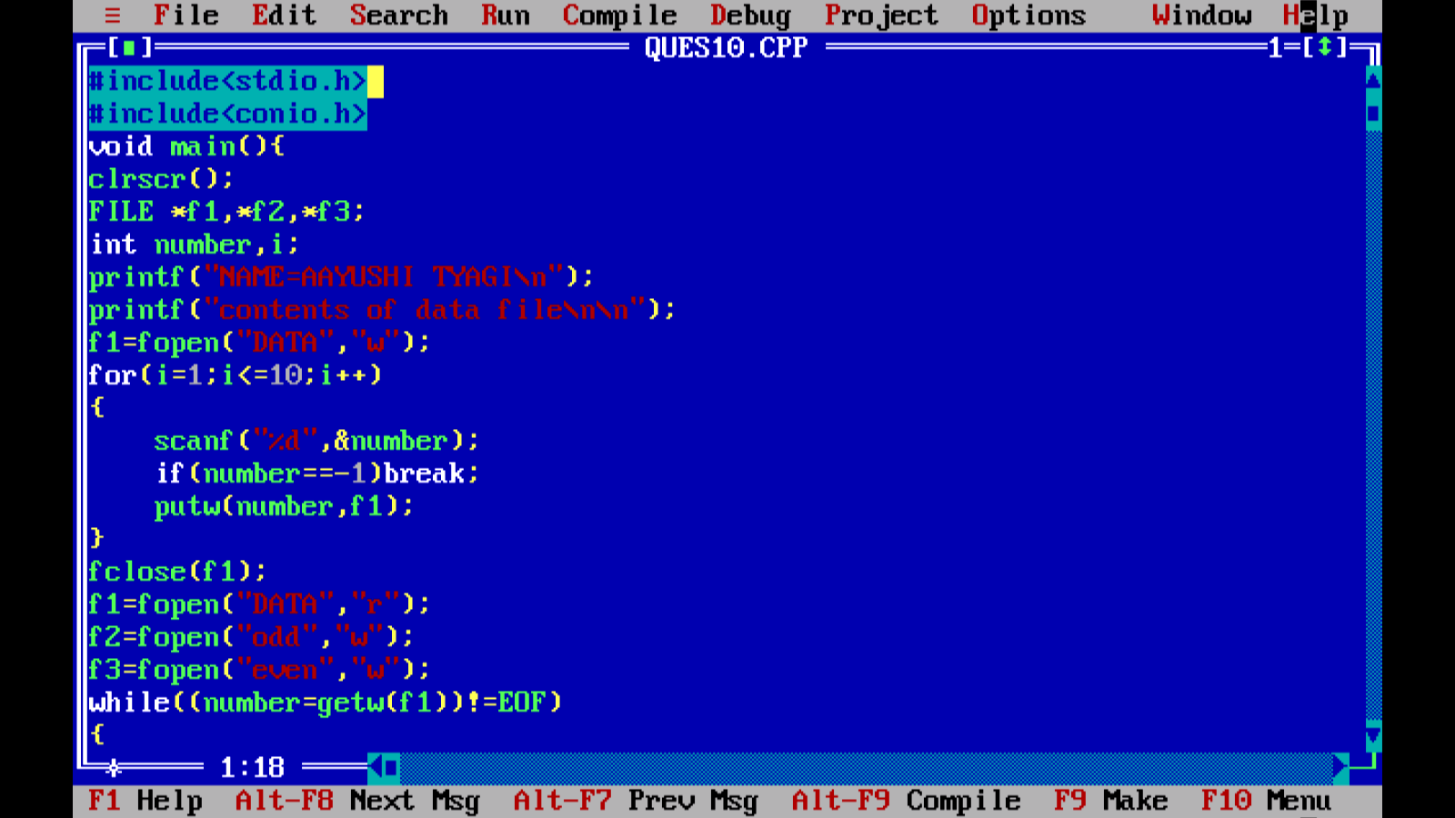

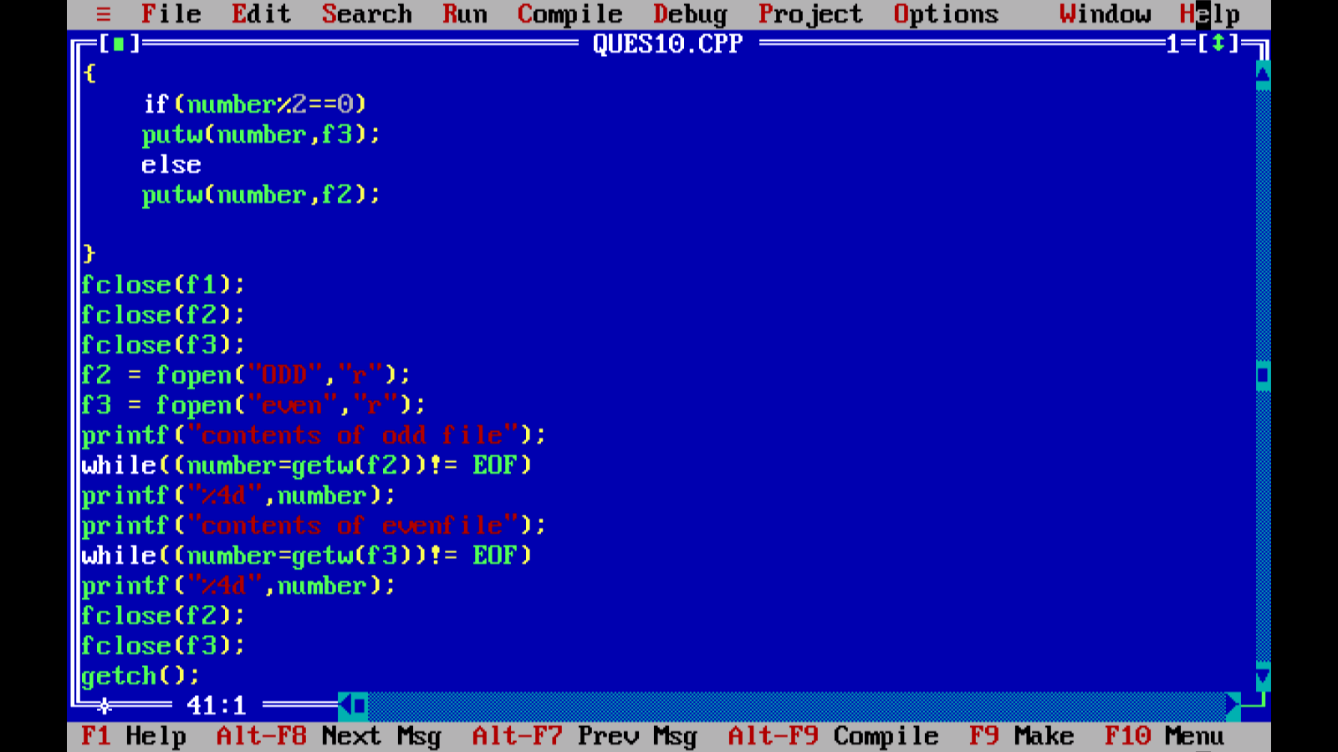

Output:

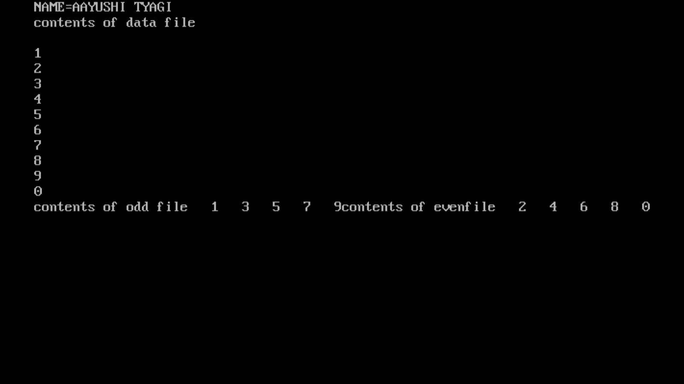

PROGRAM 79:

WRITE A MENU DRIVEN PROGRAM TO CONSTRUCT A CALCULATOR FOR FOLLOWING ARITHMETIC OPERATIONS: ADDITION,SUBTRACTION,MULTIPLICATION,DIVISION,AVERAGE AND PERCENTAGE.

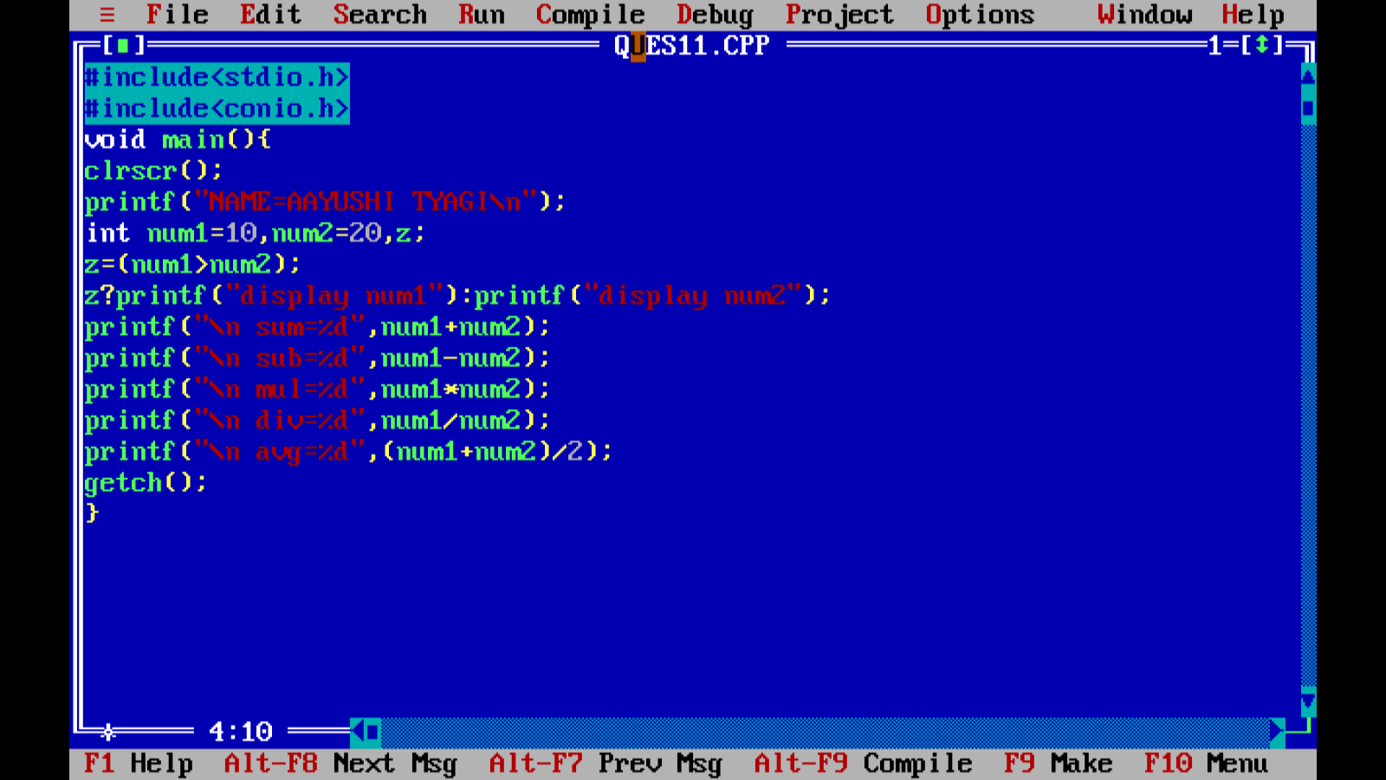

Output:

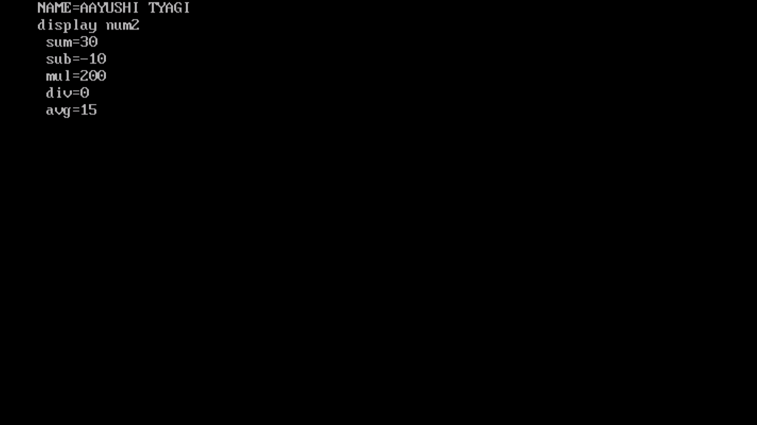

PROGRAM 80:

WRITE A PROGRAM TO CONVERT A HEXADECIMAL NUMBER INTO A BINARY NUMBER:

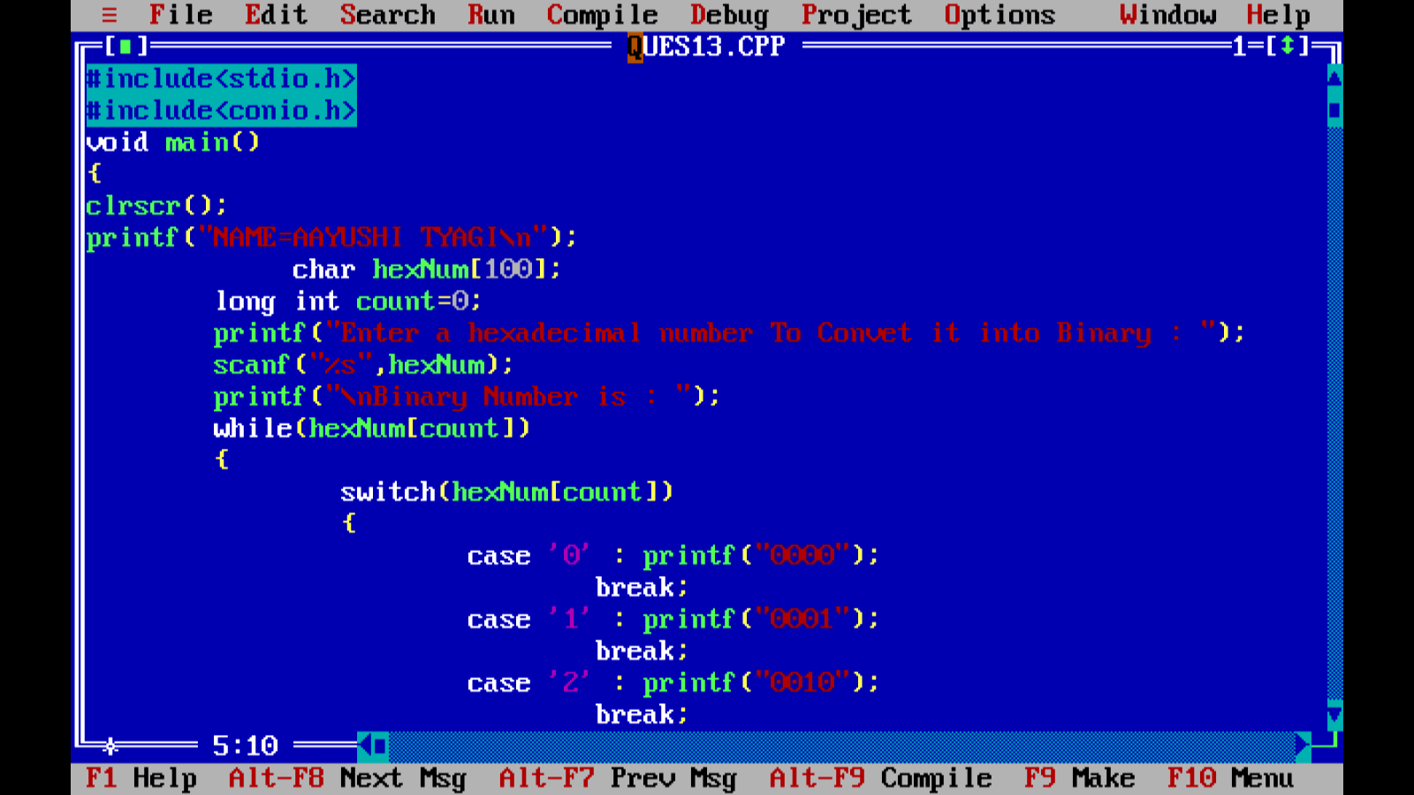

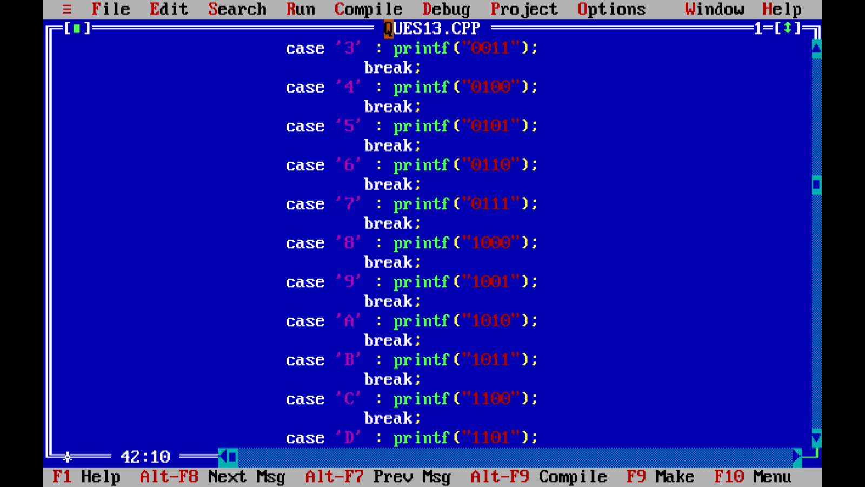

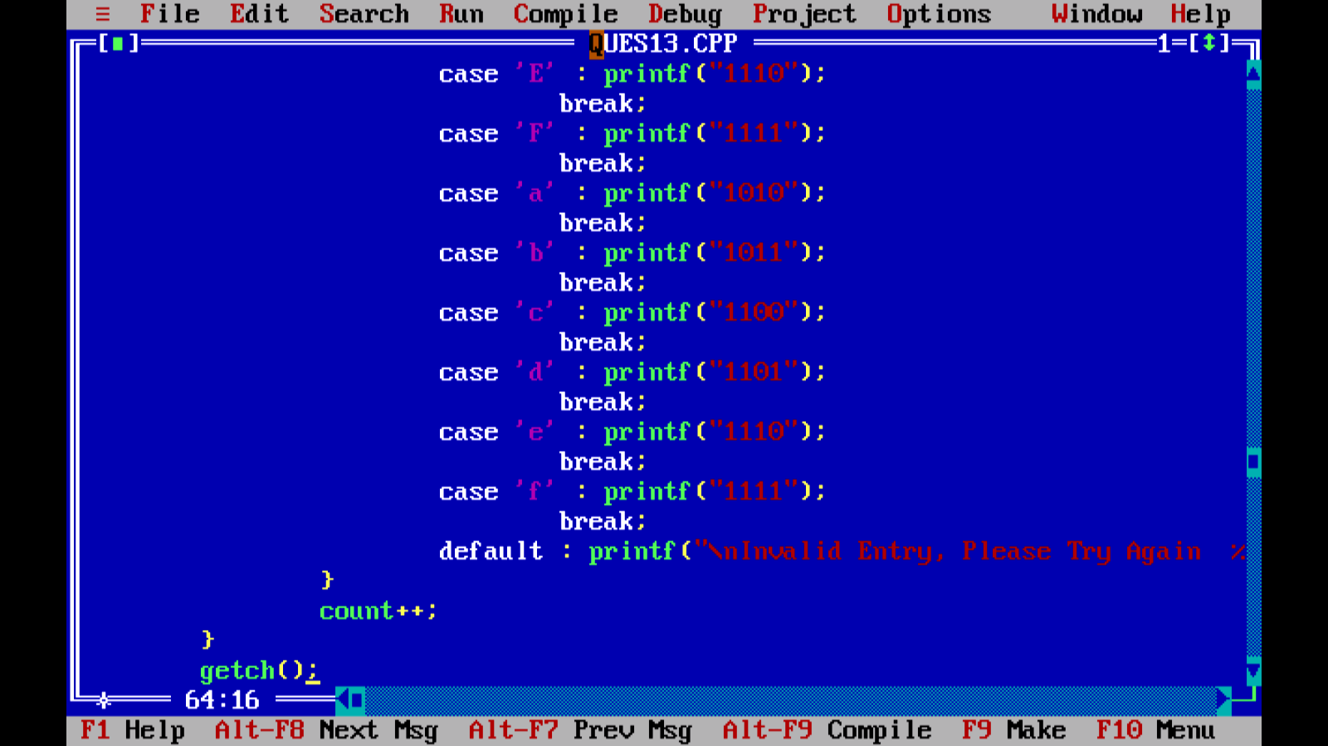

Output:

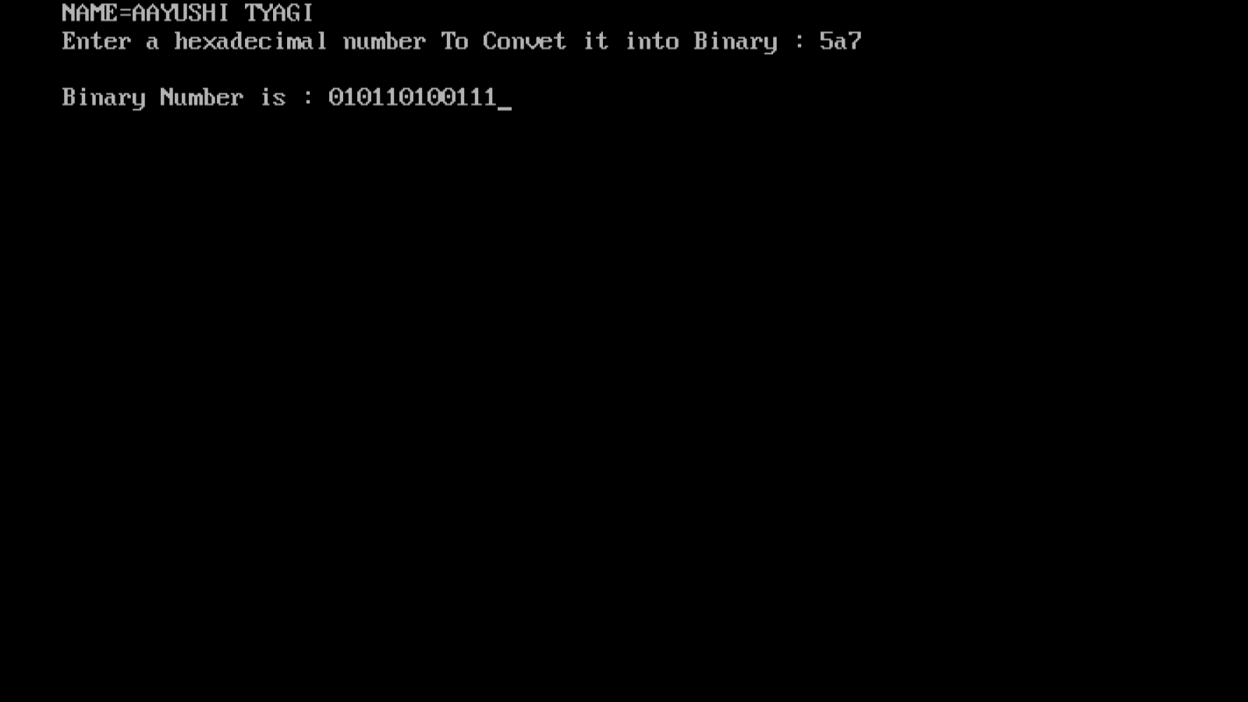

PROGRAM 81:

WRITE A PROGRAM TO CALCULATE FACTORIAL OF A NUMBERAND DISPLAY FIBONACCI SERIES UPTO N TERMS USING RECURSIVE FUNCTIONS

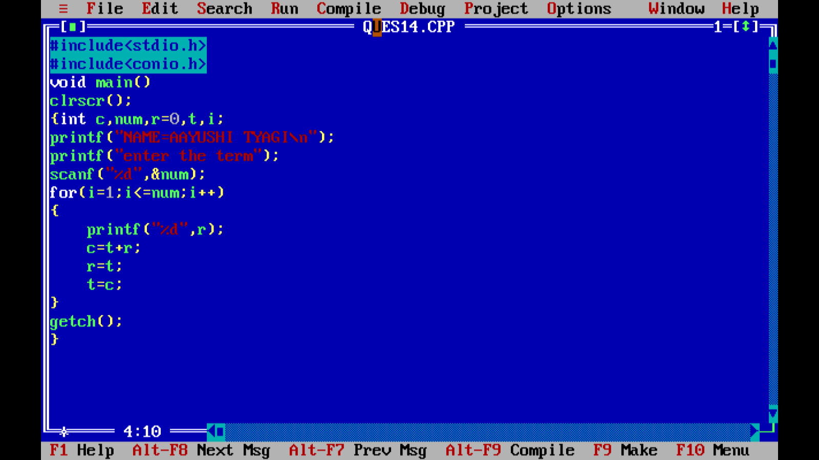

Output:

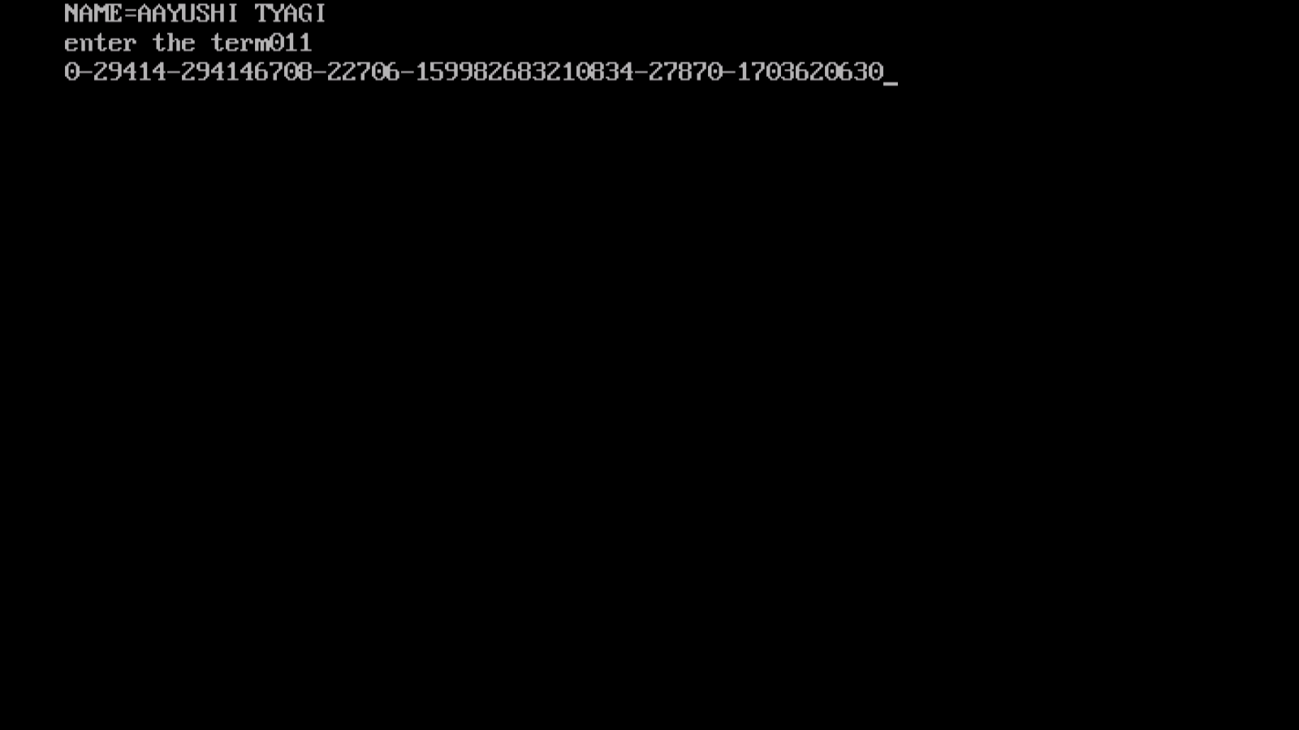

PROGRAM 82:

WRITE A PROGRAM TO PERFORM

1)MATRIX ADDITION 2)MATRIX MULTIPLICATION,AND

3)MATRIX TRANSPOSE ON 2D ARRAYS

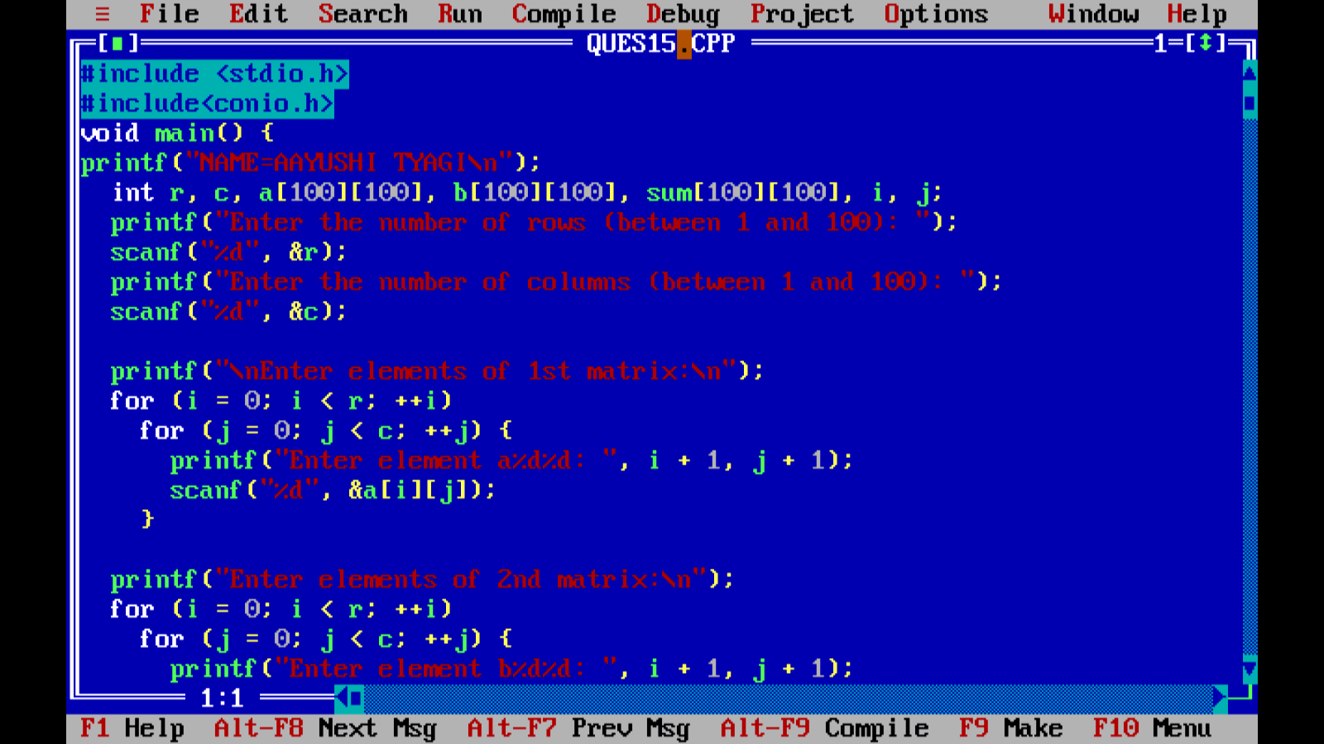

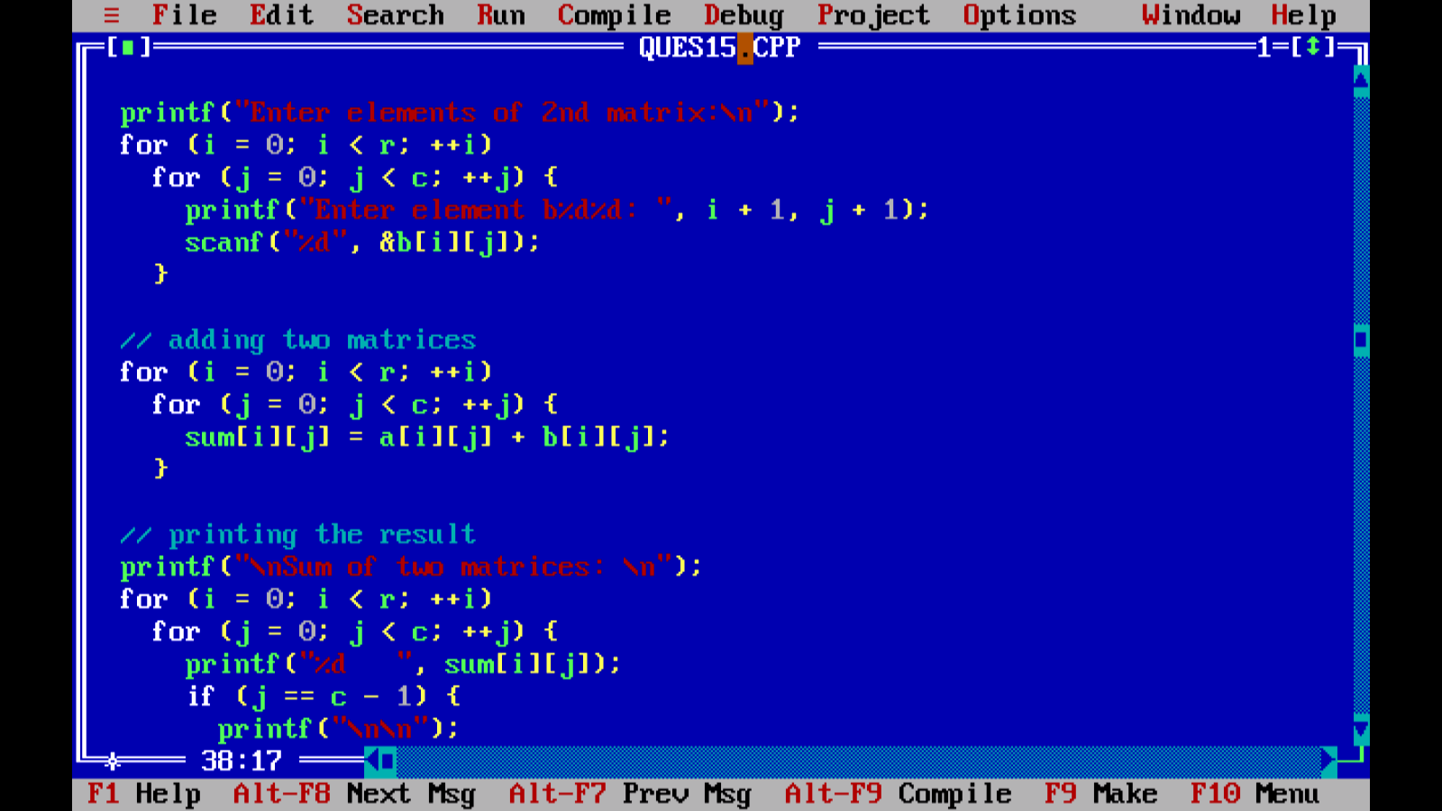

Output:

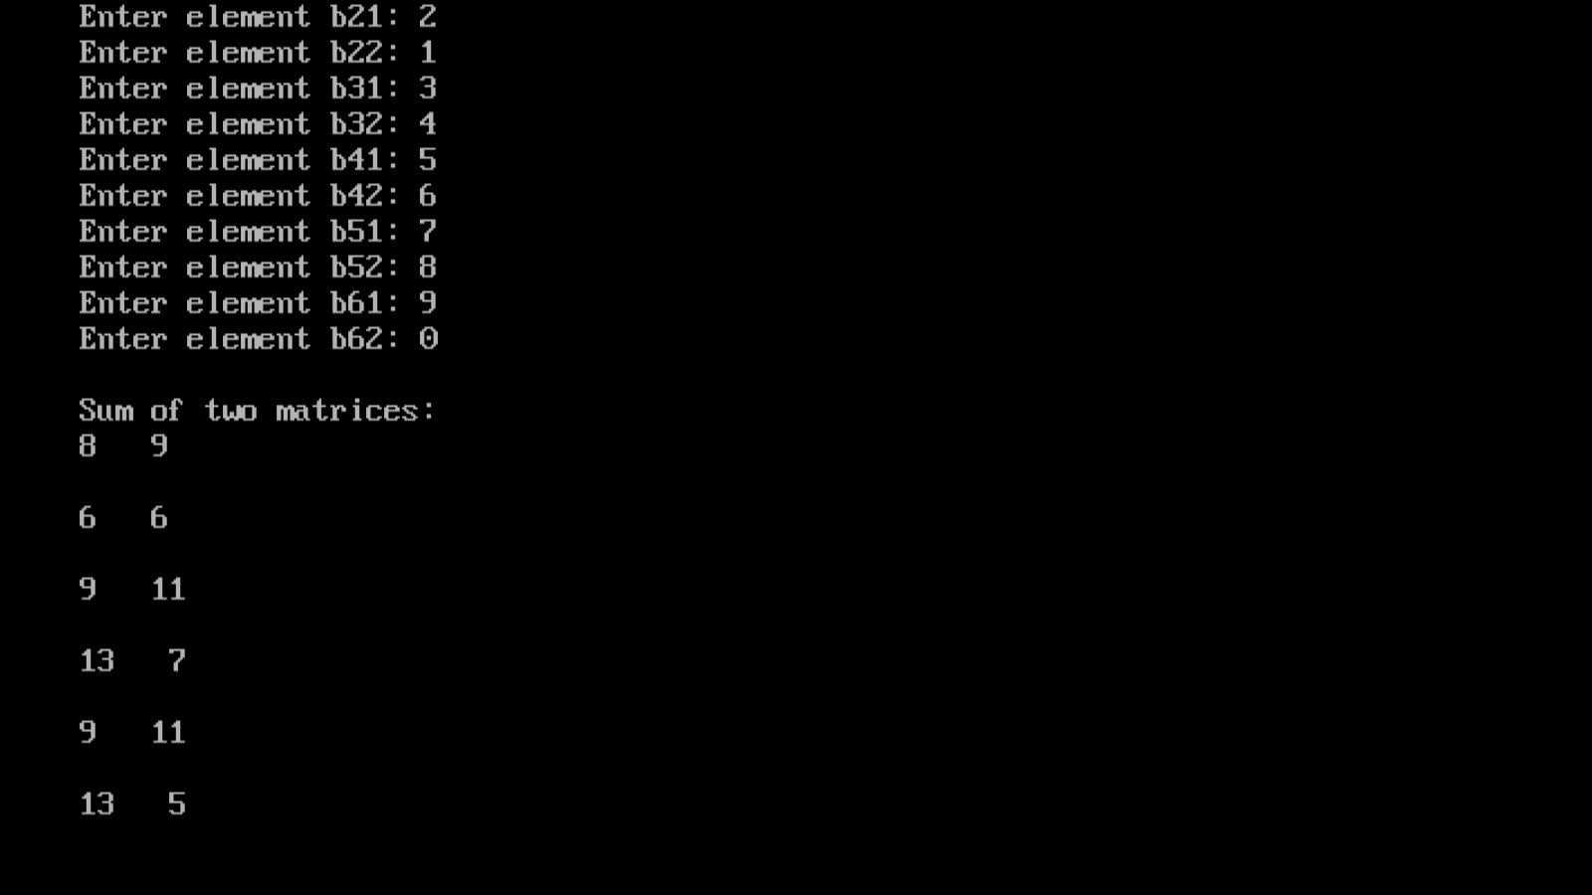

PROGRAM 83:

WRITE A PROGRAM TO MAKE USE OF ARRAYS WITH STRUCTURES IN THE FOLLOWING WAYS:

1)USE ARRAY AS A STRUCTURE DATA MEMBER

2)CREATE ARRAY OF STUCTURE VARIABLES

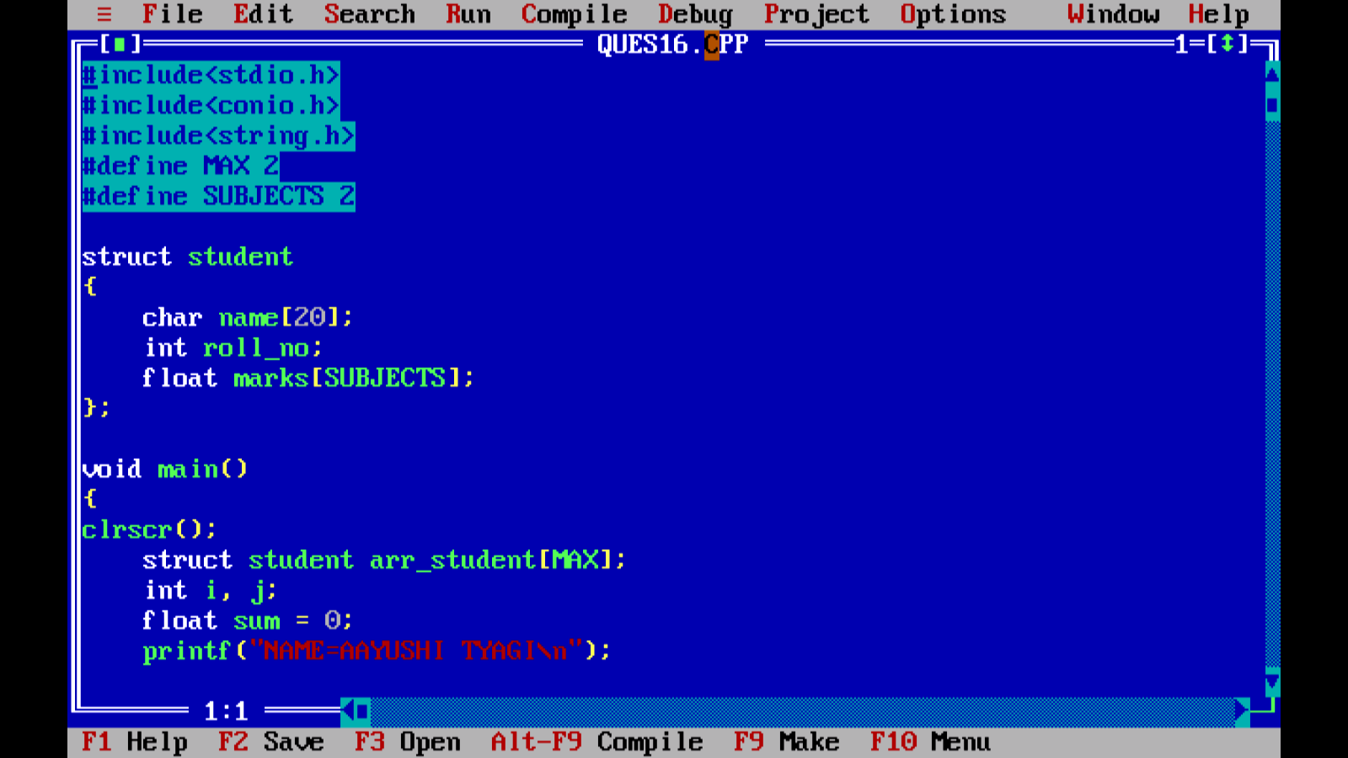

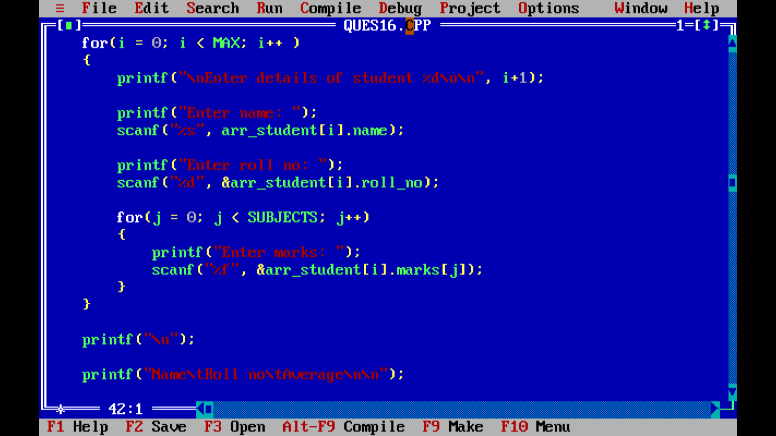

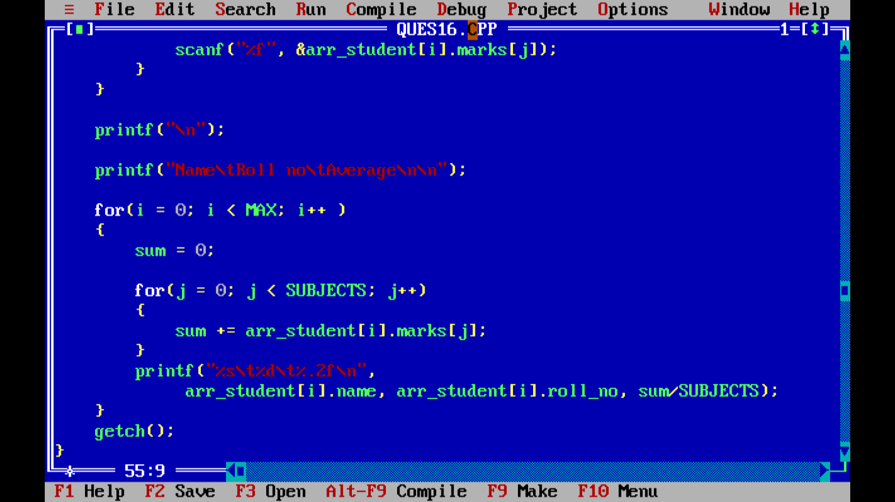

Output:

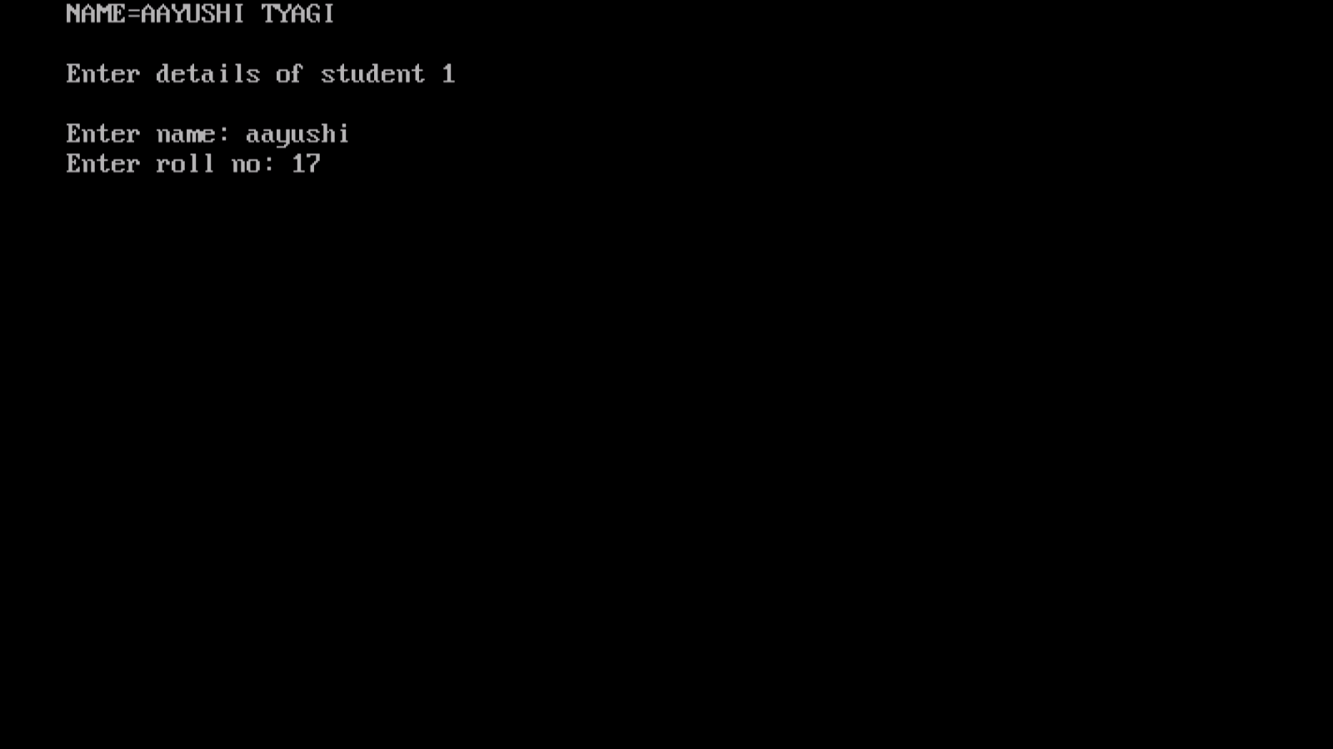

PROGRAM 84:

WRITE A PROGRAM TO COMPARE THE CONTENTS OF TWO FILES BY TAKING NAMESOF THE FILES THROUGH COMMAND LINE ARGUMENTS

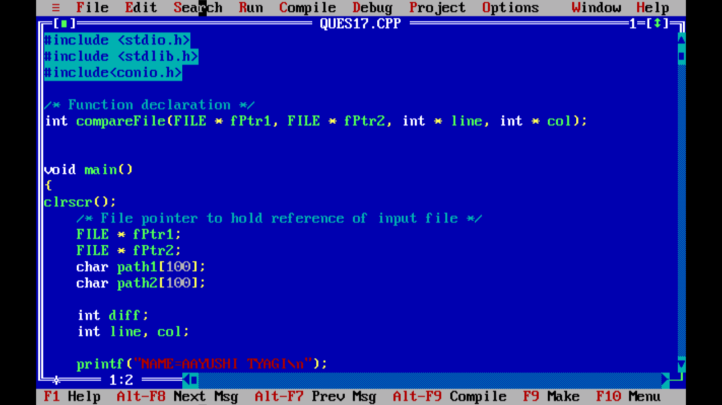

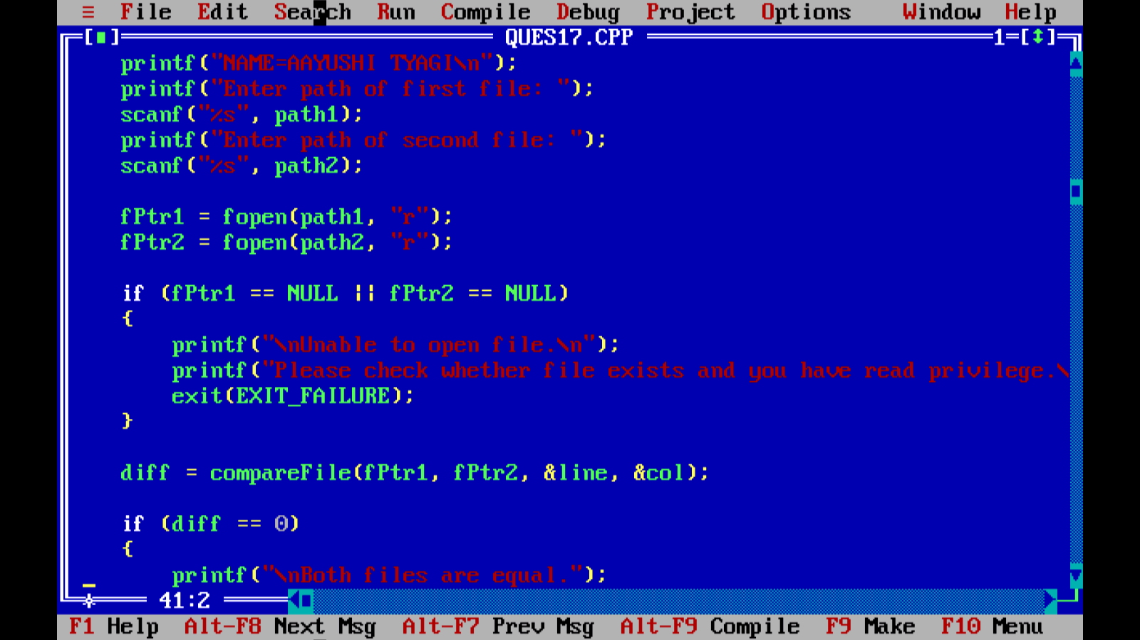

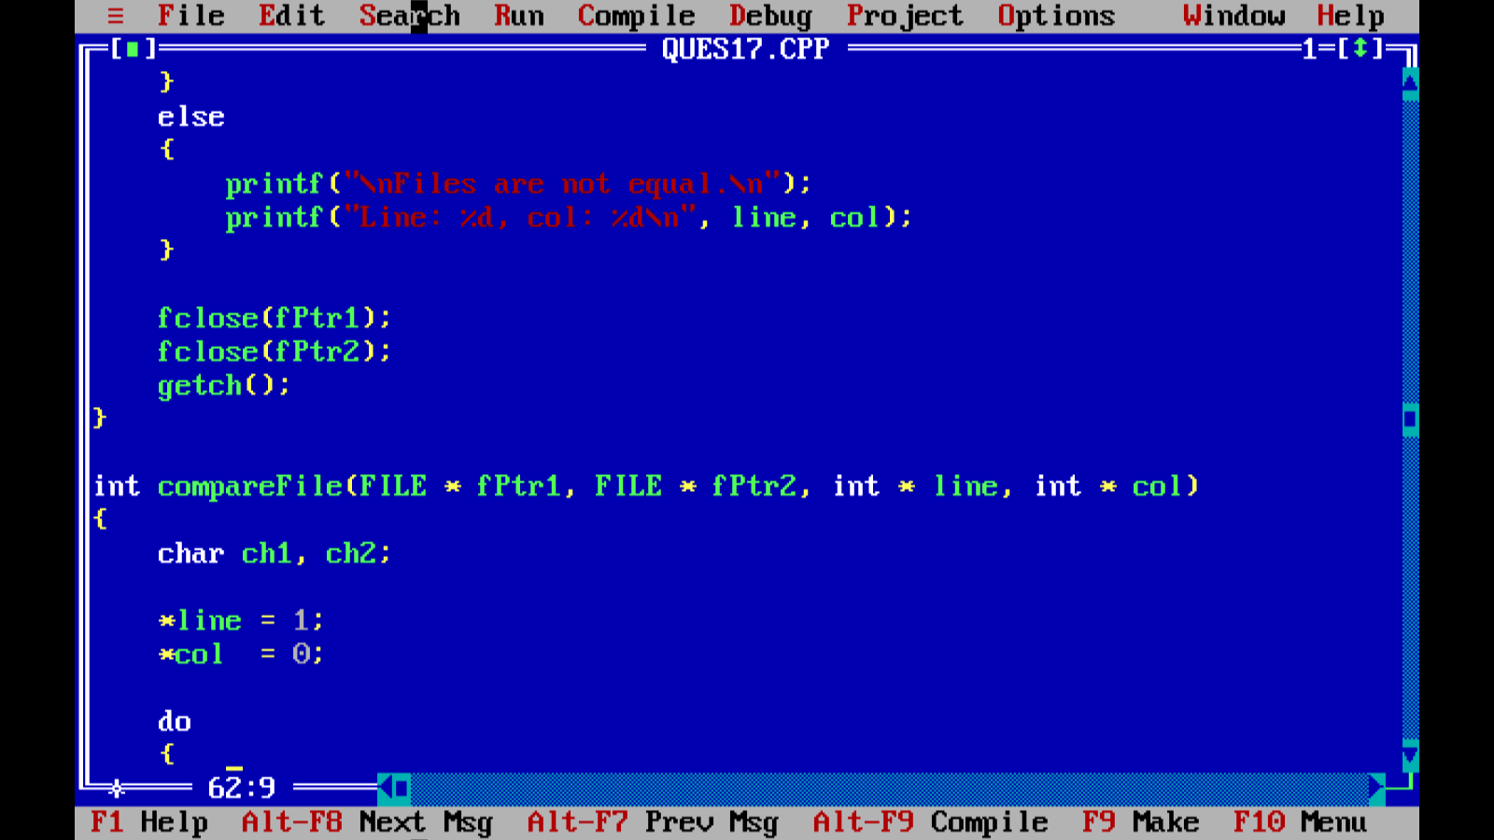

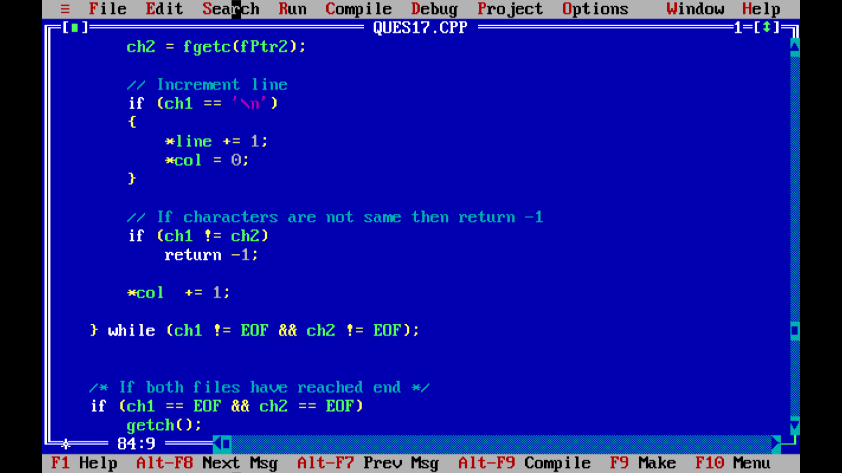

Output:

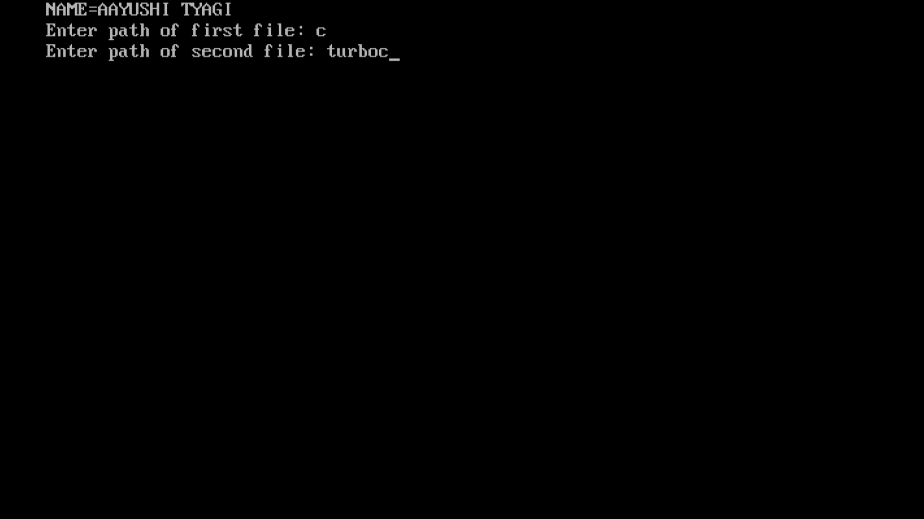

PROGRAM 85:

WRITE A PRO GRAM TO PERFORM I/O AND MAKE USE OF FILE POSITIONING FUNCTIONS ON BINARY FILES,(USING FSEEK,FTELL,REWIND FUNCTION)

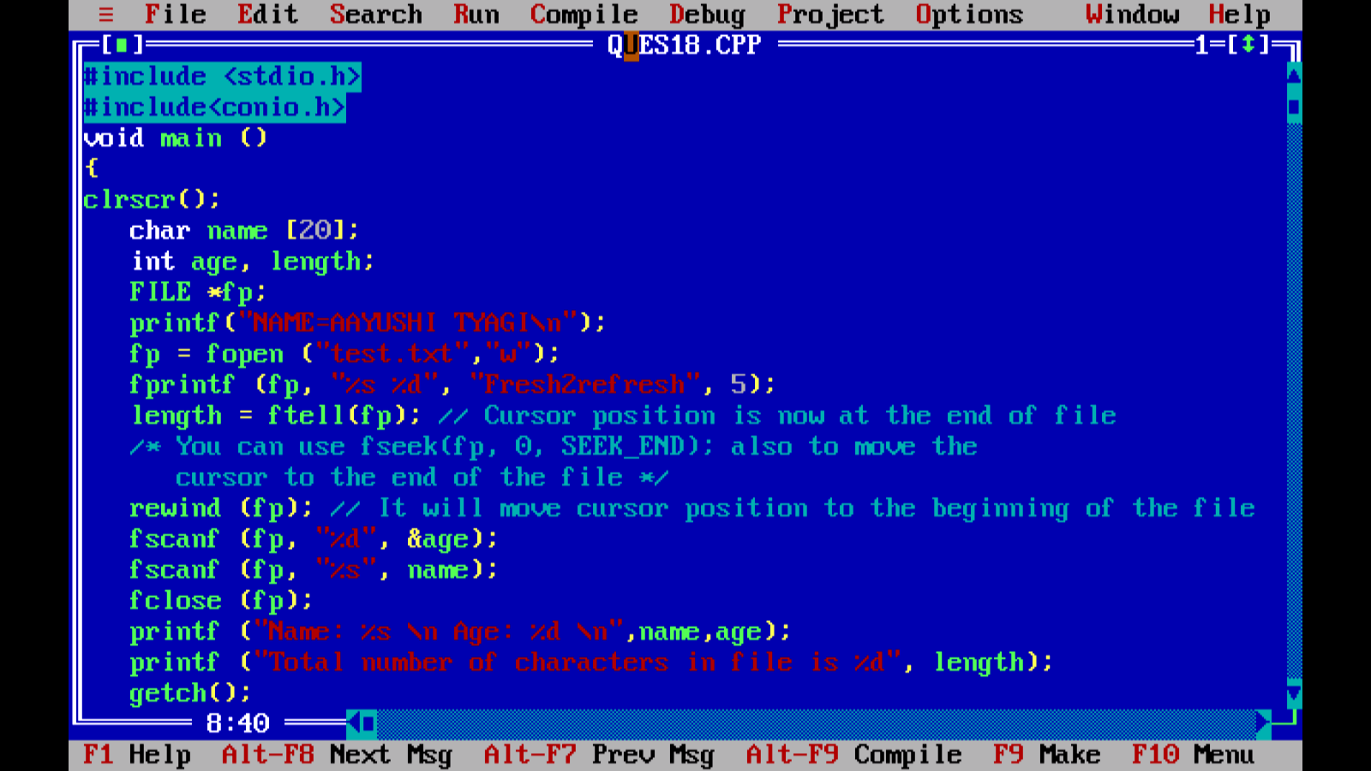

OUTPUT:

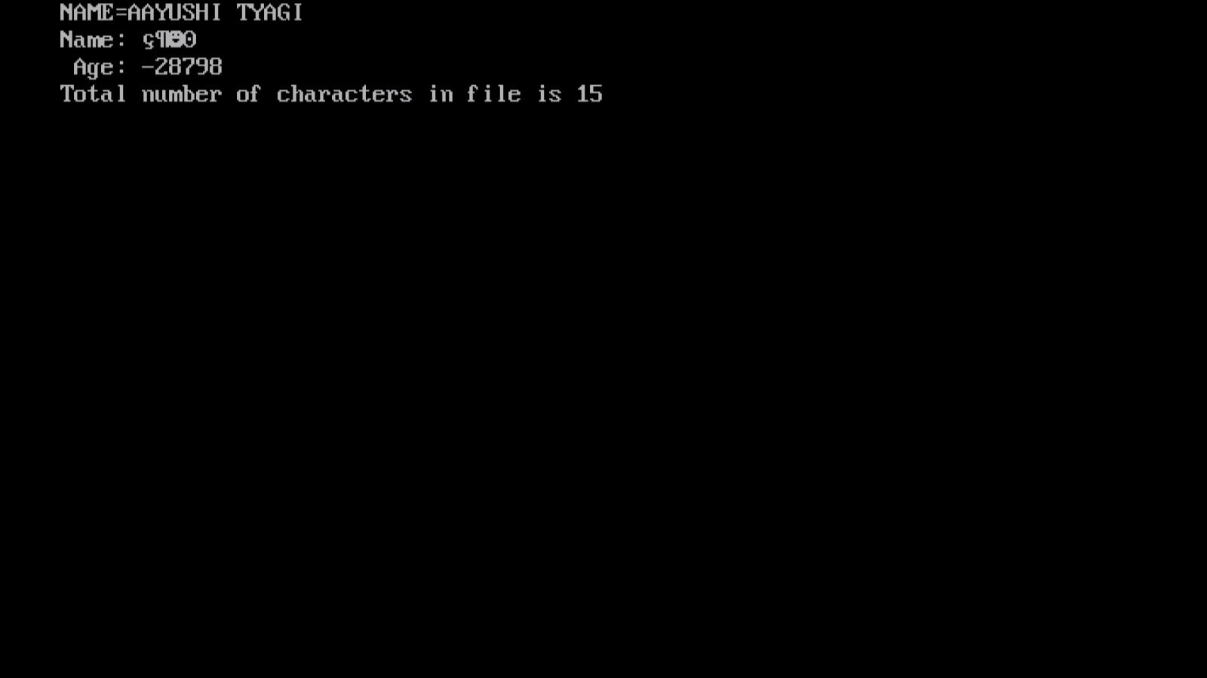

PROGRAM 86:

WRITE A MENU DRIVEN PROGRAM TO IMPLEMENT THE FOLLOWING STRINGS OPERATIONS:

1)CALCULATE LENGTH OF A STRING

2)CONCETENATE AT THE END OF A GIVEN

3)COPY ONE STRING TO ANOTHER

4)COMPARE CONTENTSOF TWO SRINGS

5)COPY NTH CHARACTER STRING TO ANOTHER

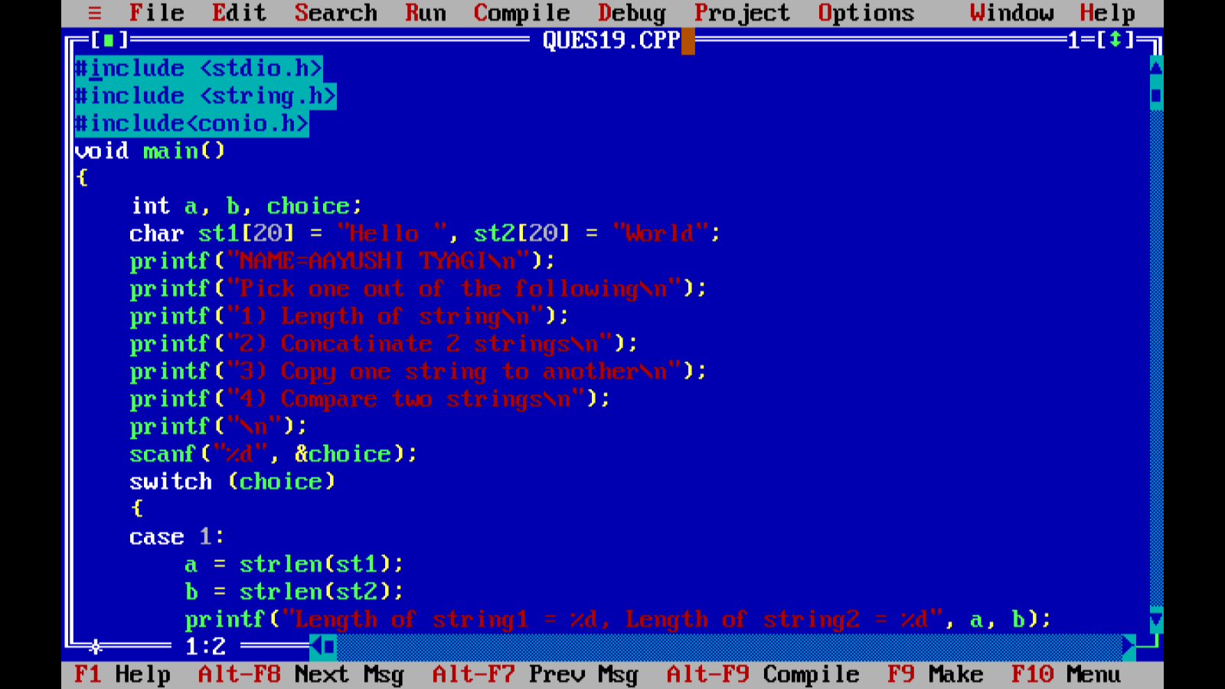

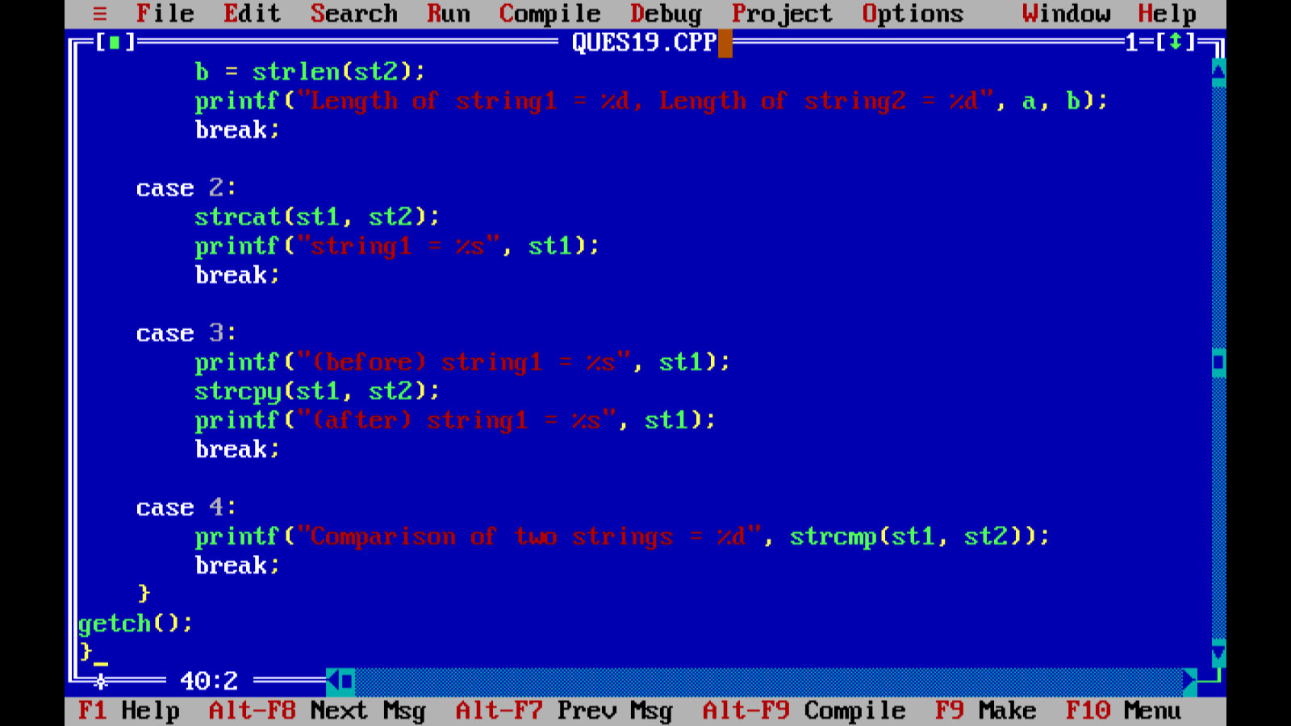

­OUTPUT:

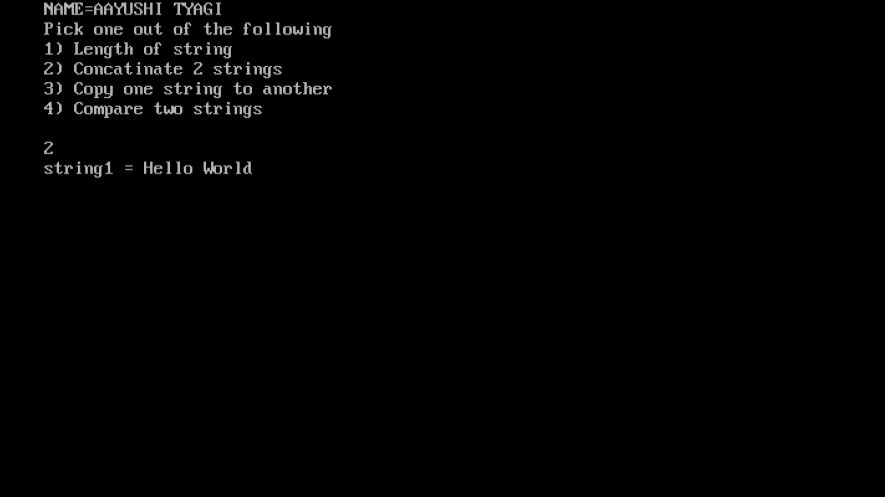

PROGRAM 87:

WRITE A PROGRAM TO READ TIME IN STRING FORMAT AND EXTRACT HOURS,MINUTES AND SECOND ALSO CHECK TIME VALIDITY.

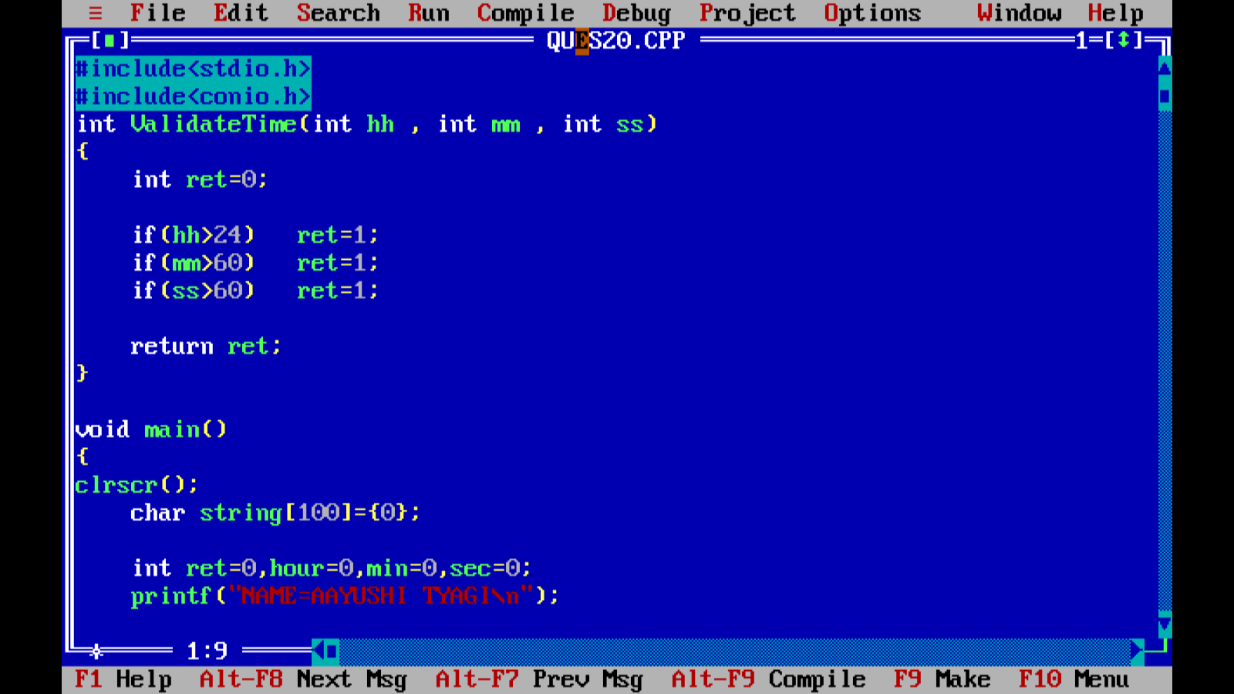

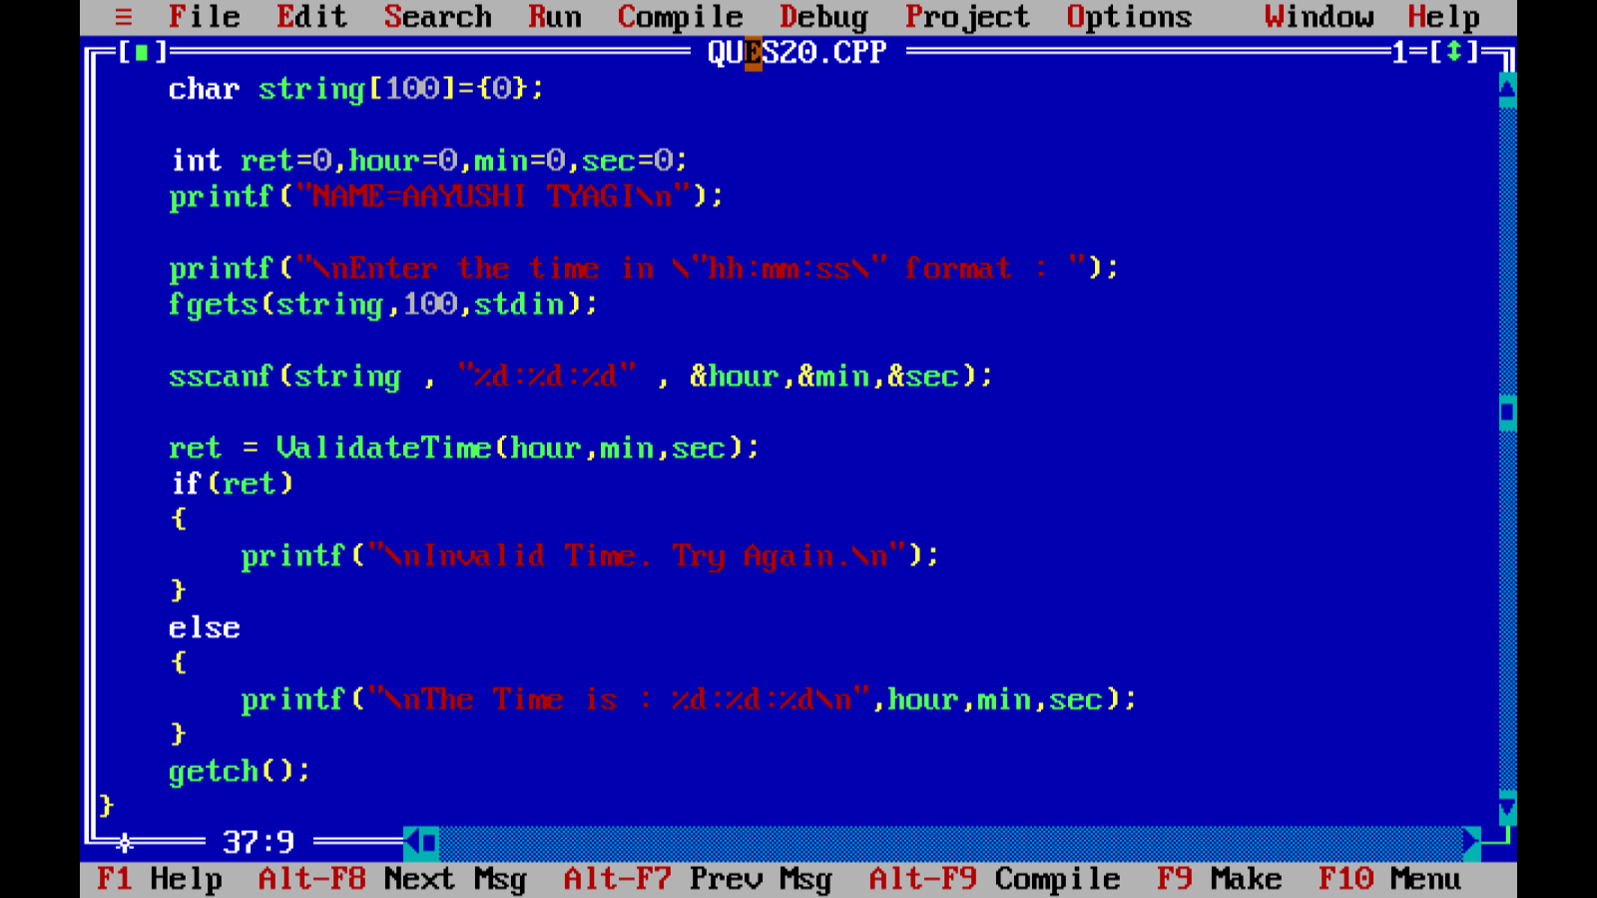

OUTPUT:

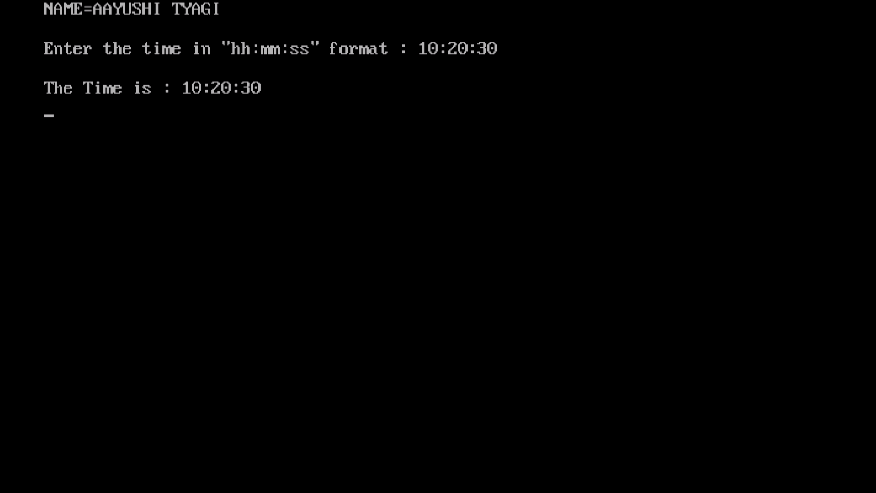

PROGRAM 88: